**Q1.**

Circle two words in the passage below that are **synonyms** of each other.

Having queued  for  over  an  hour,  Sanjit  found  that  his  tolerance

was  being  severely  tested.  Most  of  the  other  children  had  lost

patience  and  gone  elsewhere.

**1 mark**

**Q2.**

Which verb is a **synonym** of the verb produce?

|  |  |
| --- | --- |
|  | Tick **one**. |
| make |  |
| buy |  |
| sell |  |
| trade |  |

**1 mark**

**Q3.**

Circle the two words that are **synonyms** in the passage below.

The   café   serves   delicious   snacks   and   cakes

until   noon.

After   midday,   you   can   also   order   hot   lunches,

sandwiches   or   soup.

**1 mark**

**Q4.**

Circle the two words in the sentence below that are **synonyms** of each other.

He  was  lucky  to  win  first  prize  –  he  knew  it  was

fortunate  that  his  closest  rival  had  decided  not  to  take

part.

**1 mark**

**Q5.**

Draw a line to match each word with its **synonym**.

|  |  |  |
| --- | --- | --- |
| **Word** |  | **Synonym** |
| vast |  | dull |
|  |  |  |
| swift |  | busy |
|  |  |  |
| drab |  | huge |
|  |  |  |
| bustling |  | fast |

**1 mark**

**Q6.**

Replace the underlined word with a word that has a similar meaning.

Write the new word in the box.

When they returned, all the others had disappeared.

|  |
| --- |
|  |

**1 mark**

**Q7.**

Tick the word that is similar in meaning to:

abrupt

|  |  |
| --- | --- |
|  | Tick **one.** |
| slow |  |
| seldom |  |
| often |  |
| sudden |  |

**1 mark**

Mark schemes

**Q1.**

**Award 1 mark** for the correct words circled.

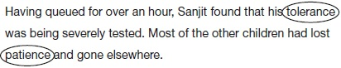

**1 mark**

**Q2.**

make



**1 mark**

**Q3.**

**Award 1 mark** for both synonyms encircled.

The café serves delicious snacks and cakes until .



After , you can also order hot lunches, sandwiches



or soup.

**1 mark**

**Q4.**

**Award 1 mark** for **both** words encircled.

He was  to win first prize – he knew it was



that his closest rival had decided not to take part.

**1 mark**

**Q5.**

**Award 1 mark** for all four correct.

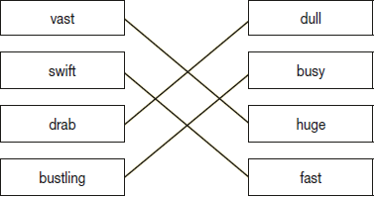

**1 mark**

**Q6.**

**Award 1 mark** for a suitable past participle synonym, eg:

*•        vanished / gone / left*

**1 mark**

**Q7.**

|  |  |
| --- | --- |
|  |  |
|  |  |
|  |  |
| sudden |  |

**1 mark**