**Q1.**

Which word can have the letters un in front of it to make another word?

|  |  |
| --- | --- |
|  | Tick **one**. |
| tie |  |
| big |  |
| hot |  |
| sit |  |

**1 mark**

**Q2.**

Add **two** letters to the word happy to make a word that means not happy.

We went to a football game. Our team lost and I

was very ___ ___happy.

**1 mark**

**Q3.**

Draw a line to match each **prefix** to the correct word to make a different word. Use each prefix only once.

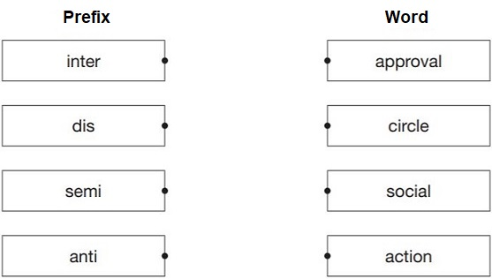

**1 mark**

**Q4.**

The prefix re- can be added to the root word play to make the word **replay**.

Tick the meaning of the word **replay**.

|  |  |
| --- | --- |
|  | Tick **one**. |
| to play together |  |
| to play later |  |
| to play again |  |
| to play badly |  |

**1 mark**

**Q5.**

What does the **prefix** multi- mean in the words multicultural, multipurpose and multicoloured?

|  |  |
| --- | --- |
|  | Tick **one**. |
| some |  |
| few |  |
| all |  |
| many |  |

**1 mark**

**Q6.**

Draw a line to match each **prefix** to a word to make **four** different words.

Use each prefix only once.

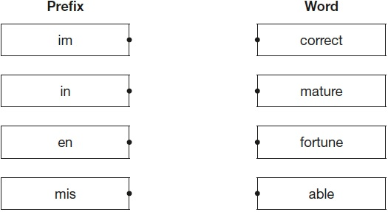

**1 mark**

**Q7.**

The **prefix** mis- can be added to the word read to make the word misread.

What does the word **misread** mean?

|  |  |
| --- | --- |
|  | Tick **one.** |
| to read quickly |  |
| to read incorrectly |  |
| to read again |  |
| to read before |  |

**1 mark**

**Q8.**

Which one **prefix** can be added to all three words below to make their antonyms?

Write the prefix in the box.

secure

active

complete



**1 mark**

**Q9.**

Explain how the different **prefixes** change the meanings of the two sentences below.

The chef said the pasta was uncooked.

This means that the pasta ______________________________________

___________________________________________________________________

The chef said the pasta was undercooked.

This means that the pasta ______________________________________

___________________________________________________________________

**1 mark**

**Q10.**

Draw a line to match each **prefix** to the correct word so that it makes a new word.

|  |  |  |
| --- | --- | --- |
| **Prefix** |  | **Word** |
| re |  | mature |
|  |  |  |
| de |  | understood |
|  |  |  |
| mis |  | legible |
|  |  |  |
| im |  | frost |
|  |  |  |
| il |  | do |

**1 mark**

**Q11.**

What does the prefix ‘bi’ mean in this group of words?

**bi**lingual            **bi**annual            **bi**sect            **bi**noculars

|  |  |
| --- | --- |
|  | Tick **one.** |
| two or twice |  |
| outside or external |  |
| under or below |  |
| through or across |  |

**1 mark**

**Q12.**

Add a **prefix** to the beginning of each word to form its **antonym**.

______________agree

______________legal

______________regular

**1 mark**

**Q13.**

Add a **prefix** and a **suffix** to the word below to make a new word.

_________________honest_________________

**1 mark**

Mark schemes

**Q1.**

**Award 1 mark** for the correct box ticked

tie



**1 mark**

**Q2.**

**Award 1 mark** for the letters *un* written in lower case.

*We went to a football game. Our team lost and I was very u n happy.*

**Also award the mark** for *unhappy* written out in full and spelt correctly.

**1 mark**

**Q3.**

**Award 1 mark** for all **four** correct.

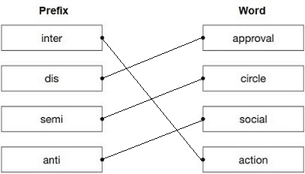

**1 mark**

**Q4.**

to play again



**1 mark**

**Q5.**

**Award 1 mark** for the correct box ticked.

many



**1 mark**

**Q6.**

**Award 1 mark** for all **four** correct.

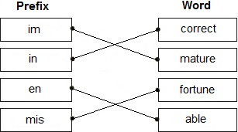

**1 mark**

**Q7.**

to read incorrectly



**1 mark**

**Q8.**

**Award 1 mark** for the correct prefix.



**1 mark**

**Q9.**

**Award 1 mark** for an explanation of both sentences, e.g.

The chef said the pasta was uncooked.

This means that the pasta *has not been cooked*.

This means that the pasta *is not cooked (at all)*.

The chef said the pasta was undercooked.

This means that the pasta *isn’t fully cooked*.

This means that the pasta *isn’t cooked enough*.

**1 mark**

**Q10.**

**Award 1 mark** for all five correct.

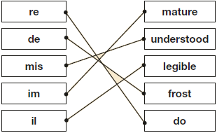

**1 mark**

**Q11.**

|  |  |
| --- | --- |
| two or twice |  |

**1 mark**

**Q12.**

**Award 1 mark** for all three correct.

***dis***agree

***il***legal

***ir***regular

**1 mark**

**Q13.**

**Award 1 mark** for a correct prefix and suffix.

***dis***honest***ly***

***dis***honest***y***

**1 mark**