**Q1.**

Add a suffix to the word light in the sentence below to make an **adverb**.

It was raining light_______ at playtime today.

**1 mark**

**Q2.**

Look at the parts of the words in bold.

cheer**ful**   help**ed**   hope**less**   kind**ness**

What is the name for this part of the word?

|  |  |
| --- | --- |
|  | Tick **one**. |
| an adverb |  |
| a noun phrase |  |
| a suffix |  |
| a verb |  |

**1 mark**

**Q3.**

Draw a line to match each word to the **suffix** that turns it into a noun.

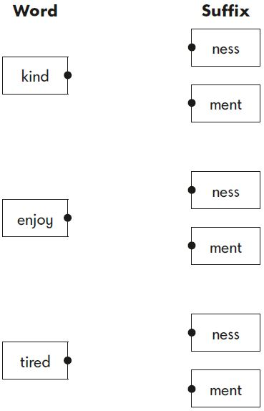

**1 mark**

**Q4.**

Add a **suffix** to the word fall to complete the sentence below.

The autumn leaves are fall                   to the ground.

**1 mark**

**Q5.**

Draw a line to match each word to the correct **suffix**.

Use each suffix only once.

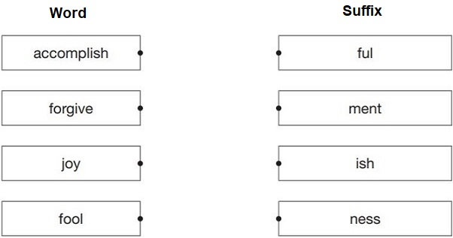

**1 mark**

**Q6.**

Add a **suffix** to the words in the boxes to complete the sentences.

Our school believes in _____________________ for all pupils.

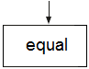

We took _____________________ clothing in case it turned cold.

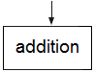

**1 mark**

**Q7.**

Complete each sentence below with a word formed from the root word thought.

Olisa was a very ___________________ girl.

The children looked ____________________ at the poster

on the wall.

**1 mark**

**Q8.**

Draw a line to match each word to the correct **suffix** to make an **adjective**.

|  |  |  |
| --- | --- | --- |
| **Word** |  | **Suffix** |
| manage |  | ish |
|  |  |  |
| harm |  | able |
|  |  |  |
| self |  | ful |

**1 mark**

**Q9.**

Complete the table below by adding a **suffix** to each noun to make an **adjective**.

|  |  |
| --- | --- |
| **Noun** | **Adjective** |
| care |  |
| nature |  |
| mess |  |
| danger |  |
| beauty |  |

**1 mark**

**Q10.**

Circle two **suffixes** that can be added to the word below to make new words.

**enjoy**

ful           ment           able           less           ness

**1 mark**

**Q11.**

Add a **suffix** to this word to make an **adjective**.

fear ______________________

**1 mark**

Mark schemes

**Q1.**

**Award 1 mark** for the letters *ly* written in lower case.

*It was raining light****ly*** *at playtime today*.

**Also award the mark** for *lightly* written out in full and spelt correctly.

**1 mark**

**Q2.**

**Award 1 mark** for the correct box ticked.

a suffix



**1 mark**

**Q3.**

**Award 1 mark** for all **three** matched correctly.

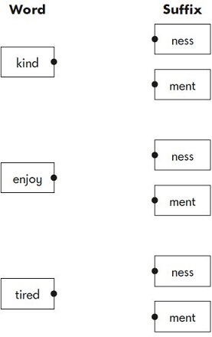

**Additional guidance:**

•        Provided it is correct, any suffix box can be used (more than once).

**1 mark**

**Q4.**

**Award 1 mark** for:

•     ing

**Additional guidance:**

•        The suffix must be spelt correctly.

•        If pupils write the whole word – *falling* – this must be spelt correctly.

**1 mark**

**Q5.**

**Award 1 mark** for all **four** lines correctly drawn.

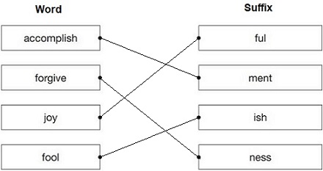

**1 mark**

**Q6.**

**Award 1 mark** for two correct words inserted.

Our school believes in *equality* for all pupils.

We took *additional* clothing in case it turned cold.

**Do not accept** misspellings.

**1 mark**

**Q7.**

**Award 1 mark** for two correct words derived from the word thought, e.g.

Olisa was a very *thoughtful / thoughtless* girl.

The children looked *thoughtfully / thoughtlessly* at the poster on the wall.

**Do not accept** misspellings.

**1 mark**

**Q8.**

**Award 1 mark** for all **three** correct.

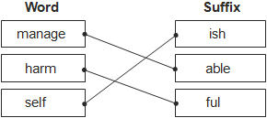

**1 mark**

**Q9.**

**Award 1 mark** for a correctly completed table.

|  |  |
| --- | --- |
| **Noun** | **Adjective** |
| care | Accept an appropriate adjective, e.g. *careful/careless/carefree/careworn* |
| nature | Accept an appropriate adjective, e.g. *natural* |
| mess | Accept an appropriate adjective, e.g. *messy* |
| danger | Accept an appropriate adjective, e.g. *dangerous* |
| beauty | Accept an appropriate adjective, e.g. *beautiful/beauteous* |

**Also accept** responses using capital letters.

**Do not accept** misspellings.

**1 mark**

**Q10.**

**Award 1 mark** for both suffixes encircled.

ful            less    ness



**1 mark**

**Q11.**

Accept any adjective derived from ‘fear’, eg:

•        fear**some**

•        fear**ful**

•        fear**less**

•        fear**ed**

**Do not accept** adverbs, eg:

•        *fearfully*

•        *fearlessly*

**1 mark**