**Zebra Class – Spring Term Home Learning – Week 8 – 1.3.2021**

**On the 4th of March, it is World Book Day!**

**Monday:**

* Maths – LO: forming expressions. **This will be a short online session at 9.30am before children complete their work.**

TTRS for twenty minutes.

* English – LO: character profile. Read from the city dump page to ‘the images had changed…’ (images attached). Think about what we know of the character Tristan. Draw a picture of Tristan and annotate around the image what you know about him and what you would like to find out. You could also include some questions to ask him on post-it notes.
* Reading – Design a new front cover for the book you have read. Don’t forget the title and author!

Complete short comprehension attached.

* Spellings – In a game of Scrabble, each letter is worth a certain number of points. Write out 5-10 words and then add up the total of the letters. Which of your spelling words has the highest total value?



**Tuesday:**

* Maths – LO: substitution. **This will be a short online session at 9.30am before children complete their work.**

TTRS for twenty minutes.

* English – LO: note of advice. Think about what Tristan has seen in the viewer and whether you believe he should use the machine again. Come up with three reasons encouraging Tristan to look into the viewer, and another three reasons why he shouldn’t. Decide which point of view you want to take, before writing a note of advice to Tristan. Make sure that you include an introduction (explaining why you are writing), your three reasons as to why he should either look into the viewer or not, and finally a conclusion to summarise. Once completed, make sure to read back over it, looking for punctuation and spelling errors.
* Science – LO: demonstrate understanding of adaptation. **This will be a short online session at 1.30pm before completing work.**
* Music – We are moving on to looking at harmony, so you need to have a quiet space to be able to sing. Follow the link: <https://classroom.thenational.academy/lessons/to-sing-in-canon-71j3gr>. You will have the opportunity to explore your vocal range, before learning two songs.
* Additional PE (if you wish!) – KS2 Multi-skills between 10.00 – 10.45am. Follow the link: <https://zoom.us/j/98900563704?pwd=QXAyNU54NTU1c3hqZUllb3cwdm85UT09>

Meeting ID: 989 0056 3704

Passcode: PASSLIVE

* Reading – Find five interesting words in the text. Write down the meaning of each word and then use each one in a sentence of your own.
* Spellings – Complete the spellings wordsearch. These include more commonly misspelt words from the year 5/6 words.

**Wednesday:**

* Maths – LO: formulae. **This will be a short online session at 9.30am before children complete their work.**

TT Rockstars for twenty minutes.

* English – LO: response to a note of advice. From the letter that you wrote yesterday, imagine that you are Tristan responding to this? How might you feel after reading this letter of advice? Would you agree with it or not? What would you say back to the letter writer? Put yourself in the shoes of Tristan and reply to the note of advice. Once completed, make sure to read back over it, checking for punctuation and spelling errors.
* French – This term, we will be looking at introductory phrases in French. Complete lesson 3, which is all about months of the year: https://classroom.thenational.academy/lessons/saying-the-months-cmv66c. As an extension, you can always complete lesson 4; however, this is optional (saying what month your birthday is in - https://classroom.thenational.academy/lessons/saying-the-month-your-birthday-is-in-6nk36r).
* Reading: Write down five questions that you could ask someone to find out if they have read your current book correctly.

Complete comprehension attached about Stormzy (page 7 – 11).

* Spellings: Complete the spellings wordsearch. These include commonly misspelt words.
* RE: We will continue to learn about Sikhism by discussing what Sikhs believe about God: <https://classroom.thenational.academy/lessons/what-do-sikhs-believe-about-god-6grpcc>. As you have now had five sessions looking at Sikhism, please now write a short paragraph about what you have learnt so far.

* Art: LO: drawing techniques. Work through the PowerPoint presentation and the activity sheet (both on the school website). You will be able to practise techniques such as: cross-hatching, blending, stippling and contour-hatching.

**Thursday**

**World Book Day – there will be an assembly at 9.30am in which you can dress up as your favourite character if you would like.**

* Maths – LO: forming equations. **This will be a short online session at 11.15am before children complete their work.**

Additional: Completion of the year 6 arithmetic test attached. Answers available with it as well.

* English – **This will be an online session straight after the assembly at 9.30am (around 10am) before children complete their work.**
* PE: Choose a Joe Wicks (or your favourite online exercises!) workout to do indoors or out in the garden.
* Topic – LO: to explore where in the world food comes from. **This will be a short online session at 1.30pm before children can go and complete their work.**
* Reading: Draw a picture of one of the settings in the story and then write a description of where it is and what happened there.

Complete short comprehension attached.

* Spellings: Make a crossword puzzle with your spellings. Come up with clues for each one, including answers so that it can be checked!
* PSHE: Following on from Wellbeing Wednesday, you can complete the work sent by Mrs Davies (uploaded onto School Class Dojos and website).

Watch the following video to continue our understanding of healthy lifestyles: you will be learning about exercise routines before being able to create your own. Follow the link - <https://classroom.thenational.academy/lessons/my-own-workout-75j6at> .

**Friday**

* Maths – LO: solving simple one-step equations. **This will be a short online session at 9.30am before children complete their work.**
* English – LO: story mapping. Read to the end of the book. Where do you think Tristan has gone? How does this make you feel? Why do you think the mother acted in the way that she did? Has the story taught you anything? How do people remember who you are? Do you think that Tristan was always meant to find the viewer? Write your answers down to these questions. Finally, create a map of the story using drawings and annotations to record the main events.
* Purple Mash (Computing) – Before starting the next topic, you must make sure that you have completed your quizzes from the previous term. Our next topic is Text Adventures: these are computer games which use text instead of graphics. Computer games have a story that is designed to react to the choices that you make. You need to decide on your own text adventure: choose a theme. The idea is that the player will be presented with choices that have different consequences. Have a go at the Red Riding Hood example (on your 2Do) – have a copy of goes to see how your choice affects what happens within the Text Adventure. Once completed, open up a new document on 2Connect. Create a plan of your chosen Text Adventure, showing the different choices and the responses to those choices. Below is an example for Red Riding Hood.

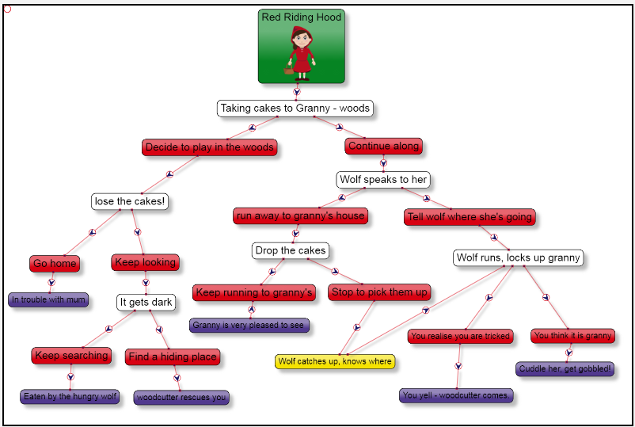

* Reading –Design a poster for the book you have read to persuade other people to read the story.

Complete short comprehension attached.

* PE - KS2 Multi-skills between 10.00 – 10.45am or 1.30 – 2.15pm. Follow the link: <https://zoom.us/j/98900563704?pwd=QXAyNU54NTU1c3hqZUllb3cwdm85UT09>

Meeting ID: 989 0056 3704

Passcode: PASSLIVE

* Spellings – Complete the spelling wordsearch: these include commonly misspelt words.