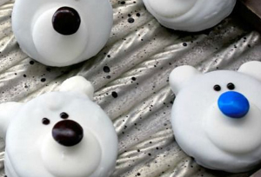Polar Bear Peppermint Creams

-What you need:

* 1 cup of icing sugar
* 1 egg white, beaten
* 15 blue, or green jelly beans or M&M’s
* Peppermint extract
* 1 sieve
* Parchment paper
* Mixing bowl

**Directions**

**1 –** Put the icing sugar through a sieve to remove all the lumps.

**2** – Beat the egg white and add a little at a time to the icing sugar.

Note: Stop adding the egg white when the mixture becomes like Play Doh.

**3 –** Add 3 drops of the peppermint extract. Mix well and taste – you may have to add a couple more drops depending on your preference.

**4 –** Divide the dough in half. Roll into 15 balls about the size of cherry tomatoes.

**5 –** Flatten balls with your hand to resemble the bear’s head.

**6** – Place the “heads” on the parchment paper

**7 –** Use half the remaining dough to make blueberry-size balls for snouts. Flatten these slightly and place on head.

**8** – Add a jelly bean to each snout for the nose.

**9 –** Use the rest of the dough to make the ears by shaping them into tiny balls. Press gently onto the top of the heads with your fingertips. Use a toothpick to shape the eyes.

**10 –** Leave your peppermint polar bears to dry on the parchment paper for 3 to 4 hours or overnight.

Store in airtight container for up to one month.