**Home learning – Tiger Class: Overview - Week 1**

**Maths**

White Rose Maths Year 5, Week 11

[Year 5 | White Rose Maths](https://whiterosemaths.com/homelearning/year-5/) – Perimeter and Area

Monday – Measure perimeter

Tuesday – Perimeter on a grid

Wednesday – Perimeter of rectangles

Thursday – Perimeter of rectilinear shapes

Friday – Calculate perimeter

Worksheets and answers to be sent separately. Please mark after each activity to see how well you’ve done!

**English**

The Polar Express

[Polar Express by Chris Van Allsburg & read by Liam Neeson - YouTube](https://www.youtube.com/watch?v=ELy_4fH_h0E)

Monday – Describe a picture, using all five senses, using metaphors and similes.

Tuesday – Comparison of two scenes.

Wednesday – Santa’s gift – what would you choose and why?

Thursday – To create interesting sentences, in 4 stages.

Friday – Russia Reading Comprehension – don’t print the whole thing! It is differentiated into 3 levels, one star being the easiest and three stars being the hardest.

Detailed lessons will be sent separately.

**Reading**

Please read for at least 20 minutes every day. Try and read to an adult for some of this time.

**Science – Life Cycles**

Compare two different life cycles.

**Topic - Russia**

Information Pages

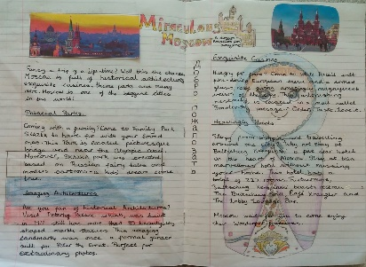 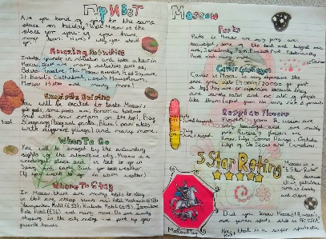

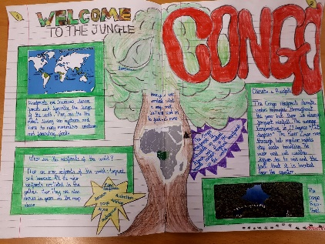 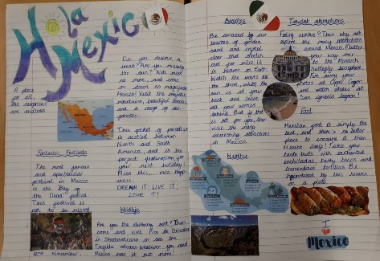

**TT Rockstars**

10 minutes a day, including the ‘Daily Sound Check’.

**Spellings**

Choose 10 words from the Year 5/6 list that you find tricky and learn them. Put them in to a sentence. Could you be clever, and start each sentence with a fronted adverbial phrase?

e.g.

All of a sudden, the **ancient** statue began to move.

Don’t forget, there will be a test after Christmas on the first three columns!