Honeyed carrot soup

**WARNING**

This recipe involves using a knife and cooker hob you **must** be supervised by an adult.

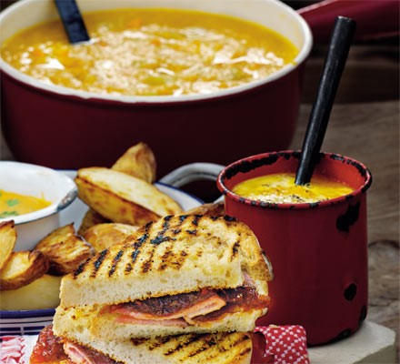**Ingredients**

* 2 tbsp [butter](https://www.bbcgoodfood.com/glossary/butter-glossary)
* [2 small leeks](https://www.bbcgoodfood.com/glossary/leek-glossary) , sliced
* 800g [carrots](https://www.bbcgoodfood.com/glossary/carrots-glossary) , roughly chopped
* 2 tsp [clear honey](https://www.bbcgoodfood.com/glossary/honey-glossary)
* [small pinch dried chilli flakes](https://www.bbcgoodfood.com/glossary/chilli-glossary) (optional)
* 1 bay leaf
* 2 ½l vegetable stock use stock cubes
* [soured cream or yogurt](https://www.bbcgoodfood.com/glossary/yogurt-glossary) , to serve

**Method**

* **STEP 1**

Melt the butter in a large saucepan over a medium heat. Add the leeks to the pan, then cook for 3 mins until starting to soften. Add the carrots, honey, chilli (if using) and bay leaf, then cook for 2 mins.

* **STEP 2**

Pour in the stock, bring to the boil, then simmer for 30 mins. Blend the soup in batches, return to a clean pan, then season to taste. When ready to serve, bring back to a simmer, then ladle into mugs. Add a swirl of soured cream or yogurt and serve with garlic bread or bacon butties.