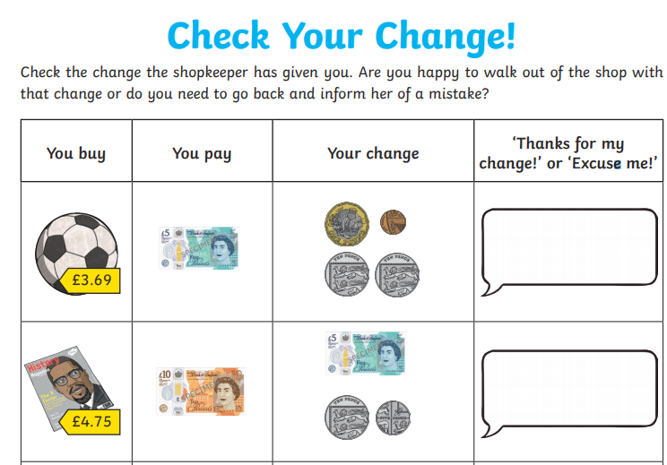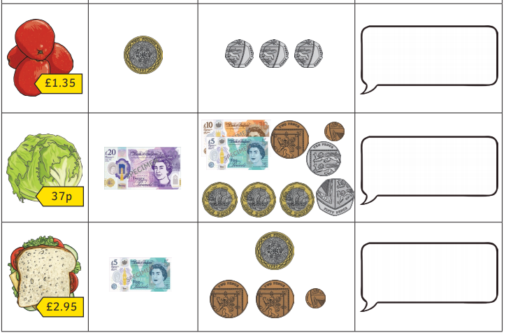``

Answers:

Excuse me

Excuse me

Excuse me

Excuse me

Thanks for my change