Date

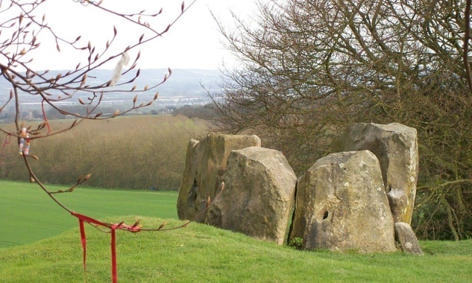Stone Age Home learning

(Task 2 )

We have amazing examples of Stone Age monuments in the Medway Valley – a few miles from our school!

Can you find out the names or locations of these monuments?

Lets go on a

Paragraph Hunt!

I found out these names

Name of monument Where?



I think they were used for ………………………………………………………………………..

……………………………………………………………………………………………………………………

CONTENTS