Date:

Task One: Imagine you have ONLY these stone tools to do tasks with in your present daily life (of you and your family, or at school). Try to think of as many things as possible that you could manage to do, using the two types of tool available. (It’s not easy, but have a go!)

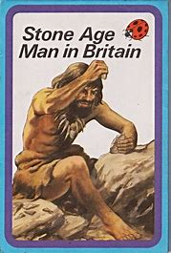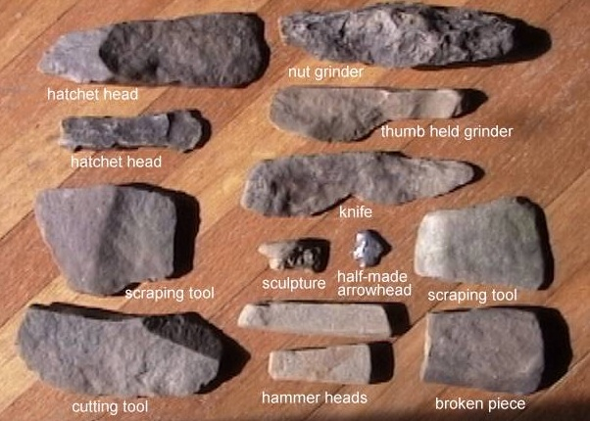

Using a large rounded Using a stone with a

piece of stone sharpened edge

1. Crack open the Christmas 1. Cut open a packet of crisps

Hazel nuts!