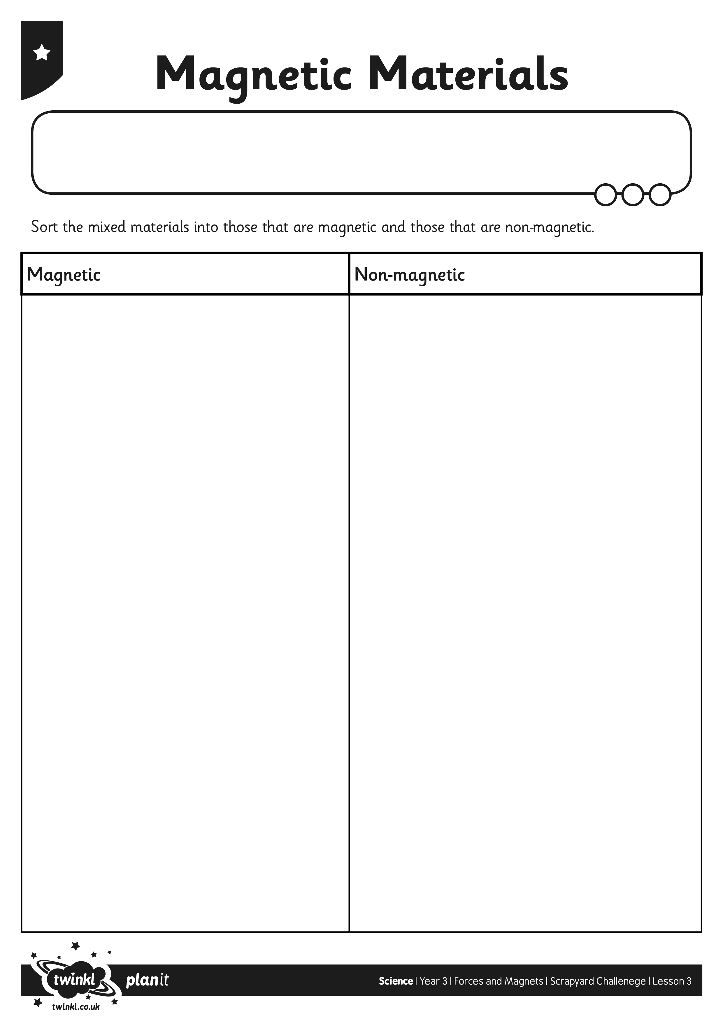
I can sort magnetic and non-magnetic materials.
I can sort magnetic and non-magnetic materials.
I can sort magnetic and non-magnetic materials.

