

Lunsford Primary School – Home Learning
Monday 8th February – Friday 12th February 2020
Year 3 – Lion Class
Weekly Maths Tasks | Reading tasks
Watch the video and then attempt the worksheet if there is one for that day.  Monday  Spr3.5.4 - Make tally charts on Vimeo  Tally chart worksheet  Tuesday  Spr3.5.5 - Draw pictograms on Vimeo  Draw pictogram worksheet  Wednesday  Spr3.6.1 - Interpret pictograms on Vimeo  Interpret pictograms worksheet  Thursday  No video today just complete the worksheet please.  Pictogram worksheet  Friday  Spr3.6.3 - Bar charts on Vimeo  Bar chart worksheet  15 mins of TTRockstars daily  If you would like any additional maths tasks:  Access the Oak National Academy Maths lessons for Year 3 | Monday – Staying warm comprehension- multiple choice questions  Tuesday – The sand castle comprehension- multiple choice questions  Wednesday- Read your book for 20 mins and record in your Buster’s book club record.  Thursday – Frog life cycle comprehension- multiple choice questions  Friday – Building a birdhouse comprehension- multiple choice questions  - If you have run out of things to read, try re-reading an old favourite or join Kent Libraries online to access lots of e-books and audiobooks  www.kent.gov.uk/leisure-and-community/libraries  - There is also a free e-book library available on https://home.oxfordowl.co.uk/books/free-ebooks/
SPaG
Monday – Complete sheet 5 that is titled Year 3 and 4 correct the spelling Mistake.


Tuesday – Complete the Year 3 spelling words wordsearch.

Wednesday – Use the words from yesterday’s word search to write a sentence. You need to learn how to spell them so can use the look, cover, write, check approach.

Thursday – The games were popular so I would like you to play them again!
Play the Spelling game on ICT games. Check your spellings with the bats! Make sure that you click on Year 3 and 4 part for our words.
Spooky Spellings || Practise spelling Common Exception Words (ictgames.com)
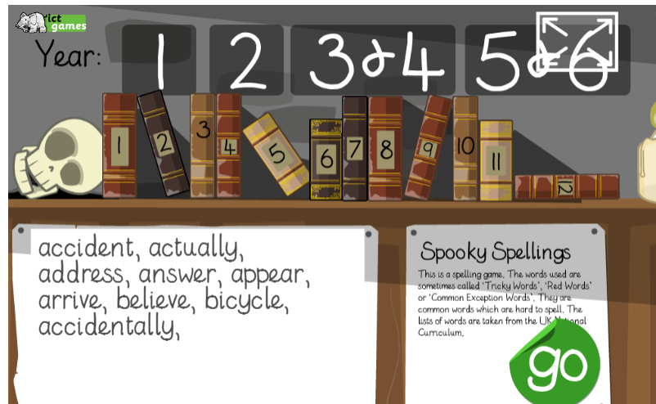

Friday – Play the Coconut vowel game. You can choose the difficulty level that suits you best. Fill the gaps in the words with the correct vowel sounds. Make sure you choose the correct year group, Year 3.
Coconut Vowels - Arcademics
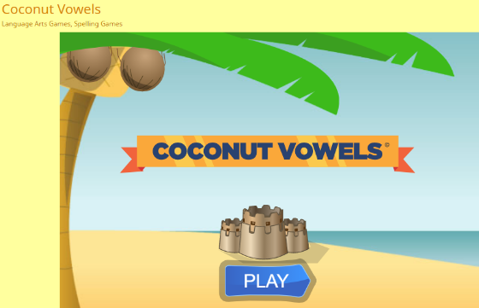

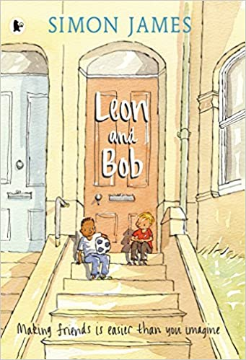
Weekly Writing Tasks

Monday 8th February 2021
Write a diary entry in role as a character

https://www.youtube.com/watch?v=M2TniloDMM4
Watch the YouTube video to hear the full story of Leon and Bob.
Was the story what you expected based on what you read last week? What else do we find out about Leon? Does it remind you of any experiences you have had? At the end of the story how do you think Leon feels to have a friend?
Your task is to write a diary entry in role as Leon about how it feels to finally have a friend. Think about what Leon might say. How might he be feeling? How are things different for Leon by the end of the story?
Remember to write in first person as if you are Leon eg. I, me, my.
Be sure to check your work through carefully then try to use a different coloured pen or pencil to edit and improve your work – just like we have our purple pens in school.

Tuesday 9th February 2021
Write a conversation between Leon and Bob

Try to think of as many different words as you can use that you could use instead of ‘said’. Eg. Shouted, whispered, answered. Write them down. Try to think of at least 10.
Try to add some adverbs to some of your ideas. Remember adverbs describe a verb. Eg. Leon shouted loudly. Loudly is an adverb as it describes how Leon is shouting.
Listen to the story again if you need to. At the end of the story Leon and Bob go to the park together. What do you think the next scene would be? What might the characters do? What conversation might they have?
Your task is to write a conversation between Leon and Bob. Remember if someone is speaking, we need to use inverted commas (speech marks).
Eg. “What are your hobbies Leon?”, said Bob.
There is more information here if you are unsure
https://www.bbc.co.uk/bitesize/topics/zvwwxnb/articles/ztcp97h
When you are writing the conversation between Leon and Bob you need to put inverted commas “ ” around what they are saying.
Remember to also start a new line when each person starts talking.
“How long have you lived here?”, asked Bob curiously.
“Only a few months”, whispered Leon quietly. “I live with my mum and my dad is away in the army”.
“Wow! That is interesting”, Bob replied.
“Do you enjoy playing football?”, Leon mumbled nervously.
Remember!
- Try to use more interesting words than said.
- Use inverted commas to show what the characters are saying
- Start a new line for a new speaker
- Check your work carefully

Wednesday 10th February 2021
Write a description of a good friend
Think about what having a friend means to Leon.
Why are friends important to you?
What makes a good friend?
What special memories do you have with your friends?
Write at least two paragraphs describing what makes a good friend. Try to use some good descriptive language and explain your ideas.

Thursday 11th February
Write a book review
We hope you have enjoyed the story of Leon and Bob.
Today you are writing a book review of the story. We would like you to explain:
Who are the main characters and what is the story about?
What did you like about the story? What was your favourite part and why?
Which are your favourite illustrations and why?
Is there anything you did not enjoy about the story and why?
Who would you recommend the story to and why?
Here is a link to the story being read if you want to watch it again
https://www.youtube.com/watch?v=M2TniloDMM4

Friday 12th February
Write a story
Leon and Bob is a story all about friendship.
Your final English task this term is to write your own story all about two friends. Try to plan your story before you start writing.
Think carefully about who your characters are going to be and what they are like. What is going to happen in your story? Are your two characters going to meet and become friends? Maybe they will go on an adventure together? Try to use your imagination to think of an exciting idea.
Try to write for at least 30 minutes. If you would like to, you can type your work. Remember to write in full sentences. Check your work through carefully when you have finished writing and correct any mistakes.

Afternoon Topic work

Monday

History – Can you make a model of a Bronze Age boat? See The additional instructions on the website under remote learning.

French – Watch the video introducing numbers 1-10 in French.
French Lesson 17 - NUMBERS 1-10 - Learn French - The French Minute - YouTube
Learn the numbers in French 1-15. Practise saying them out loud. Then complete the matching sheet.

Tuesday

Science – Run the PowerPoint and try and answer the questions about forces and magnets. See how many questions you can answer.

Computing
Lesson 5 – Meeting up online
Watch the next clip following Winston, Kara and the Smart Crew, Chapter 5: Be Careful when meeting up. This is about the dangers of meeting up with someone you meet online.
https://www.childnet.com/resources/the-adventures-of-kara-winston-and-the-smart-crew/chapter5
You may want to watch the clip a couple of times.
- What are the possible dangers of meeting up with someone you have met online?
- What advice do the Smart Crew give about meeting up with people you have met online?
- The Admiral reminds Kara and Winston of the importance of being SMART to stay safe online. What does SMART stand for? Create a colourful poster to show all that you have learnt about being SMART and staying safe online.

Wednesday

PSHE
Eat Well, Live Well with Mr Sidat – Images in the Media
This is the next lesson in our ‘Healthy Living’ theme for this term. Click on the link below and work through the video and activities.
https://classroom.thenational.academy/lessons/images-in-the-media-cdk32r

PE
PASS Dance Lessons 5 / 6
Use the PASS website to complete Dance lesson 5 for Year 3/4 under the ‘Home Learning’ Section or the YouTube link below.
PASS HOME LEARNING YEAR 3 4 DANCE PIRATES LESSON 5 - YouTube
Lesson 6 is only 5 minutes, a chance for you to rehearse and perform your final dance. We would love to see any pictures or video clips on dojo of you performing your dances at home!
PASS HOME LEARNING YEAR 3 4 DANCE LESSON 6 - YouTube

Thursday

Art
Watch this clip https://www.bbc.co.uk/teach/class-clips-video/art-and-design-draw-self-portrait/z6ytscw Have a go at drawing a self-portrait using pencils using the techniques you have learnt. Then have a think about one of your friends and what makes them special. Using a medium of your choice (pens, pencils, paints etc) create a portrait of your friend.
Friday
PE
PASS Live Multi Skills Lesson 1.30 – 2.15
Please use the log in details that were sent via class dojo to log in to the live Zoom session. Please remember to read the disclaimer and policy document that was also sent out.

Music
Music Year 3/ 4 – Recognising time signatures
https://classroom.thenational.academy/lessons/recognising-time-signatures-68u3gd
You will need some headphones (or somewhere to work where you won't disturb anyone else). Click on the link above and work through the lesson on the screen.

Don’t forget Mr Anscombe’s celebration assembly at 2.30pm this afternoon too details of the zoom have been emailed to you.
#TheLearningProjects

