

Lunsford Primary School – Home Learning
Monday 25th January – Friday 29th January 2020
Year 3 – Lion Class
Weekly Maths Tasks | Reading tasks
Watch the video and then attempt the worksheet if there is one for that day.  Monday  Spr3.4.1 - Count money (pence) on Vimeo  Complete the recap count money sheet. This is just a recap from Year 2 so if you find it easy that is good! If not, have a closely at the word problems.  15 mins of TTRockstars  Tuesday  Spr3.4.2 - Count money (pounds) on Vimeo  Complete the Count money pounds recap sheet for today. Again this is revision so I am hoping you can try and complete it independently.  15 mins of TTRockstars  Wednesday  Spr3.4.3 - Pounds and pence on Vimeo  Complete the Pounds and pence sheet.  15 mins of TTRockstars  Thursday  Spr3.4.4 - Convert pounds and pence on Vimeo  Complete the convert pounds and pence sheet.  15 mins of TTRockstars  Friday  Spr3.4.5 - Add money on Vimeo  Complete the Add money sheet.  15 mins of TTRockstars  If you would like any additional maths tasks:  Access the Oak National Academy Maths lessons for Year 3 | Monday – Sea turtles reading comprehension  Tuesday – Recycling reading comprehension  Wednesday- Read your book for 20 mins and record in your Buster’s book club record.  Thursday – Elephants at the zoo reading comprehension  Friday – Planting a vegetable garden reading comprehension  - If you have run out of things to read, try re-reading an old favourite or join Kent Libraries online to access lots of e-books and audiobooks  www.kent.gov.uk/leisure-and-community/libraries  - There is also a free e-book library available on https://home.oxfordowl.co.uk/books/free-ebooks/
SPaG
Monday – Complete sheet 3 that is titled Year 3 and 4 correct the spelling Mistake. Only complete this page as we are doing them each Monday until half term.


Tuesday – Complete the Year 3 spelling words wordsearch.

Wednesday – Use the words from yesterday’s word search to write a sentence. You need to learn how to spell them so can use the look, cover, write, check approach.

Thursday – Play the Spelling game on ICT games. Check your spellings with the bats! Make sure that you click on Year 3 and 4 part for our words.
Spooky Spellings || Practise spelling Common Exception Words (ictgames.com)
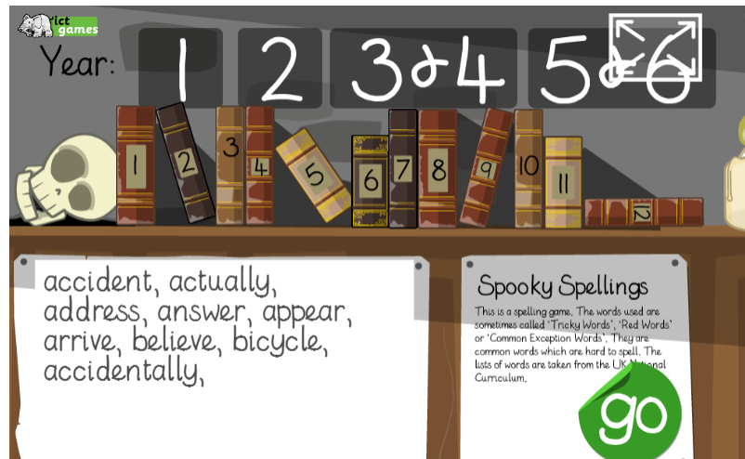

Friday – Play the Coconut vowel game. You can choose the difficulty level that suits you best. Fill the gaps in the words with the correct vowel sounds. Make sure you choose the correct year group, Year 3.
Coconut Vowels - Arcademics
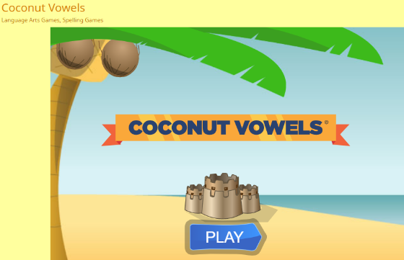

Weekly Writing Tasks
DO NOT READ THE WHOLE BOOK YET, WAIT UNTIL YOU ARE DIRECTED TO SO IT DOESN’T SPOIL THE SUSPENCE.

Monday 25th January
Re-read the story as you have had the weekend and might have forgotten the key parts. Choose one of the animals from the story. Think of some reasons of what they would say to the men to get them to change their minds. What words could persuade them? Think of at least three to four really good reasons. Look at the persuasive word mat to help you with your writing. How might they be thinking and feeling? How can you put that feeing into your ideas so that the men will really listen?

This is an example, I chose the bee.

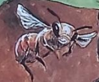
I beg you to listen. I may be small, but I am very important within this ecosystem. My hive and home are within this mighty tree and if you chop it down there will be devastating consequences for everyone! You see, I pollinate the trees and the flowers, so without me and the other bees there would be no more flowers or trees. I urge you to reconsider your decision and think about the impact that cutting down the tree would cause. I suggest you think carefully before you act. This is not just my home, but is the lifeline of the whole ecosystem. We would be lost and even worse, we will not survive without it.

Tuesday 26^{h} January
Watch the video: https://www.bbc.co.uk/news/education-13784999
After you have watched the video think about the harmful effects that logging has on the environment and the local area. Now think about the some of the benefits of logging that it may bring to the local community.
Use a table to list them, like the one below.

Harmful effects of logging | Benefits of logging

The article below the video on the web page has some more ideas to support your writing today.

Wednesday 27th January
Read the whole book again. Reflect on the ending of the story and think about the following questions.
What did the man do?
Why do you think he did this?
What do you think will happen next?
Pretend that the smaller man is now going to go back to the larger man. What do you think will happen when he returns? What will they say to each other? How will they react to each other in this situation? What will the larger man’s concerns be? How will the smaller man justify his actions? How will the larger man respond?
Try to write out a conversation that they would have. You can present the conversation how you wish. So, you might want to use speech bubbles for each man or you could write out a line by line conversation between them. Get creative with your conversations. You could role play your conversations with an adult too?

Thursday 28th January Planning stage for tomorrow’s lesson
Today we are going to plan a fact file about the Rainforest. This could be one page of A4 or you can make a little book. You can decide how you present your work.
What main title will your fact page have?
What subheadings will your fact page have? Maybe you could write about where the Rainforests of the world are, you could write about the animals found there, the trees, protecting the rainforest, what impact logging has or the benefits of logging.
Remember today is just a rough draft, using the time to research your facts and gathering your information.
Friday 29th January
Today you are going to write the final draft of your fact file about Rainforests. You need to oraginse your ideas and group them together so that you can easily read them. Use your best presentation skills and make it bright and colourful. You could even write a double page spread. This is where you use two pages of lined paper to spread the information out. You can add fact boxes, pictures, captions and subheadings.
Here are a few examples of how you might want to present your ideas.
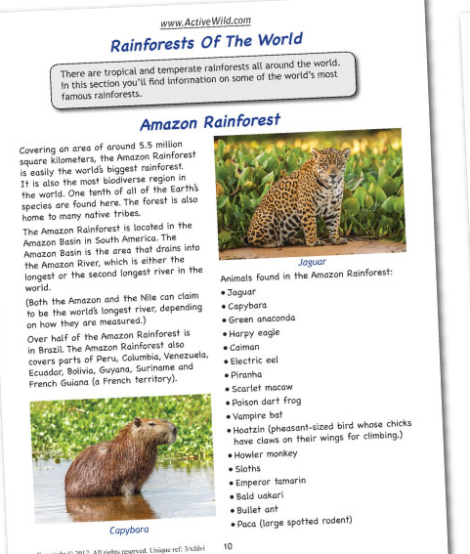
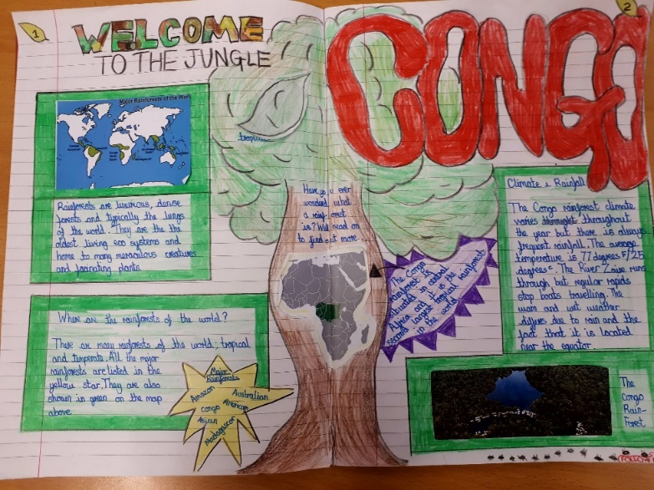

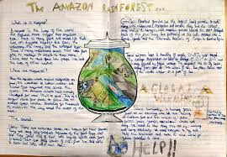
Afternoon Topic work

Monday

History – Stone Age cave paintings. Today you need to read the additions information from the sheet on the website and read the Power Point. Then answer the questions from the sheet.

French – Days of the week
Read through the PowerPoint presentation which will help you to say the names of the week. Use the buttons to listen to the pronunciation.
Then cut out all the cards and play a matching game. You could also turn them all over and try and find pairs. As you get a pair, say the day of the week in French out loud. Ask an adult to help check your pronunciation.
If you can’t print, write the words out on paper and make your own cards.

Tuesday

Science – This week we are looking at different types of forces. A force is a push or pull acting upon an object.
Here are 3 forces that we will look at today:
Gravity
Air resistance
Friction

Gravity is a type of force, which attracts and object towards the centre of the Earth.
Air resistance is a force of air pushing against a moving object.
Friction this is resistance between two surfaces that are in contact with each other.

Read the Power Point through and then draw arrows for each object to show if there is gravity, friction or air resistance being placed on the object.
Some might have 1 force, some 2 or 3 forces acting upon it.
Check your work against the answers to see if you are correct.

Computing
For the rest of this term in computing we are learning about online safety with the help of Kara, Winston and the SMART Crew.
Lesson 3 – Protecting Personal Information
Watch the next clip following Winston, Kara and the Smart Crew, Chapter 3: What should you keep safe? This is learning about protecting our personal information.
https://www.childnet.com/resources/the-adventures-of-kara-winston-and-the-smart-crew/chapter3
You may want to watch the clip a couple of times.
- What games do you like to play online? Do you protect your personal information?
- The Smart Crew give some useful advice to Kara and Winston. Make a list of ‘dos’ and ‘don’ts’ to show what you should and shouldn’t do if you want to make sure that your personal information stays private.

Wednesday

PSHE
Eat Well, Live Well with Mr Sidat – Time to get active!
This is the third lesson in our ‘Healthy Living’ theme for the rest of this term. Click on the link below and work through the video and activities.
https://classroom.thenational.academy/lessons/time-to-get-active-cth62c

PE
PASS Dance Lesson 3
Use the PASS website to complete Dance lesson 3 for Year 3/4 under the ‘Home Learning’ Section or the YouTube link below.
PASS HOME LEARNING DANCE YEAR 3-4 PIRATES LESSON 3 - YouTube

Thursday
Art
Henri Rousseau themed art.
- Henri Rousseau was a famous artist known for his paintings of jungle scenes.
- Read the information in the PowerPoint on the class page of the website and look carefully at the pictures of his work. Think about his style, the colours and shapes he uses.
- You can also watch this clip about him and his work https://www.bbc.co.uk/teach/class-clips-video/art-and-design-ks2-henri-rousseaus-surprised/zrdyd6f
Art and Design KS2: Henri Rousseau’s 'Surprised!' - BBC Teach
Presenter-led animated examination of Henri Rousseau’s 'Surprised!', exploring the use of imagination in painting. Relevant for teaching Art and Design at KS2 and at 2nd Level.
www.bbc.co.uk
- This link is also in the PowerPoint.
- Choose activity 1 or 2 from the PowerPoint.

Friday
PE
PASS Live Multi Skills Lesson 1.30 – 2.15
Please use the log in details that were sent via class dojo to log in to the live Zoom session. Please remember to read the disclaimer and policy document that was also sent out.

Music
Music Year 3/ 4 – Exploring 3 beats in a bar
https://classroom.thenational.academy/lessons/exploring-3-beats-in-a-bar-ccukcc
You will need some headphones (or somewhere to work where you won't disturb anyone else). Click on the link above and work through the lesson on the screen.

Don’t forget Mr Anscombe’s celebration assembly at 2.30pm this afternoon too details of the zoom have been emailed to you.
#TheLearningProjects

