

Lunsford Primary School – Home Learning
Monday 18th January – Friday 2nd January 2020
Year 3 – Lion Class
Weekly Maths Tasks | Reading tasks
Watch the video and then attempt the worksheet if there is one for that day.  Monday  Spr3.3.4 - How many ways? on Vimeo  How many ways? worksheet  15 mins of TTRockstars  Tuesday  Today there is no worksheet just the activities on the Video clip. Follow it and answer the questions as you go.  Spr3.2.5 - Divide 100 into 2, 4, 5 and 10 equal parts on Vimeo  15 mins of TTRockstars  Wednesday  Today there is no worksheet just the activities on the Video clip. Follow it and answer the questions as you go.  Spr3.3.1 - Divide with remainders activity on Vimeo  15 mins of TTRockstars  Thursday  Complete the mini assessment for multiplication and division. Try to complete as much as you can by yourself and then mark your work against the answers. Send me over your scores.  15 mins of TTRockstars  Friday  Play the multiplication and division game.  You are at the end of the multiplication and division block! Well done for trying so hard!  There are 3 different levels of difficulty. 1 star is the easiest, 2 stars medium and 3 stars is the hardest. Try and challenge yourself.  15 mins of TTRockstars  If you would like any additional maths tasks:  Access the Oak National Academy Maths lessons for Year 3 | Monday – Cave paintings quick read  Tuesday – Stone age stew quick read  Wednesday- Read your book for 20 mins and record in your Buster’s book club record.  Thursday – Stone age time periods quick read  Friday – A hunter with a heart  - If you have run out of things to read, try re-reading an old favourite or join Kent Libraries online to access lots of e-books and audiobooks  www.kent.gov.uk/leisure-and-community/libraries  - There is also a free e-book library available on https://home.oxfordowl.co.uk/books/free-ebooks/
SPaG
Monday – Complete sheet 2 that is titled Year 3 and 4 correct the spelling Mistake. Only complete this page as we are doing them each Monday until half term.
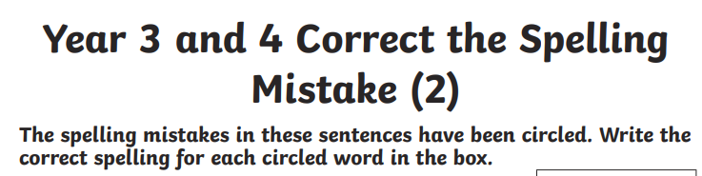

Tuesday – Complete the Year 3 spelling words wordsearch.

Wednesday – Use the words from yesterday’s word search to write a sentence. You need to learn how to spell them so can use the look, cover, write, check approach.

Thursday – Watch the following clip and complete the game/quiz.
What is a fronted adverbial? - BBC Bitesize
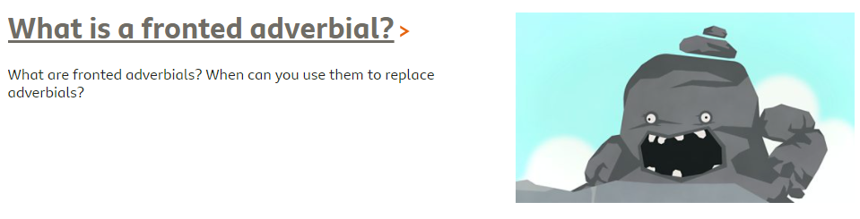

Friday – Watch the following clip and complete the game/quiz.
What is an expanded noun phrase? - BBC Bitesize
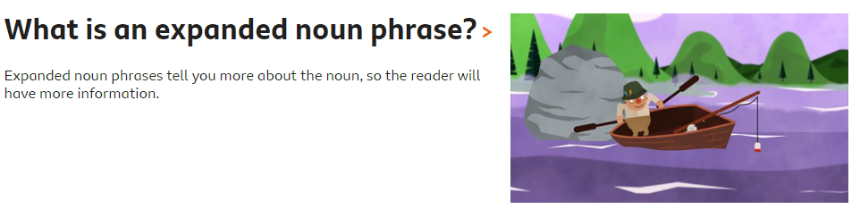

Weekly Writing Tasks
DO NOT READ THE WHOLE BOOK YET, WAIT UNTIL YOU ARE DIRECTED TO SO IT DOESN’T SPOIL THE SUSPENCE.
This week we are reading The Great Kapok Tree by Lynne Cheery
The Great Kapok Tree by Lynne Cherry - YouTube
The book is also on the website in a PDF file

Monday 18th January
Read the introductory page of the book which is on the PowerPoint presentation.
Let’s have a think about what we already know about Rainforests. From our work in topic and what we have read before.
Can you create a grid to jot down your ideas and oragnise your thoughts? You can add to it as we work through the week. A template of this grid is on the website.
What I already know about Rain forests | What I want to find out about Rainforests. | Where might I go to find out more about Rainforests.

Think about the questions:
Why do you think this ecosystem is here? Where is the Amazon Rainforest located in the World? Why?
Watch the following video https://www.youtube.com/watch?v=3vijLre760w
Then view this video specifically about the Amazon Rainforest https://www.youtube.com/watch?v=5IzzogrKo6k
Can you add to your knowledge grid?

Tuesday 19th January Setting description
After watching the You Tube videos and thinking about what a Rainforest is, today we would like you write a setting description.
First, watch the first 4 minutes of this video: Rainforest Beneath the Canopy - YouTube - YouTube
Now watch for a second time. Whilst you watch it can you note down any powerful words or phrases used to describe the setting?
Such as:
Huge trees stand like monuments
Amist the symphony of life
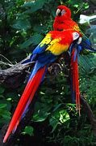
Outliving the dinosaurs
These words and phrases tell us that the Rainforest is strong, powerful and ancient.
Look at the images of the Rainforest and describe it using powerful words and phrases. You are allowed to magpie from the videos. Make sure that your sentences make sense and that you have used capital letters and full stops. You could also use paragraphs to organise your ideas.
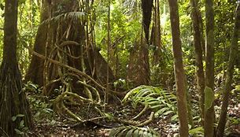
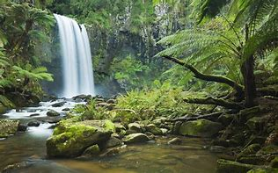
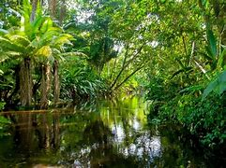

Wednesday 20th January
Read the first page of the book aloud. Answer the following questions in full sentences.
- What do you like and dislike about what you see on the first page of the text?
- Does it remind you of anything in real life or stories that you might have read before?
- Do you have any questions about it? Does any thing puzzle you?
- Who are the two men in the Rain Forest? What are they doing?
Write a prediction about what you think will happen in the text. Do not peek!
Once you have written your prediction down, read page 2 of the text. Were your predictions correct? Why do you think the men might be chopping down the tree? What impact will that have on the forest. Discuss with an adult or jot down your thoughts. Add any information into your knowledge grid from Monday.

Thursday 21st January
Think about standing in the Rain Forest. What sounds might you hear? Play the following sound clip Rainforest Ambience Sounds | Effects | Sound Bites | Sound Clips from SoundBible.com
What sounds can you pick out? Animals, wind, trees.
Write a list of what you might hear.
Example:
Water flowing
Howling monkeys
Crickets chirping
After you have written your list, add words and phrases and try to construct a poem.
The title could be Rainforest Sounds, The Mighty Rainforest or make up your own. I have tried to write the beginning of a poem to give you some ideas……

Sounds of the Rainforest
Deep in the thick of the forest, it is alive with extraordinary sounds
Water drips, drips, drips from the leaves.
Howling monkeys call their young.
Crickets chirp in time, like a choir.
You could either write your poem down or record it in a performance.

Friday 22nd January
Re-read page 1 and 2 of the text and think about the flowing questions……
- Why do you think the man is cutting down tree?
- What impact do you think this will have on the ecosystem?
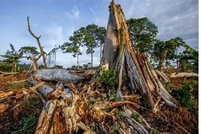
Watch this video about deforestation. SOS Schools Pack Part 2: Deforestation - YouTube
Take each of the headings below and write a short paragraph about it. What does it mean? What is happening? Why does it happen? What is the impact?
Logging
Farming
Impact

Afternoon Topic work

Monday – History
This week we are looking at hunting during the Stone Age. Have a look at the additional sheet and do some research about the different animals that would have been around during that time and complete the art work.

French – My family
Look on the website link Talking About Your Family - KS2 French - BBC Bitesize - BBC Bitesize
Just look at the part of the page below, listen to the pronunciation and practise saying the words in French to an adult.
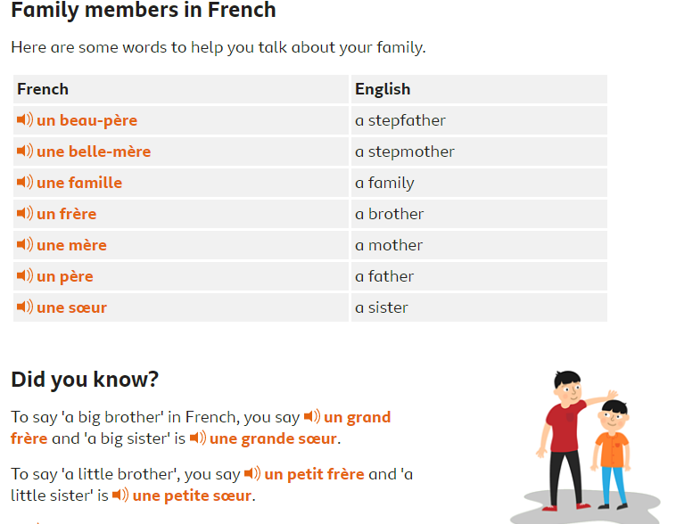

Tuesday
Science
Read through the Power Point presentation about magnets. Read the questions and discuss them with an adult. Then click on the magnet and watch the video clip.
If you have a magnet around the house you can use it to hunt magnetic and non-magnetic materials and record on the sheet. If you do not have a magnet, have a think about what you think might be magnetic or not. Again, record your ideas.
Computing Lesson 2 – Trusting Information Online
Watch chapter 2 ‘What is reliable’ and answer the questions. https://www.childnet.com/resources/the-adventures-of-kara-winston-and-the-smart-crew
1. What do Winston and Kara notice when they start to search different websites and the pirate map for information about Hooya Cove?
2. What advice do the Smart Crew give about trusting information online and making sure it is reliable?

Wednesday
You can decide whether to complete a Forest school activity or Cosmic Yoga video from You tube. If you search Cosmic Yoga, lots of different videos come up and you can choose the one that you want to complete.

Forest School – The children at school will be going out in the Forest school area again so use this time at home to go outside and do some of the forest school activities that we do.
Here are some examples:
- Collect sticks, leaves, berries and create a nature picture.
- Climb a tree with an adult supporting you.
- Make a den outside, can you make it waterproof?
- Dig for worms. Can you find other insects?

PSHE
Activity 1- Food, glorious food!
In this lesson, we will explore what a diet is and why it is so important.
https://classroom.thenational.academy/lessons/food-glorious-food-64vkec

Activity 2- Don’t forget you also have a wellbeing Wednesday activity to complete that Mrs Davies will post on the School shared story and join us for the assembly on zoom.

Thursday
Art
- Think about the story of ‘The Great Kapok Tree’. Re-read your poem from this morning’s English and listen again to the rainforest sounds.
Rainforest Ambience Sounds | Effects | Sound Bites | Sound Clips from SoundBible.com
- Using colour pencils, pastels, paint or any medium of your choice, create a rainforest picture for your poem. For example, if you have mentioned hearing toucans you could draw one in a tree.
- If you would like some help with ideas and how to get started you could have a look at some of these video clips for inspiration! You could also sketch a few ideas first on scrap paper.

Tips on drawing leaves, colours and foliage - https://www.youtube.com/watch?v=jbgbMnenkAU
How to draw various rainforest animals https://www.youtube.com/results?search_query=how+to+draw+rainforest+animals

Friday

PE
PASS Live Multi Skills Lesson 1.30 – 2.15
Please use the log in details that were sent via class dojo to log in to the live Zoom session. Please remember to read the disclaimer and policy document that was also sent out.

Music
Music Year 3/ 4 - Exploring 2 beats in a bar
All you will need are headphones (or somewhere to work where you won't disturb anyone else), pencil & paper and your hands. Work through the lesson below.
Week 3 lesson
https://classroom.thenational.academy/lessons/exploring-2-beats-in-a-bar-6xk34d

Don’t forget Mr Anscombe’s celebration assembly at 2.30pm this afternoon too details of the zoom have been emailed to you.
#TheLearningProjects

