

Lunsford Primary School – Home Learning
Monday 1st February – Friday 5th February 2020
Year 3 – Lion Class
Weekly Maths Tasks | Reading tasks
Watch the video and then attempt the worksheet if there is one for that day.  Monday Spr3.5.1 - Subtract money on Vimeo  Subtract money worksheet  Tuesday Spr3.5.2 - Give change on Vimeo  Give change worksheet  Wednesday  Today there is no video. Just ‘check my change’ sheet. Check to see if the shop keeper has given you the correct change or not. Answers are on page 2 – do not peek!  Thursday  Try to answer the shopping questions from the website. You might have to complete two steps to find the answer or the change.  Friday  Play the game using the link to make different amounts using coins.  Coin cruncher | Students | MoneySense (mymoneysense.com)  Try the money assessment sheet.  15 mins of TTRockstars  If you would like any additional maths tasks:  Access the Oak National Academy Maths lessons for Year 3 | Monday – Soap reading comprehension  Tuesday – The Power cut reading comprehension  Wednesday- Read your book for 20 mins and record in your Buster’s book club record.  Thursday – Crawling caterpillars reading comprehension  Friday – Dad loves ice cream reading comprehension  - If you have run out of things to read, try re-reading an old favourite or join Kent Libraries online to access lots of e-books and audiobooks  www.kent.gov.uk/leisure-and-community/libraries  - There is also a free e-book library available on https://home.oxfordowl.co.uk/books/free-ebooks/
SPaG
Monday – Complete sheet 4 that is titled Year 3 and 4 correct the spelling Mistake. Only complete this page as we are doing them each Monday until half term.

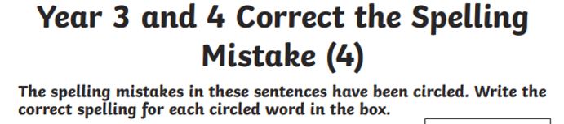

Tuesday – Complete the Year 3 spelling words wordsearch.

Wednesday – Use the words from yesterday’s word search to write a sentence. You need to learn how to spell them so can use the look, cover, write, check approach.

Thursday – Try the ‘What is a clause?’ sheet. There are 6 questions to answer. This is a mini quiz to see how much you can remember.

Friday – Adjective Detective - The Children's University of Manchester Play the game by identifying the adjectives in the sentences. Click on the man for the next sentence to try.
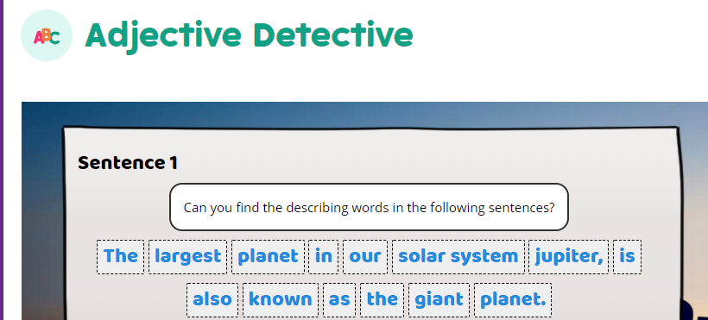

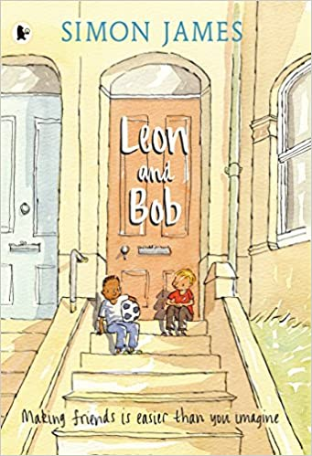
Weekly Writing Tasks

Leon and Bob by Simon James

Monday 1st February 2021
Making story predictions and developing an understanding of characters
Look carefully at the front cover of the book.
What are your predictions for the text? What do you think the story might be about? What do you think will happen to the characters? Where do you think the story is set?
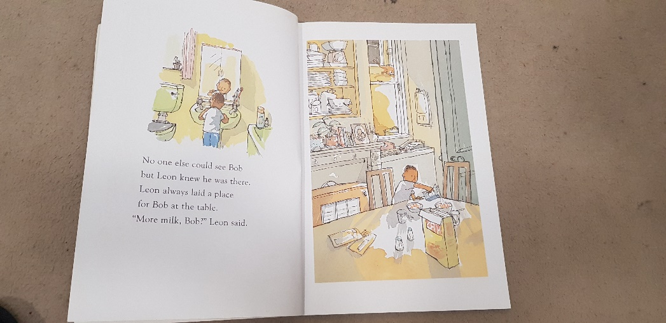
Write a sentence for each of your answers. Remember to punctuate them correctly with capital letters and full stops.
Read the first page of the book.

Look carefully at the picture. What can you see? What do we know about Leon?
Write at least two sentences to explain your thoughts.

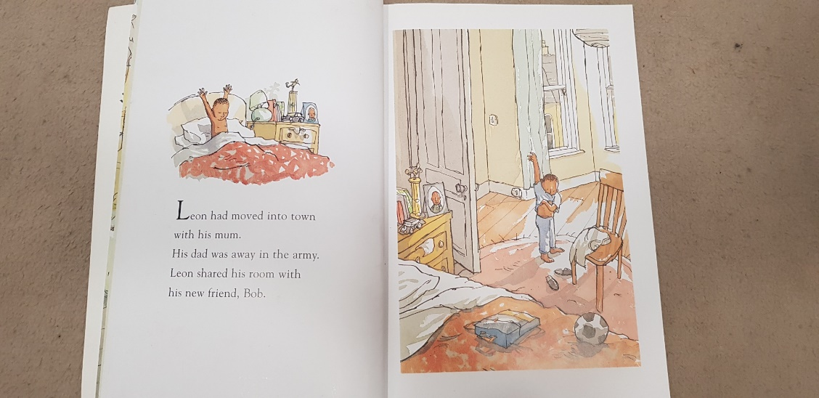
This is the next page of the book.
What have we found out about Bob? Why can no one else see him?
Write a sentence to explain who you think Bob is.

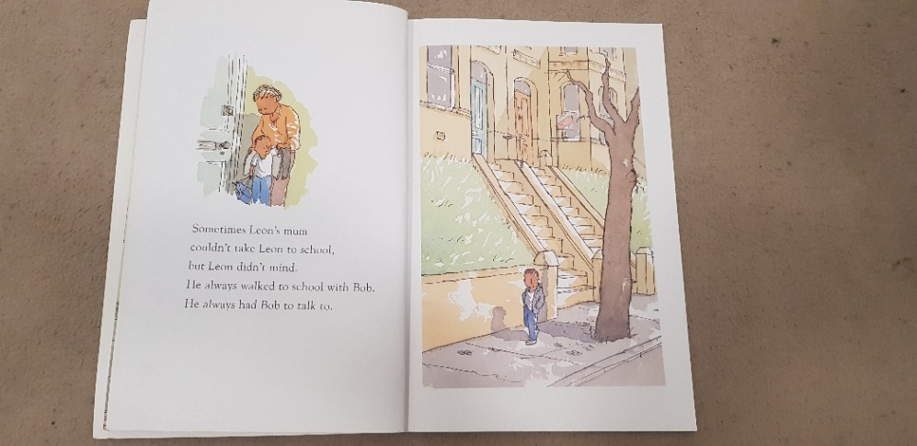
Tuesday 2nd February 2021
Writing a character profile
What have we found out about the story so far?
Who is Leon? Who is Bob?
This is the next page of the story for you to read.
Today we are going to be thinking about characters.
The main character in this book is Leon.
What do we know about him so far?
Write down some notes or you could use a brainstorm.
Now think about these questions…..
How old do you think Leon is?
Where does he live?
Who does he live with?
Who doesn’t he live with and why?
Who is Bob?
What does Leon do with Bob?
Why might Leon have an imaginary friend?
Try to add some more information to your notes or brainstorm.
Now you are going to use your notes to write a character profile about Leon explaining what we know about him so far and what we think about him.
Here is an example opening to help you out.
Leon is the main character in ‘Leon and Bob’. He is a young boy who has just moved into town with his mum. From looking at the illustrations, I think he is about eight years old. Leon’s dad does not live with him as he is away in the army.
I think Leon might be lonely because….
In the text….
You need to write in full sentences and correct punctuation. Year 4 should try to write in paragraphs. Try to explain your ideas using the text and think carefully about the words you are using.
Remember to check your work through carefully including spellings and punctuation.
Can you improve your vocabulary? Find a word in the thesaurus and choose a more interesting alternative. Or change a word if you have repeated it a lot.

If you do not have a thesaurus at home, you can use https://kidthesaurus.com/

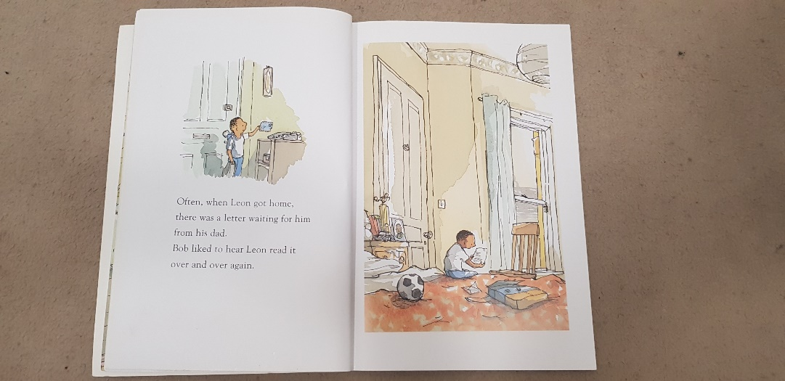
Wednesday 3rd February 2021
Writing a letter in role as a character
Remind yourself about the story so far.
This is the next page for you to look at.
Why does Leon’s dad send him letters?
How do you think Leon feels when he receives one?
Today you are going to imagine that you are Leon and write a letter to Leon’s dad. Think carefully about what Leon might say. You can use information from the text to help you and your imagination to make up some extra details.
Leon’s life in his new home / new town. What is his new home like? What is his day to day life like? What is his school like?
Leon’s thoughts and feelings.
Questions he might ask his dad about his life away from home in the army. What are his army barracks like? The food? When will he be home next?
Remember to write in first person (I, we, me) as you are imagining you are Leon. Try to include interesting details.
Check your work through carefully.
Here is an example letter opening which might help you with your work.

Dear Dad,
So much has happened since your last letter. Last week Mum and I moved into the new house in town. It is huge! My bedroom is really cosy and decorated in my favourite colours although I still miss my old room.
What is your room like at the barracks? On my bedside table I have all of my shiny football trophies plus my favourite picture of you in your dark-green uniform. I can’t wait to play football with you in the park next to our house.
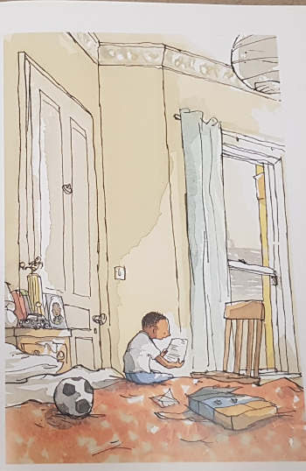

Thursday 4th February
Writing a description
Look at the picture of Leon’s bedroom. His room contains evidence of his life and reflects who he is a person, his family and his interests.
Write a list of things you can see in Leon’s room. Try to add some adjectives to describe them.
Eg. shiny, gold football trophy; messy, crumpled clothes; cosy bed with a soft, red duvet
These are all expanded noun phrases.
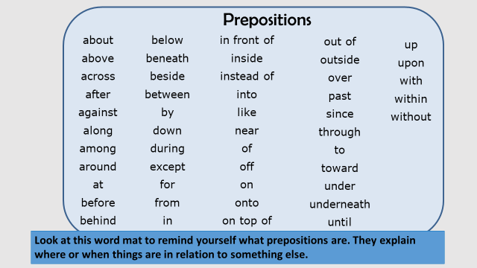

Add some prepositional phrases to your ideas about Leon’s bedroom
Eg. on the shelf / under the bed / in the drawer
You are now going to use your ideas to write a description of Leon’s bedroom. Remember to write in full sentences and include prepositions and expanded noun phrases. Check your full stops, capital letters and commas. Try to include lots of interesting vocabulary and use a dictionary or thesaurus if you have one.
Year 4 please try to write in paragraphs

Friday 5th February Writing a poem

Earlier in the week we looked at then wrote about Leon’s bedroom.
Have a think about your own room. What is in there? What things are special? How is it decorated? What are your favourite memories?
Create a brainstorm to show your ideas. Try to include some expanded noun phrases and prepositions.
You are now going to use your ideas to write a poem about your bedroom. If you prefer you can write about an imaginary room. Remember to start a new line (with a capital letter) for each idea. You might wish to use some of these sentence starters to help you. Remember to give your poem a title.
In my room…
On my wall…
Under my bed I keep…
In the corner….
On the shelf…
Behind my chair…
Through my window…
It’s a special place because….

Afternoon Topic work

Monday

History – What did prehistoric humans eat? Find out by reading the facts on the worksheet on the website and visit the website below:
https://planbee.com/blogs/news/stone-age-facts-for-children-and-teachers
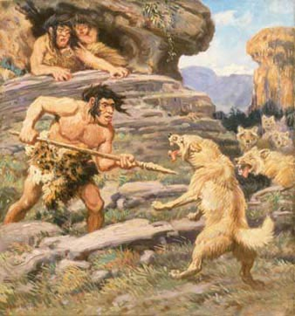
Your challenge now!
- Create a menu and of what you plan your family to eat for two Stone Age meals - breakfast and the main meal of the day.
Would you have a starter, main course, then pudding?
What foods would you choose?
- Now make a drawing of your main meal.
Ahh, no chicken nuggets, no chips, no burgers, no ice cream - what tasty Stone Age meal can you plan instead?
- Then draw and colour your picture, labelling each food so I can work out what delicious meal you are planning.
(Remember they would not have had plates, nor knives or forks and spoons. I wonder what they used instead?)

French – Days of the week
Practice your days of the week again and watch French KS2: Days of the week - BBC Teach sing along and try pronouncing your words carefully.
Can you create a poster showing the days of the week so that you can remember them? Make it bold bright and colourful.

Tuesday
Computing
Lesson 4 – Cyberbullying
Watch the next clip following Winston, Kara and the Smart Crew, Chapter 4: Who should you tell? This is about bullying online.
https://www.childnet.com/resources/the-adventures-of-kara-winston-and-the-smart-crew/chapter4
You may want to watch the clip a couple of times.
- How does Kara feel when she sees the nasty messages and picture?
- Why is it important to tell a trusted adult what has happened?
- Create your list of ‘Top 5 Tips’ to show the important advice that the Smart Crew give about cyberbullying.

Children’s Mental Health Week Activity
- Join the whole school Wellbeing Assembly at 2pm if you are able to.
- Try the ‘Draw your Feelings’ activity using the YouTube link below. All you need is a piece of paper and something to draw with. You may wish to use different colours.
Draw Your Feelings - Children's Mental Health Week 2021 - YouTube
- We will be sharing some of our drawings and talking about them in our Wednesday morning zoom meeting.
- If you would like any further activities, this is the link for Place2Be’s Art Room:
The Art Room at Home - Place2Be

Wednesday

PSHE
Eat Well, Live Well with Mr Sidat – My Own Workout
This is the next lesson in our ‘Healthy Living’ theme for this term. Click on the link below and work through the video and activities.
https://classroom.thenational.academy/lessons/my-own-workout-75j6at

PE
PASS Dance Lesson 4
Use the PASS website to complete Dance lesson 4 for Year 3/4 under the ‘Home Learning’ Section or the YouTube link below.
PASS HOME LEARNING YEAR 3-4 PIRATES DANCE LESSON 4 - YouTube

Thursday

Art – In English you have looked at Leon’s bedroom and described it. Your task today is to plan and draw your dream bedroom. Think carefully about the layout and what you want to include in it. Label all the key features neatly and colour it in carefully.
Friday
PE
PASS Live Multi Skills Lesson 1.30 – 2.15
Please use the log in details that were sent via class dojo to log in to the live Zoom session. Please remember to read the disclaimer and policy document that was also sent out.

Music
Music Year 3/ 4 – Exploring 6 beats in a bar
https://classroom.thenational.academy/lessons/exploring-6-beats-in-a-bar-c5jpce
You will need some headphones (or somewhere to work where you won't disturb anyone else). Click on the link above and work through the lesson on the screen.

Don’t forget Mr Anscombe’s celebration assembly at 2.30pm this afternoon too details of the zoom have been emailed to you.
#TheLearningProjects

