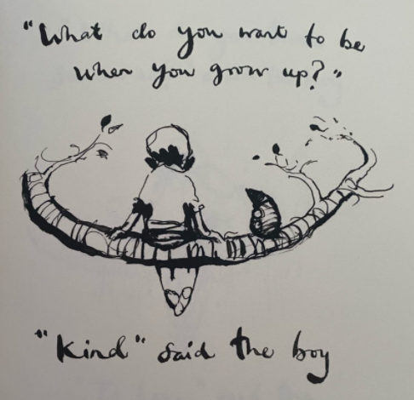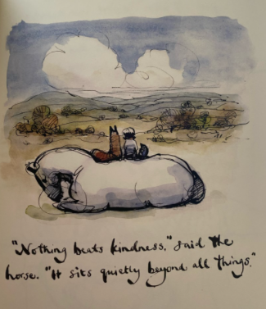

* What do these pictures mean to you? Write a few sentences explaining what kindness means to you.
* Why do you think kindness make us and other people feel happy?
* Write down an example of a time when your kindness helped you and someone else to feel happy.

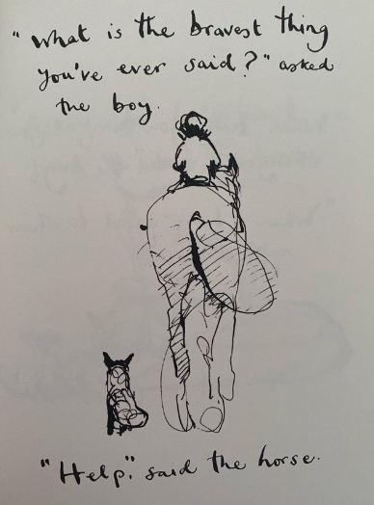

What does it mean to be ‘brave’?

Why do you think it is a good thing to ask for help when you need it? Can you think of a time when you have asked for help at home/in school?

Write down an example of a time you have felt brave. Why did this make you feel brave?