Monday 18th January
Join me on zoom at 10am to introduce the home-learning for this week and catch-up.

SPaG
Last week we learnt the spelling rule for the /s/ sound spelt as ‘c’ before e, i and y. Practise this rule by completing the crossword game.

English – Describing your hero
Look back over the table you completed on Friday to design your hero. Today, I would like you describe your hero in sentences. What is your hero’s name? Try and consider what your hero looks like and what his/her personality is like? Traction Man has a bungee rope in the story and travels around on a jet-powered trainer. Does your character have any special tools or equipment? Do they have a special superpower? How do they travel on their missions?

When you are completing your description of your hero, try and include capital letters and full stops. You may also be able to include some adverbs to describe your verbs (action words). For example:

Lightning Girl bravely jumps onto her electric umbrella when she rescues a damsel in distress.

Reading
Complete The Wonderful Wizard of Oz reading comprehension

Maths – Doubling
Watch this video https://vimeo.com/490420115 and complete the worksheet. If you complete this and want an extra challenge, there is also a ‘doubling challenges’ document with extra questions.

TT Rockstars/Hit the Button
Log onto TT Rockstars or go onto Hit the Button (https://www.topmarks.co.uk/maths-games/hit-the-button) and play for around 15-20 mins to practise your times tables or number bonds.

RE – Islam: Understanding why Muslims follow the Prophet Muhammed
Last week we began our new topic on Islam. The Prophet Muhammed is a special leader to Muslim people. Over 1400 years ago he taught Muslims how to follow God. A Prophet is like a messenger, and Muslims believe the Prophet Muhammed was God’s special messenger who told others to follow him.
Watch the BBC Bitesize video about the Islamic story ‘Muhammed and the Crying Camel’ https://www.bbc.co.uk/teach/class-clips-video/religious-studies-ks1-the%20islamic-story-of%20the-prophets-and-the-ants-and-the-crying-camel/z4vprj6
Then explain what the message of this story is and what lesson it teaches to Muslim people.

Computing – Using objects in coding
Watch the pre-recorded video on Dojo before you begin this activity on Purple Mash.

Open ‘free code chimp’ in your 2Do’s list. You will now be looking at the coding screen. Today we will be writing code to program an object to do an action. Click on design button and then drag a turtle onto the blank screen.

Now go back to the coding screen and drag code onto the screen to program the turtle. You could start with:

Once you have written the code, press the play button at the top and click on your turtle – Did it work? Try different types of code to see what the turtle does!

Tuesday 19th January
SPaG
Today we are going to continue learning about different types of sentences. This week we are looking at commands. Look at this BBC Bitesize link https://www.bbc.co.uk/bitesize/topics/zrqqtfr/articles/z8strwx and then go through the questions on the powerpoint called ‘Sentence types – commands’.

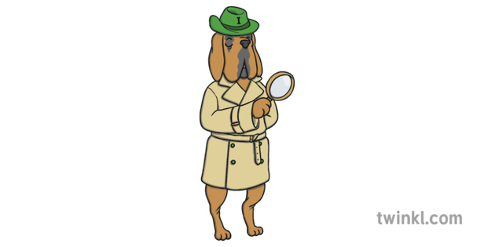
English – Make inferences about the story
Firstly, listen to the new video I have posted on Dojo of the new pages of Traction Man is Here. Today we are going to be making some inferences about the story so far. Inferencing is when we ‘read between the lines’ of a story to understand things that we are not clearly told by the author. In class we use our reading dog called Inference Iggy to help us with this skill.

Open the document ‘Inference questions’ and work through the questions, writing your answers in full sentences. When inferencing, you need to explain your answers to add detail. We usually use the subordinating conjunction ‘because’, ‘when’ or ‘if’ to help us do this.

Reading
Complete A New Pet reading comprehension

Maths – Understanding multiplication/division
Join me on zoom at 9.30am for a live session to go through this activity.
Complete the questions ‘understanding multiplication and division’. The questions will get more challenging further down the sheet you go.

TT Rockstars/Hit the Button
Log onto TT Rockstars or go onto Hit the Button (https://www.topmarks.co.uk/maths-games/hit-the-button) and play for around 15-20 mins to practise your times tables or number bonds.

Science – Living things and their habitats: Local habitats
Open and read the powerpoint ‘local habitats’. Make a poster about the different types of local habitats and write some information about each one.
Wednesday 20th January
SPaG
Today we are learning a new spelling rule - /n/ sound spelt as ‘kn’ and ‘gn’ at the beginning of words. Open the powerpoint and learn the spellings at the end.

English – Speech bubbles (zoom session)
Join me on zoom at 9.30am for a live session to go through this activity.
Listen to the story again on Dojo. Try and think about what the characters might say if they were able to speak and why. What do you think their voice would be like? How would they be speaking?

Using the ‘speech bubbles’ document, write some speech for the characters in the pages. You could write speech bubbles for 1 character or multiple characters from the pages so far. When a character speaks in the story or when any character speaks in most books, this is usually shown with inverted commas – “Hooray for Traction Man”. Once you have written your speech bubbles, try saying them out loud in the voice that you think the character would have.

Reading
Choose a reading book of your choice/a school book to read for 15-20 mins and record this in your reading record for Buster Book Club.
Maths – Recognising coins
We are now moving onto our next Maths topic which is Money.
Watch this video https://vimeo.com/470140979 and complete the worksheet.

TT Rockstars/Hit the Button
Log onto TT Rockstars or go onto Hit the Button (https://www.topmarks.co.uk/maths-games/hit-the-button) and play for around 15-20 mins to practise your times tables or number bonds.

PE
Choose one of the following to complete:
- PE with Joe workout https://www.youtube.com/c/TheBodyCoachTV/videos
- Cosmic Kids yoga https://www.youtube.com/c/CosmicKidsYoga/videos
- PASS live zoom multi-skills lesson 1.30pm-2.15pm
https://zoom.us/j/91302539690?pwd=UlIrSkczektYWDNrbWVlc3FoZytpUT09
Meeting ID: 913 0253 9690
Password: PASSLIVE

PSHE – Wellbeing Wednesday activities
Open the ‘Wellbeing Wednesday’ document. On Page 2 there is an activity to complete about self-esteem which is our theme for this week. You need to draw a picture of yourself in the box and then write two things you are good at underneath.
Thursday 21st January
SPaG
Go onto Spelling Frame https://spellingframe.co.uk/ click on Year 2 and complete spelling rule 5 (/n/ sound spelt as ‘kn’ and ‘gn’ at the beginning of words).

English – Diary entry (zoom session)
Join me on zoom at 9.30am for a live session to go through this activity.
Today we are going to be writing a diary entry as Traction Man to reflect on what has happened to him so far in the story. It may be a good idea to listen to the story again on Dojo before you begin.

When you listen to the story, make a few quick notes about what happens in order (for example: opened on Christmas Day saves farm animals from evil pillows looks for lost wreck of sieve…)

Now write your diary in role as Traction Man in sentences. Try and think about how Traction Man may feel at different points in the story when you’re writing your diary. You may also be able to include some exclamation sentences (!) or question sentences (?). Don’t forget to start with ‘Dear Diary’!

Reading
Complete The Helicopter Tour of London reading comprehension

Maths – Recognising notes
Watch this video https://vimeo.com/470140979 (same as yesterday to revise) and complete the worksheet.

TT Rockstars/Hit the Button
Log onto TT Rockstars or go onto Hit the Button (https://www.topmarks.co.uk/maths-games/hit-the-button) and play for around 15-20 mins to practise your times tables or number bonds.

Geography/Art – Drawing an Asian house
Open the document ‘drawing an Asian house’ and have a go at drawing your own version! How is this house different to the one you live in? You could do some research on Asian houses or look at some photos.
Friday 22nd January
Join me on zoom at 1.30pm to have a story/games and end of the week catch-up!

SPaG
Complete the worksheet ‘correct the sentence’. You can choose which sheet to complete, the second is more challenging.

English – Thank you letter
Look at the picture below of Christmas Day at Granny’s house –
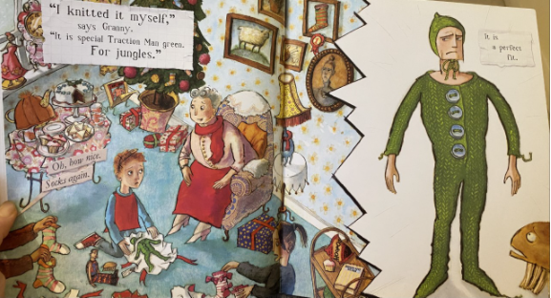

Have a think about how the boy feels about receiving this gift from his Granny for his Traction Man – What does his face tell you about how he feels? How does the suit fit Traction Man? What does Traction Man’s face tell you about how he feels towards his new suit?

Today we are going to be in role as Traction Man again and write a letter to Granny to say thank you for the knitted green romper suit which he receives as a Christmas present. Remember you are writing in the first-person tense using ‘I’ and ‘we’. You may be able to include some question sentences in your letter, using a question mark.

Reading
Complete the Penguins comprehension

Maths – Count pence
Watch this video https://vimeo.com/471306740 and complete the worksheet.

TT Rockstars/Hit the Button
Log onto TT Rockstars or go onto Hit the Button (https://www.topmarks.co.uk/maths-games/hit-the-button) and play for around 15-20 mins to practise your times tables or number bonds.

Music
Here is the link to the planet Venus. Compare to Mars from the first week of home learning.
https://www.youtube.com/watch?v=5Hpb2gp4mtc

