Please spend the following amount of time on each activity (approx.):
SPaG (spelling, punctuation and grammar) – 15/20 mins
English – 1 hour (I will upload a read aloud video onto Dojo of the pages you need from the book each week)
Reading – 15/20 mins
Maths – 1 hour
TT Rockstars/Hit the Button – 15/20 mins
Science/Computing/Geography/Music (PM activity) – 1 hour

Monday 11th January
SPaG
We are going to practise the spelling rule we learnt last week - /j/ sound spelt as ‘ge’ and ‘dge’ at the end of words and sometimes ‘g’ elsewhere in words before e, i and y.
Please complete the handwriting sheet or word search to practise using this spelling rule.

English – Writing in role as Traction Man
Listen to the next part of the story that I posted on Dojo this week. Have a think about what Traction Man may be thinking about and how he is feeling so far in the story.

Today we are going to be writing in the first-person tense as if we are Traction Man (using ‘I’ or ‘we’). I would like you to imagine you are Traction Man and you are retelling your day so far, starting from being opened by the boy on Christmas Day to diving into the sink to find the lost wreck of the Sieve. Try and include how you would be feeling and what you may be thinking about as Traction Man. You may want to start with an interesting sentence opener like “What a long day I’ve had…” or “Today another mission has been completed…”

Reading
Complete the snail reading comprehension.

Maths – Odd and Even Numbers
Please watch the following video https://vimeo.com/498261586 and then complete the worksheet.

TT Rockstars/Hit the Button
Log onto TT Rockstars or go onto Hit the Button (https://www.topmarks.co.uk/maths-games/hit-the-button) and play for around 15-20 mins to practise your times tables or number bonds.

RE –
This term we are going to be learning about Islam.
I would like you to open the ‘Islam’ powerpoint and watch the BBC clip on the powerpoint (you can follow this link to watch it: https://www.bbc.co.uk/bitesize/clips/zrn34wx) Once you have done this, write some facts/notes about what you have learnt.

PSHE
This term our new Jigsaw topic is called ‘Dreams and Goals’.
Our first session is about goals to success. I would like you to think about something you have achieved and felt proud of. Then, how did this make you feel at the time?
Complete the ‘treasure chest’ document to explain your success and your feelings about this.
Tuesday 12th January
SPaG
Today we are learning about types of sentences, particularly how patterns in a sentence show us it is a question. Open the powerpoint ‘Sentence types – questions’ and work through the activities.
English – Expanded noun phrases
‘Traction Man is Here’ is full of expanded noun phrases. An expanded noun phrase is made up of a noun (naming word i.e. person, place or thing) and at least one adjective (describing word) and can be in any order. For example: ‘Evil Pillows’.
If there is more than one adjective, they may be separated with a comma.

Using the pages from the story that we’ve read so far, I want you to write a list of the expanded noun phrases you can find (watch the video on Dojo to listen to the pages).

Then I would like you to make your own expanded noun phrases that are not linked to the story. For example, ‘fast, fierce tiger’.

Reading
Complete the Charlie and the Chocolate Factory reading comprehension.

Maths – Divide by 2
Please watch the following video https://vimeo.com/498260506 and then complete the worksheet.

TT Rockstars/Hit the Button
Log onto TT Rockstars or go onto Hit the Button (https://www.topmarks.co.uk/maths-games/hit-the-button) and play for around 15-20 mins to practise your times tables or number bonds.

Science
Last week we began learning about living things and their habitats and understanding how we know something is living, dead or has never been alive using the MRS GREN rhyme.
This week I would like you to go on a treasure hunt around your house/garden. Open the document called ‘living, dead, never alive treasure hunt table’. Choose items to compare and complete the table.
What do you notice about the things you have chosen? Are there more in one category than the others?

Computing
Open Purple Mash and on your 2Do list there is an activity to complete called ‘Debug challenges chimp’. You need to try and debug (fix) the code to make it work.
Wednesday 13th January
SPaG
Today we are going to learn a new spelling rule - /s/ sound spelt using ‘c’ before e, i and y.
Open the powerpoint with the same name and practise the spellings at the end of the powerpoint.

English – Expanded noun phrases
Following on from yesterday, today I would like you to come up with your own expanded noun phrases that could be used in the story. For example: ‘destructive Scissors’, ‘slippery, soft Gloves’ or ‘rocky hills of the Fireplace’. Look around your house to think of things to use to make your expanded noun phrases or look at the pictures in the story to help you.

Once you have completed your expanded noun phrases, try writing them into sentences. For example: ‘Traction Man battled against the destructive Scissors to save the day.’

Reading
Read your own book for 15-20 mins and write it in your reading record for Buster Book Club.

Maths – Divide by 5
Please watch the following video https://vimeo.com/498262138 and then complete the worksheet.

TT Rockstars/Hit the Button
Log onto TT Rockstars or go onto Hit the Button (https://www.topmarks.co.uk/maths-games/hit-the-button) and play for around 15-20 mins to practise your times tables or number bonds.

Forest School
In school we will be going out for Forest School in the afternoon. You could also complete some similar outdoor activities -
Here are some examples:
- Create a model using sticks, leaves, berries etc.
- Climb a tree with an adult supporting you.
- Make a den
- Try some digging in the mud – can you find any insects?
Thursday 14th January
SPaG
Go onto Spelling Frame https://spellingframe.co.uk/. Click Year 2 and play spelling rule 4 – The /s/ sound spelt ‘c’ before e, i and y.

English – Describing a setting
Listen to the story again on Dojo and then look at the pages below:
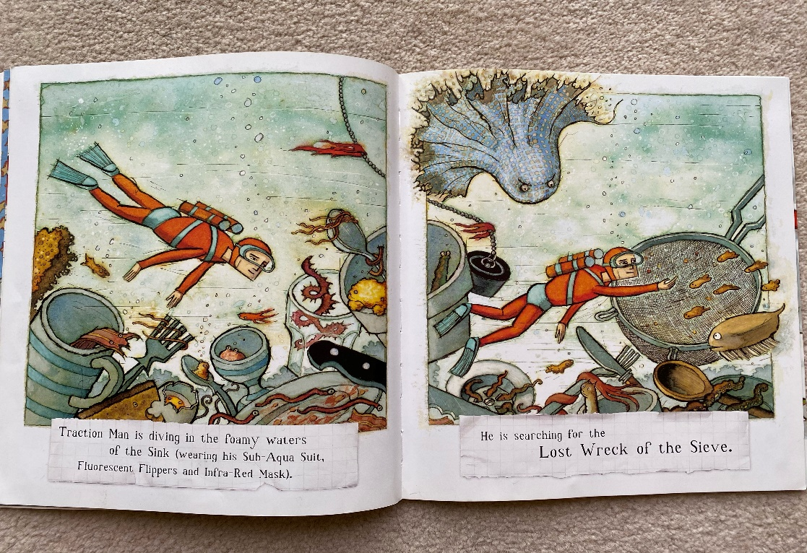

Write a list of nouns that you see in the picture i.e. mug, fork, plug. Then turn these nouns into expanded noun phrases by adding adjectives, such as: ‘monstrous Plug’.
Using these expanded noun phrases and the picture above, I would like you to describe the setting. What can you see? Where is Traction Man? What is he doing in the picture? What creatures are watching him?
You can use my example to help you write your own setting description:
Down in the cloudy water of the kitchen sink, Traction Man was swimming in his red sub-aqua suit searching for the lost wreck of the sieve. Crawling out of the dark plug holes there are orange, tangled tentacles ready to reach out and catch their prey…

Reading
Complete the wanted poster reading comprehension.

Maths – Divide by 10
Please watch the following video https://vimeo.com/498262386 and then complete the worksheet.

TT Rockstars/Hit the Button
Log onto TT Rockstars or go onto Hit the Button (https://www.topmarks.co.uk/maths-games/hit-the-button) and play for around 15-20 mins to practise your times tables or number bonds.

Geography – Researching China
Complete some research about the country China using the worksheet called ‘China fact sheet’. You could use the internet, books, travel guides, atlases etc.
Friday 15th January
SPaG
Complete the SPaG mat worksheet.

English – Designing your own hero
Using the document ‘designing a hero’, I would like you to make up your own superhero. Before you begin, think about what a hero is and what they do. What stories do you know about heroes? What makes them special? What superpowers do they have? What are they like as a person? What makes them different from a villain?

Write down your ideas about your own hero into the table and then draw a picture of your hero. When writing your ideas, try and use adjectives or expanded noun phrases to add lots of detail. Then label your picture with their interesting features.

Reading
Read your own book for 15-20 mins and write it in your reading record.

Maths – Solving division problems
Open the document ‘division problems’ and work through the questions using either the sharing or grouping method that we learnt last week. These questions become more challenging the further down the sheet you go.

TT Rockstars/Hit the Button
Log onto TT Rockstars or go onto Hit the Button (https://www.topmarks.co.uk/maths-games/hit-the-button) and play for around 15-20 mins to practise your times tables or number bonds.

Music
Compare this week’s planet music to last week https://www.youtube.com/watch?v=T0Fx24Xzc3U
How is it different?

Art
Our Art topic will be focusing on an art technique called collage.
Research what ‘collage’ is and have a look at some pictures.

Linking to our Geography work on China, this week I would like you to research Chinese masks. What do you notice about them? What patterns are used? Which colours are used most often? Are there any animals or specific pictures used on the masks? What were masks most often used for?

