Please spend the following amount of time on each activity (approx.):
SPaG (spelling, punctuation and grammar) – 15/20 mins
English – 1 hour (I will upload a read aloud video onto Dojo of the pages you need from the book each week)
Reading – 15/20 mins
Maths – 1 hour
TT Rockstars/Hit the Button – 15/20 mins
Science/Computing/Geography/Music (PM activity) – 1 hour

Tuesday 5th January
SPaG
Choose three of the Year 2 high frequency words we have learnt so far this year and use one of the following strategies to practise them (see Y2 home learning page on website for high frequency words):
look, say, cover, write and check
writing words in the air, on someone’s back with your finger, on your hand etc.
chunking into syllables
write into sentences

English - Write a recount of one day from your Christmas half term.
Today I would like you to write a recount of one day from your break. You can choose any day to write about.
You need to write about your day in order, starting from what happened at the beginning of your day through to the end. You also need to use time conjunctions to help order your work (i.e. firstly, then, next, after that, finally). Try and include lots of information and description of your day to add detail to your recount.

Reading
Complete the comprehension ‘Antarctic Gazette’

Maths – Dividing: Making equal groups by sharing (recap lesson)
Please watch the following video (Video: https://vimeo.com/492603273) and then complete the worksheet (see Y2 home learning page on website).

TT Rockstars/Hit the Button
Log onto TT Rockstars or go onto Hit the Button (https://www.topmarks.co.uk/maths-games/hit-the-button) and play for around 15-20 mins to practise your times tables or number bonds.

Science
This term we will be beginning our new Science topic on living things and their habitats. Today we will learn about how we know something is living, dead or have never been alive.

Have a read through the powerpoint called ‘living, dead or never alive’ (see Y2 home learning page on website).
Once you have done this, try the activity sheet. You need to choose 3 things from around your home/garden and using the MRS GREN mnemonic explain why you have decided they are either living, dead or have never been alive.

Wednesday 6th January
SPaG
On Purple Mash open the 2Do called ‘Rainy Day’. This is a grammar game to practise using subordination (using ‘when’, ‘if’, ‘that’, ‘because’) and co-ordination (using ‘or’, ‘and’, ‘but’).
English - Responding to a picture.
We are now beginning our new story for this term called Traction Man is Here! by Mini Grey.

Have a look at the picture below of the boy’s letter to Santa asking for a Traction Man. Talk about the picture with someone else – Who do you think wrote the letter? What do you think happened in the ‘terrible parachute’ incident? What do you think a Traction Man is? Would you like one? What do you notice about the toys/costumes drawn?

I would like you to write your response to this picture and your prediction for what this story may be about. Try and use the above questions to help you with your ideas. Try and structure your sentences using words like ‘and’, ‘or’, ‘but’, ‘when’, ‘because’ and ‘if’ to extend your ideas.

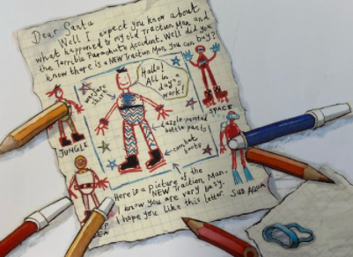

Reading
Choose one of your school books or a book of your choice to read for 15-20mins.

Maths - Dividing: Making equal groups by sharing
Please watch the following video (Video: https://vimeo.com/492603633) and then complete the worksheet (see Y2 home learning page on website).

TT Rockstars/Hit the Button
Log onto TT Rockstars or go onto Hit the Button (https://www.topmarks.co.uk/maths-games/hit-the-button) and play for around 15-20 mins to practise your times tables or number bonds.

Computing
This term we are continuing with our topic on coding and algorithms.

Log onto Purple Mash and open your 2Do called ‘repeat and timer example’ (if you do not have your login in details then please let me know via Dojo).

Open up this 2Do and have a read through the code Purple Mash has made. Then, click on the play button at the top of the screen. Try clicking one at a time on the repeat and then timer options and see what happens to the objects (see below):
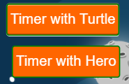
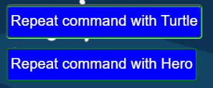

What do you notice happens to the hero? What do you notice happens to the turtle? Do they run at different speeds? Has the code worked or will there be some issues with it?

You could then press stop and go back into code mode and try changing some of the code to see what happens to the hero and turtle! Please make sure you save your work if you do change any of the code so I can see what you have done.

Thursday 7th January
SPaG
Today we are practising the spelling rule - /j/ sound spelt as ge and dge at the end of words, and sometimes spelt as g elsewhere in words before e, i and y.
Open the powerpoint called ‘The j sound spelt with -dge or -ge at the end of words, and sometimes spelt as g elsewhere in words before e, i and y’ and practise the words at the end (see Y2 home learning page on website). Can you think of anymore rules that follow this spelling pattern?

English – Collecting a word bank of persuasive language
Have a look at the next page in the book of the boy asleep in his bed (see below). Have a think about these questions: Who do you think the boy is?, What is happening?, Does it remind you of any books/films/tv?
Have a look now at the writing on the Traction Man box. Have you seen something similar before? What does it make you think/feel?
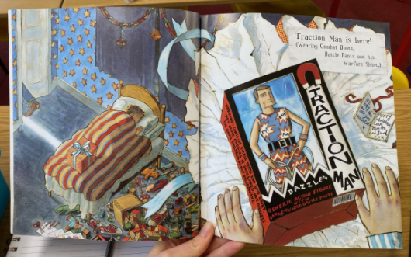

Today I would like you to make a word bank of interesting words and phrases/adjectives that may persuade someone to buy a Traction Man to help us with our writing tomorrow. For example, ‘fun action hero’, ‘an outfit for every occasion’, ‘dazzling trousers’, ‘strong bungee cord’.
Reading
Complete the comprehension ‘A postcard from Mo Farah’

Maths - Dividing: Making equal groups by grouping (Recap of Year 1)
Please watch the following video (Video: https://vimeo.com/492603899) and then complete the worksheet (see Y2 home learning page on website).

TT Rockstars/Hit the Button
Log onto TT Rockstars or go onto Hit the Button (https://www.topmarks.co.uk/maths-games/hit-the-button) and play for around 15-20 mins to practise your times tables or number bonds.

Geography
This term we will be beginning our new Geography topic on the country China.

Today I would like you to make a start by writing down all you know about China. This could be anything from facts to animals or food! You could also try drawing some pictures to go alongside your ideas.

Friday 8th January
SPaG
Today we are going to practise the spelling rule you learnt yesterday - /j/ sound spelt as ge and dge at the end of words, and sometimes spelt as g elsewhere in words before e, i and y.
Go onto Spelling Frame (https://spellingframe.co.uk/), click onto Year 2, and practise Spelling Rules 1, 2 and 3

English – To be able to persuade
Today we are going to persuade people to buy a Traction Man using our word banks from yesterday. You need to write in sentences using your interesting words and phrases to add details that would make someone want to spend their money on a Traction Man! What is so amazing about him that I have to buy one? What makes him different to other action dolls? Don’t forget to include capital letters and full stops, as well as exclamation marks and question marks if you can.

Reading
Choose one of your school books or a book of your choice to read for 15-20mins.

Maths - Dividing: Making equal groups by grouping
Please watch the following video (Video: https://vimeo.com/492603961) and then complete the worksheet (see Y2 home learning page on website).

TT Rockstars/Hit the Button
Log onto TT Rockstars or go onto Hit the Button (https://www.topmarks.co.uk/maths-games/hit-the-button) and play for around 15-20 mins to practise your times tables or number bonds.

Music
Have a listen to this piece of music: https://www.youtube.com/watch?v=cXOanvv4plU
What does it make you think about? Could you try drawing a picture whilst you listen to the music?
With someone in your house, discuss the following – Does the music get louder? What instruments can you hear? What does it make you think of?

