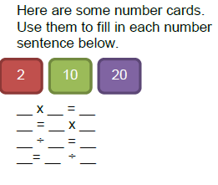Question 1

Look at these numbers.

Use these numbers to fill in the fact family below. Some numbers are filled in for you:

What rules do you notice about multiplication?

What rules do you notice about division?

10 x _______ = _________

_____ x _______ = 20

20 ÷ _____ = _________

______ ÷ 10 = _________

Question 2

Complete these calculations. Think about the methods we have learnt about to do your working out:

1. 6 x 5 =
2. 18 ÷ 2 =

Question 3

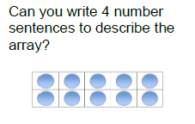Write 2 multiplication sentences and 1 more division sentence to describe this array. The first one is done for you:

10 ÷ 2 = 5

Question 3

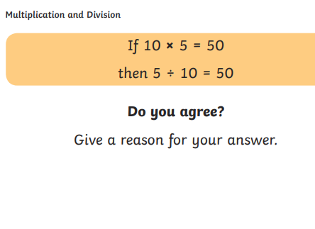

Question 4

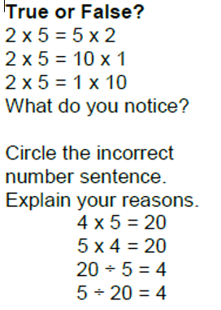

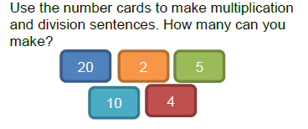Question 5

Using what you know about multiplying and dividing, why can’t you make any more number sentences? Explain your answer.