Monday 1st March
SPaG
Last week we learnt the spelling rule - adding suffixes -ing, -ed, -er, -est and -y to words ending in ‘e’ with consonant before. Open the handwriting sheet and practise the spellings. Don’t forget about long ladder letters that go under the line, or tall ladder letters that reach the top of the line!

English – Making inferences about a picture
For the next 3 days, we will be writing about the picture below. Look at the picture and answer the following questions about it:
- What creature could have just hatched from the egg?
- What could the girl be looking up at?
- Why do you think the crows are flying away?
- How do you think the girl is feeling after finding the hatched egg?
- What will happen now the egg has hatched?
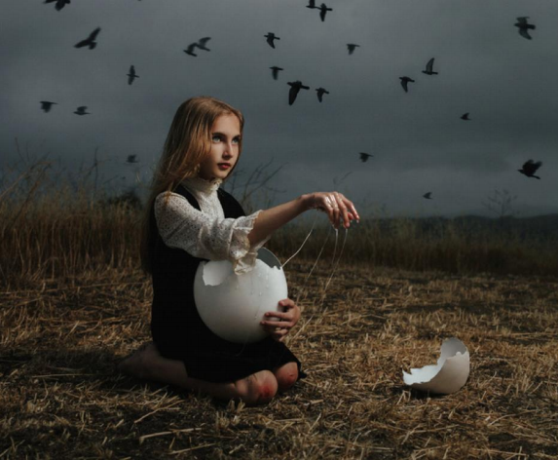

Reading
This week we are celebrating World Book Day on Thursday 4th March. Today, I would like you to complete the book scavenger hunt activity.

Maths – Draw 2D shapes
Watch the video https://vimeo.com/506146175 and complete the worksheet. (If you would like a further challenge, open the challenge sheet and complete questions 1 and 2)

TT Rockstars/Hit the Button/NumBots
Log onto TT Rockstars, NumBots or go onto Hit the Button (https://www.topmarks.co.uk/maths-games/hit-the-button) and play for around 15-20 mins to practise your times tables or number bonds. (To log into NumBots, use your TT Rockstars username and password)

RE – Judaism: Who is Jewish and what do they believe? (live session – see Dojo)
This term we are learning about Judaism and our key question for the term is ‘Who is Jewish and what do they believe?’
I would like you to open the ‘Judaism’ powerpoint and watch the following BBC clip https://www.bbc.co.uk/bitesize/clips/zd9jxnb . Once you have done this, write some facts/notes about what you have learnt.

Computing – 2Create a Story
To celebrate World Book Day this week, today I would like you to create your own story using 2Create a story on Purple Mash! You could make up your own story or recreate one of your favourites. Open your 2Do’s and then ‘2Create a Story’.
Tuesday 2nd March
SPaG
We are learning some more homophones this week. A homophone is a word that sounds the same as another but may be spelt differently and have a different meaning. Open the powerpoint and learn the spellings at the end.

English – Sick sentences
Look back at the picture from yesterday. These sentences are sick and need some help to sound better – can you improve them?
- The girl held the egg.
- It was slimy
- She felt confused.
- Her heart was beating.
Try and think about the following when improving these sentences –
Adjectives (describing words)
Verbs (doing/action words)
Adverbs (words that describe a verb or how it was done i.e. quickly, shakily, gently, silently…)
Capital letters/full stops/exclamation marks/question marks.

Can you now come up with your own sentences to describe the picture?

Reading (live session – see Dojo)
Today I would like you to share your favourite story with the class during our live session. Try and think about why it is your favourite book, some of the characters and what happens in the story so you are ready to tell the others! If you can’t join the live session, then share your story with someone in your family and take a photo.

Maths – Lines of symmetry
Watch the video https://vimeo.com/508430942 and complete the worksheet. (If you would like a further challenge, open the challenge sheet and complete questions 3 and 4)

TT Rockstars/Hit the Button/NumBots
Log onto TT Rockstars, NumBots or go onto Hit the Button (https://www.topmarks.co.uk/maths-games/hit-the-button) and play for around 15-20 mins to practise your times tables or number bonds. (To log into NumBots, use your TT Rockstars username and password)

Science – Living things and their habitats: Dependency (live session – see Dojo)
This week we are learning how living things depend on other living things to survive. Open the powerpoint called ‘Dependency’ and read through it. Then complete the ‘Dependency activity’. You need to choose one of the world habitats pictures and stick the labels on in the correct places (each sheet has a star to show how challenging it is, the more stars the more challenging!).
Wednesday 3rd March
SPaG
Go onto Spelling Frame (https://spellingframe.co.uk/) and practise rules 28 and 29. See how many homophones you already know/need to learn!

English – Finish the story (live session – see Dojo)
I need help finishing off my story! Using my story starter below and the picture, finish off the rest of the story:
On a stormy, grey afternoon a young girl stumbled across something in the middle of the dry corn field behind her house. She felt confused and was unsure what it could be so she began to slowly move closer and closer towards it. Suddenly she realised it was...an egg! But not just any egg, it was the shell of an enormous, round egg that had just been hatched! The girl was shocked as she had never seen anything quite like it in her life! She picked up the egg and could feel the cold, wet slime dripping down her hands. She began to wonder what creature could have lived inside. Then just in that moment she heard a strange noise coming from behind her…

Reading
Choose a reading book of your choice/a school book to read for 15-20 mins and record this in your reading record for Buster Book Club – extra Dojo’s on offer today for World Book Day week!
You could use the £1 book voucher to download an online story from the World Book Day website. You can find the link to the voucher in the letter sent home from the Office.

Maths – Sort 2D shapes
Watch the video https://vimeo.com/508433384 and complete the worksheet. (If you would like a further challenge, open the challenge sheet and complete questions 5 and 6)

TT Rockstars/Hit the Button/NumBots
Log onto TT Rockstars, NumBots or go onto Hit the Button (https://www.topmarks.co.uk/maths-games/hit-the-button) and play for around 15-20 mins to practise your times tables or number bonds. (To log into NumBots, use your TT Rockstars username and password)

PE
Choose one of the following to complete:
- PE with Joe workout https://www.youtube.com/c/TheBodyCoachTV/videos
- Cosmic Kids yoga https://www.youtube.com/c/CosmicKidsYoga/videos
- PASS live zoom multi-skills lesson 1.30pm-2.15pm
https://zoom.us/j/91302539690?pwd=UlIrSkczektYWDNrbWVlc3FoZytpUT09
Meeting ID: 913 0253 9690
Password: PASSLIVE

PSHE – Jigsaw: Healthy Me – Being relaxed
This week we are understanding what it means to be relaxed. Usually we relax our bodies and minds at the start of our PSHE Jigsaw lessons using ‘calm me’ time. I would like you to have a go at some of the ‘mindfulness cards’ that I have uploaded onto the website to replace our usual ‘calm me’ time. How did you feel whilst completing the activities? What things do you usually do to help you relax?
Thursday 4th March
SPaG
Complete pages 5 and 6 from the Year 2 Common Exception Words Activity Booklet. This will be a useful way to practise the Year 2 words that we need to be able to spell/read by the end of the year.

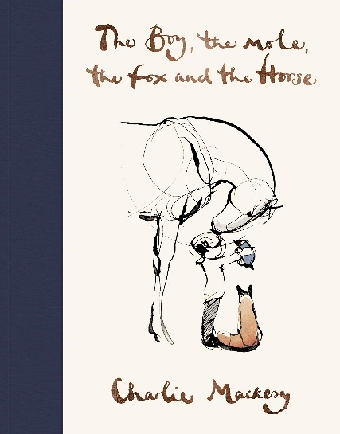
English – World Book Day! (live session – see Dojo)
Today each class will be reading the text, The Boy, the Mole, the Fox and the Horse by Charlie Mackesy to celebrate World Book Day.

Today we are going to be thinking about kindness and being brave which are two important lessons the characters discuss together in the story. Open the ‘World Book Day’ document and answer the questions. It may be a good idea to talk about them with someone in your family first.

Reading
Have a go at Mrs Sandmann’s ‘12 Book Hunt Challenge’. Please use the information sheet/12 book covers uploaded onto the website or find the information on the whole school Dojo page.

Maths – Make patterns with 2D shapes
Watch the video https://vimeo.com/508434253 and complete the worksheet. (If you would like a further challenge, open the challenge sheet and complete questions 7 and 8)

TT Rockstars/Hit the Button/NumBots
Log onto TT Rockstars, NumBots or go onto Hit the Button (https://www.topmarks.co.uk/maths-games/hit-the-button) and play for around 15-20 mins to practise your times tables or number bonds. (To log into NumBots, use your TT Rockstars username and password)

History – The Great Fire of London: Research
This week I would like you to do some research about The Great Fire of London. You could use the internet, books or even ask your family what they know! Write down your research in notes using bullet points or short sentences. There is also a game you can play to learn more about The Great Fire of London - http://www.fireoflondon.org.uk/game/
Friday 5th March
End of the day story/games and catch-up live session – see Dojo
SPaG
Today we are going to be looking at compound words. Follow this BBC Bitesize link and take the quiz https://www.bbc.co.uk/bitesize/topics/zcgv39q/articles/z38t6fr. Can you think of your own compound words? How many syllables does your compound word have – can you clap them out?
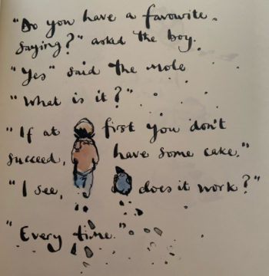
English – Continuing on from World Book Day… (live session – see Dojo)
Following on from World Book Day yesterday, we are again going to be looking at the story The Boy, the Mole, the Fox and the Horse today.

This story is a conversation between the four characters about important life lessons such as kindness, being brave, trusting others etc. Today, we would like you to write your own saying/message that the four characters could say to one another. This could be one of your favourite ones that you know of, or it could be one you have made up yourself!

Then once you have written your saying/message, we would like you to complete your own piece of art in the style of the author Charlie Mackesy. Remember – it must include some of the four characters!!

Reading
Complete the ‘World Book Day Top 5’s’ activity.

Maths – 2D shape hunt
Today I would like you to complete a 2D shape hunt around your house using the worksheet uploaded onto the website. You need to find the 2D shapes listed in the table and create a tally chart (remember a ‘5’ is 4 tally marks with a strikethrough). Keep your eyes peeled as some may be tricky to find!

TT Rockstars/Hit the Button/NumBots
Log onto TT Rockstars, NumBots or go onto Hit the Button (https://www.topmarks.co.uk/maths-games/hit-the-button) and play for around 15-20 mins to practise your times tables or number bonds. (To log into NumBots, use your TT Rockstars username and password)

Art – Design a new outfit for your favourite book character
This week I would like you to design a new outfit for your favourite book character! You can use whichever materials you like, such as pencils, paints, collage materials etc. Try and think about what things this book character needs in the story when designing its new outfit. Make sure you take your time with your drawing and include lots of details!

Music – Timbre: High and low/loud and quiet sounds
Complete the following Music lessons from Oak National Academy - https://classroom.thenational.academy/lessons/high-and-low-sounds-identifying-them-6xhkcr
https://classroom.thenational.academy/lessons/loud-and-quiet-sounds-70uk0c

