Monday 22nd February Inset day
Tuesday 23rd February
SPaG
We are learning a new spelling rule today adding suffixes -ing, -ed, -er, -est and -y to words ending in ‘e’ with consonant before. Open the powerpoint and practise the spellings at the end.

English – Making inferences
This week we are going to be focusing on a book called The Secret of Black Rock by Joe Todd-Stanton. Look at this picture from the story below:
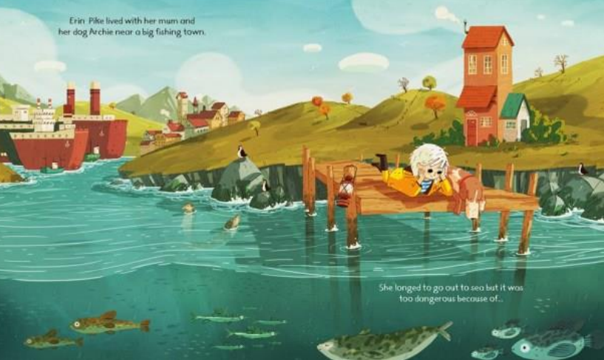

Answer the questions about the picture using the ‘Inference questions’ worksheet.

Reading
Complete the What Plants Need to Grow reading comprehension

Maths – Recognise 2D and 3D shapes
We are now going to be starting a new topic on Shape.
Watch the video https://vimeo.com/506145944 and complete the worksheet. (If you would like a further challenge, open the challenge sheet and complete questions 1 and 2)

TT Rockstars/Hit the Button/NumBots
Log onto TT Rockstars, NumBots or go onto Hit the Button (https://www.topmarks.co.uk/maths-games/hit-the-button) and play for around 15-20 mins to practise your times tables or number bonds. (To log into NumBots, use your TT Rockstars username and password)

Science – Living things and their habitats: living in a suitable habitat (live session – see Dojo)
Watch the BBC clip - https://www.bbc.co.uk/bitesize/clips/zyx76sg and think about these questions: Why do these animals live in these habitats?
How are they suited to these habitats?
What habitat do humans live in? Why do we live in these habitats?
I would like you to choose one animal and one plant. Then, think about how the habitat it lives/grows in is suited to it and how this habitat provides for its basic needs. Use the internet to research some information on each one.
Wednesday 24th February
SPaG
Go onto Spelling Frame (https://spellingframe.co.uk/) and practise rule 14 (adding suffixes -ing, -ed, -er, -est and -y to words ending in ‘e’ with consonant before)

English – Write a persuasive letter (live session – see Dojo)
Watch the video of the story I have posted on Dojo. One day, Erin decides to sneak onto her Mum’s fishing boat and travel out to sea without her knowing, but she has been warned not to go because of the legend of Black Rock.

I would like you to write a letter to Erin persuading her to either: go out to sea and find out if the legend of Black Rock is true OR turn around and go back home safely.

Your letter needs to include ‘Dear Erin’ and ‘From _____’ so it is clear who it is addressed to. You could include some questions for Erin as well as trying to persuade her of your choice. Make sure to include lots of persuasive language in your letter to try and sway Erin’s decision!

Reading
Choose a reading book of your choice/a school book to read for 15-20 mins and record this in your reading record for Buster Book Club.
If you have ran out of things to read at home, you could read/listen to the author of the week on Oak National Academy – https://library.thenational.academy/

Maths – Make 2D and 3D shapes
Watch the video https://vimeo.com/506146009. There is no worksheet today. Instead I would like you to try and make some 2D/3D shapes at home. You could use the suggestions in the video or come up with your own, for example you could use lego, cocktail or lolly sticks and blue tac, create a 3D shape net using paper/card, playdough (I have also put some sheets onto the website if you get stuck for ideas).
Now, can you name your 2D/3D shape? Can you spell it? Can you describe it to someone?

TT Rockstars/Hit the Button/NumBots
Log onto TT Rockstars, NumBots or go onto Hit the Button (https://www.topmarks.co.uk/maths-games/hit-the-button) and play for around 15-20 mins to practise your times tables or number bonds. (To log into NumBots, use your TT Rockstars username and password)

PE
Choose one of the following to complete:
- PE with Joe workout https://www.youtube.com/c/TheBodyCoachTV/videos
- Cosmic Kids yoga https://www.youtube.com/c/CosmicKidsYoga/videos
- PASS live zoom multi-skills lesson 1.30pm-2.15pm
https://zoom.us/j/91302539690?pwd=UlIrSkczektYWDNrbWVlc3FoZytpUT09
Meeting ID: 913 0253 9690
Password: PASSLIVE

PSHE – Jigsaw: Healthy Me – Understanding what is means to be healthy (live session – see Dojo)
This term we are starting our new Jigsaw topic called Healthy Me.
Complete the following activities:
- What does ‘healthy’ mean? I would like you to write down all the ways that we can keep our bodies healthy (try to think of some less obvious ones, like keeping clean, brushing your teeth etc).
- Poor Jigsaw Jo is having some trouble finding the motivation to stay healthy whilst he’s at home! Complete the Help Jigsaw Jo worksheet to give Jo some suggestions.
Thursday 25th February
SPaG
Complete pages 3 and 4 from the Year 2 Common Exception Words Activity Booklet. This will be a useful way to practise the Year 2 words that we need to be able to spell/read by the end of the year.

English – Creating and describing Black Rock (live session – see Dojo)
Black Rock is much more than a rock in the story, and all of the fish and sea creatures protect it. I would like you to re-create a drawing of Black Rock or you could try making it using materials you have at home!

Once you have drawn/created Black Rock, I would like you to make a word bank to describe it. Try and include adjectives, verbs and expanded noun phrases. Once you have created your word bank, use it to write some descriptive sentences about Black Rock. Make sure you also watch the story back on Dojo to help you gather lots of interesting vocabulary.

Reading
Complete the Hedgehogs reading comprehension

Maths – Count sides on 2D shapes
Watch the video https://vimeo.com/506146067 and complete the worksheet. (If you would like a challenge, open the challenge sheet and complete questions 3 and 4)

TT Rockstars/Hit the Button/NumBots
Log onto TT Rockstars, NumBots or go onto Hit the Button (https://www.topmarks.co.uk/maths-games/hit-the-button) and play for around 15-20 mins to practise your times tables or number bonds. (To log into NumBots, use your TT Rockstars username and password)

Geography – History: Understanding the story of The Great Fire of London
This term we are starting a new history topic about The Great Fire of London. Learn about this famous historical event by reading the powerpoint story and then use the sequencing cards to put the events in order.
Friday 26th February
End of the day story/games and catch-up live session – see Dojo
SPaG
Today we are going to be looking at the homophones their, they’re and there (sound the same but are spelt differently and have a different meaning). Look at BBC bitesize, watch the videos and complete the quiz https://www.bbc.co.uk/bitesize/topics/zqhpk2p/articles/z3cxrwx

English – Writing a diary (live session – see Dojo)
Today I would like you to write a diary in role as Erin as she thinks back over her busy day. Erin has snuck out to sea on her Mum’s boat and discovered the secret of Black Rock. She then stopped the fisherman from destroying Black Rock and making sure they all lived together happily.

Your diary should be written in the first person as you are pretending you are Erin (using ‘I’ and ‘we’). It should also be written in the past tense because all these things have already happened to Erin. It should also include lots of punctuation, such as capital letters, full stops, question marks and exclamation marks.

Reading
Complete A Scarecrow’s Job reading comprehension

Maths – Count vertices on 2D shapes
Watch the video https://vimeo.com/506146126 and complete the worksheet. (If you would like a challenge, open the challenge sheet and complete questions 5 and 6)

TT Rockstars/Hit the Button/NumBots
Log onto TT Rockstars, NumBots or go onto Hit the Button (https://www.topmarks.co.uk/maths-games/hit-the-button) and play for around 15-20 mins to practise your times tables or number bonds. (To log into NumBots, use your TT Rockstars username and password)

Art – Drawing: shadows and tone
This week we are going to be focusing on our drawing skills, particularly using shadows and adding tone. Complete the following lesson on Oak National Academy. You will need paper and a pencil –
https://classroom.thenational.academy/lessons/exploring-shadows-and-tone-6hjk0t

Music – Timbre: exploring different ways to use your voice
Complete the following Music lesson from Oak National Academy - https://classroom.thenational.academy/lessons/exploring-different-ways-to-use-your-voice-6wrk8c

