Monday 8th February
SPaG
Last week we learnt the spelling rule for the /l/ sound spelt -le at the end of words after consonants. Complete the wordsearch to practise these spellings.

English – Knowledge grid (live session – see Dojo)
Listen to the rest of the story that I’ve posted on Dojo.
In the story, the Robot meets a Bluebird that changes his life. Today I want you to have a think about what you already know about bluebirds. Complete the knowledge grid below to jot down your ideas and find out what else you would like to know. A template of this knowledge grid is uploaded on the website:

What I know or what I think I know about bluebirds | What I would like to find out | Where can I go to find out this information about bluebirds?

Reading
Complete the All About Africa reading comprehension

Maths – Make tally charts
This week we are starting a new topic on Statistics.
Watch the video https://vimeo.com/501671369 and complete the worksheet.

TT Rockstars/Hit the Button/NumBots
Log onto TT Rockstars, NumBots or go onto Hit the Button (https://www.topmarks.co.uk/maths-games/hit-the-button) and play for around 15-20 mins to practise your times tables or number bonds. (To log into NumBots, use your TT Rockstars username and password)

RE – Islam: Ramadan
This week we are going to be learning about a festival called ‘Ramadan’ that Muslim people take part in for a month each year. Read about Ramadan on this BBC bitesize page https://www.bbc.co.uk/bitesize/topics/zpdtsbk/articles/zjc2bdm and then watch this video https://www.bbc.co.uk/bitesize/clips/zm3b87h.
Complete the activity called ‘Ramadan’ to explain what you have understood about this festival.

Computing – 2Investigate (see pre-recorded video on Dojo)
Open the 2Do called ‘2Investigate Avatar Database’. Then look at the computing question sheet I’ve uploaded onto the Year 2 home learning part of the Lunsford website. Use the database to help you answer the questions about the avatars.
Tuesday 9th February
SPaG
Today we are going to revise the spelling rules that we have learnt this term. Please choose one or two of the spelling rules below, and practise these again using Spelling Frame – it may be a good idea to choose the spelling rules that you’re least confident on (https://spellingframe.co.uk/)
Then once you’ve practised, get someone in your house to test you on some spellings using the spelling rule/s you’ve chosen -
* /j/ sound spelt -ge and -dge at the end of words, and sometimes spelt ‘g’ elsewhere in words before e, i or y (spelling frame rule 1,2,3)
*/s/ sound spelt using ‘c’ before e, i and y. (spelling frame rule 4)
*/n/ sound spelt as kn- and gn- at the beginning of words. (spelling frame rule 5)
*/igh/ sound spelt with -y at the end of words. (spelling frame rule 10)
*/l/ sound spelt with -le at the end of words after consonants (spelling frame rule 7)

English – Research on Bluebirds (live session – see Dojo)
Today I would like you to complete some research on Bluebirds. You can use the ideas you jotted down on your knowledge grid yesterday to help you. Write up your research in notes, this could be as bullet points or short sentences. Below I have also put some websites that you could use to help you get started –
What is a bluebird? What do they look like? https://www.bbc.co.uk/programmes/p011t002
Where can you find bluebirds? What is their diet? What is their habitat? http://animals.nationalgeographic.com/animals/birds/bluebird/
How many species are there? What noises can they make? https://www.virginiabluebirds.org/wp-content/uploads/2013/01/childrensactivitybookfeb1820081.pdf

Reading
Complete The Enormous Turnip reading comprehension.

Maths – Draw pictograms
Watch the video https://vimeo.com/501673699 and complete the worksheet.

TT Rockstars/Hit the Button/NumBots
Log onto TT Rockstars, NumBots or go onto Hit the Button (https://www.topmarks.co.uk/maths-games/hit-the-button) and play for around 15-20 mins to practise your times tables or number bonds. (To log into NumBots, use your TT Rockstars username and password)

Science – Living things and their habitats: world habitats (live session – see Dojo)
This week we are going to be learning about world habitats. Open and read the presentation on world habitats. Choose one of the world habitats and complete some research about it. Try and find out as much information and as many facts as you can, such as: animals living in this habitat, plants that grow there, weather etc.
Then using an animal that lives in this habitat, I want you to think about how it might survive in this environment.
Wednesday 10th February
SPaG
Complete pages 1 and 2 from the Year 2 Common Exception Words Activity Booklet. This will be a useful way to practise the Year 2 words that we need to be able to spell/read by the end of the year. (We will be completing more of this booklet after half term)

English – Information leaflet/poster about bluebirds (live session – see Dojo)
Using the research that you collected yesterday, today I would like you to make an information leaflet or poster that someone could read to learn more about bluebirds. Your leaflet/poster needs to be interesting to look at, so should have lots of pictures. It should also be full of facts/information about bluebirds that is easy to read and organised into sections.

Perhaps you could organise your work into sections such as: appearance, habitat, diet, location (where do they live in the world), interesting/fun facts, size, babies etc.

Reading
Choose a reading book of your choice/a school book to read for 15-20 mins and record this in your reading record for Buster Book Club.
If you have ran out of things to read at home, you could read/listen to the author of the week on Oak National Academy – this week it is Sally Gardner https://library.thenational.academy/

Maths – Interpret pictograms
Watch the video https://vimeo.com/501674074 and complete the worksheet.

TT Rockstars/Hit the Button/NumBots
Log onto TT Rockstars, NumBots or go onto Hit the Button (https://www.topmarks.co.uk/maths-games/hit-the-button) and play for around 15-20 mins to practise your times tables or number bonds. (To log into NumBots, use your TT Rockstars username and password)

Forest School
In school we will be going out for Forest School in the afternoon. You could also complete some similar outdoor activities -
Here are some examples:
- Create a model using sticks, leaves, berries etc.
- Climb a tree with an adult supporting you.
- Make a den
- Try some digging in the mud – can you find any insects?

PSHE – Dreams and Goals: What have I achieved? (live session – see Dojo)
Think back over this term as you have been learning from home and of all the things you have achieved or been successful in doing. This doesn’t have to be just school work, it could be other things you have done whilst at home, such as: learning how to chop vegetables, helping make dinner, laying the table, looking for microhabitats, making a mask etc. Create a mindmap to show all of your achievements.
Thursday 11th February
SPaG
Today we are going to be revising how to turn adjectives into adverbs using -ly at the end of the word. Open the powerpoint and complete the activity called ‘writing sentences using adverbs’.

English – Writing instructions (live session – see Dojo)
Today we are going to be writing instructions on how to make a bird feeder. Firstly, watch this video on how to make a bird feeder in 3 different ways: https://www.youtube.com/watch?v=CW7UYp9kLi0
Once you have watched the video, choose one of the ways to make a bird feeder that you were shown. Then, write a set of instructions on how to make this type of bird feeder.

Instructions are usually numbered and begin with an imperative verb (a ‘bossy’ doing word that tells us what to do, such as: mix, pour, cut, push…). Write each instruction as a sentence, including capital letters and full stops. Don’t forget to include an equipment list so the reader knows what things they will need to make the bird feeder!

Reading
Complete From a Railway Carriage reading comprehension.

Maths – Interpret pictograms (2’s, 5’s and 10’s)
Watch the video https://vimeo.com/504484570 and complete the worksheet.

TT Rockstars/Hit the Button/NumBots
Log onto TT Rockstars, NumBots or go onto Hit the Button (https://www.topmarks.co.uk/maths-games/hit-the-button) and play for around 15-20 mins to practise your times tables or number bonds. (To log into NumBots, use your TT Rockstars username and password)

Geography – Create a willow pattern
This week I would like you to have a go at drawing a willow pattern yourself! Look at pictures of willow patterns to help you re-create one. You can use colouring pencils, felt tips or even try painting your willow pattern. Don’t forget that blue is the main colour! You could even try drawing/colouring your design onto a paper plate/cup so that it looks just like a piece of crockery.
Friday 12th February
End of the day story/games and catch-up live session – see Dojo
SPaG
Before Christmas we learnt the difference between the homophones ‘to’, ‘two’ and ‘too’. See how much you can remember by following this BBC Bitesize link https://www.bbc.co.uk/bitesize/topics/zqhpk2p/articles/zc4jpbk and completing the activities/quiz.

English – Writing a poem (live session – see Dojo)
Look at the two pages below or watch the pages on Dojo:
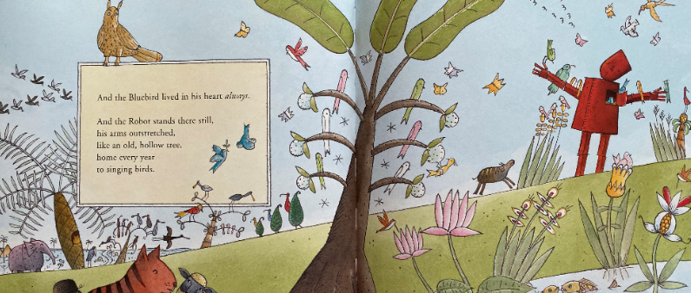
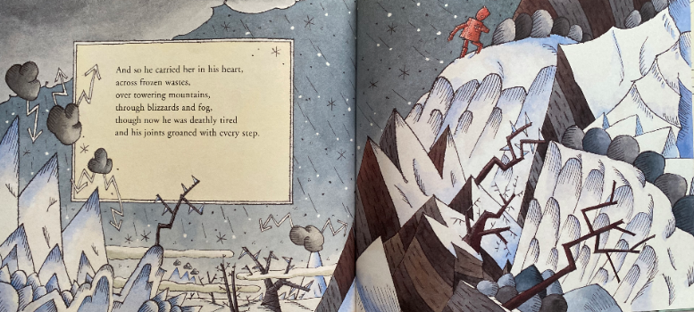
Choose one of these scenes from the story, either the winter or summer. Write a list of adjectives/verbs that you could use to describe the picture.
Then use these adjectives/verbs to make short phrases that you can order into a poem, for example:
Tweeting ‘All around me I can hear joyful tweeting birds that are singing a song’
Dark, gloomy clouds ‘Dark, gloomy clouds are covering the wintery sky’
You could try listening to these soundscapes to help you get some ideas for your poem:
(winter scene: https://www.youtube.com/watch?v=9-tOXQLFyNE )
(summer scene: https://www.youtube.com/watch?v=fliSHqAJZh8 )

Remember, a poem is very descriptive and doesn’t always have to rhyme! A poem is usually made up of lots of short sentences or phrases that link together.

Reading
Design a new front cover and blurb for your favourite book using the ‘Illustrator of the Year’ template.

Maths – Block diagrams
Watch the video https://vimeo.com/504485413 and complete the worksheet.

TT Rockstars/Hit the Button/NumBots
Log onto TT Rockstars, NumBots or go onto Hit the Button (https://www.topmarks.co.uk/maths-games/hit-the-button) and play for around 15-20 mins to practise your times tables or number bonds. (To log into NumBots, use your TT Rockstars username and password)

Art – Chinese masks
This week I would like you to create your Chinese masks using your design that you made previously. Your mask needs to be created using the collage technique, where you layer different materials on top of each other. You could use any material you have at home, such as magazines, newspaper, card, tin foil, material scraps etc. I have put the original mask template on the Lunsford website should you need it.

Music – Understanding pulse: physicalising pulse in different ways/maintaining pulse and finding the strong beats
Complete the following Oak National Academy lessons –
https://classroom.thenational.academy/lessons/physicalising-pulse-in-different-ways-crt62t
https://classroom.thenational.academy/lessons/maintaining-pulse-and-finding-the-strong-beats-cdhp4d

