Monday 1st February
SPaG
Last week we learnt the spelling rule for the /igh/ sound spelt as ‘-y’ at the end of words. Practise the spelling rule using the handwriting activity. Make sure that the tail of your ‘y’ goes under the line!

English – Responding to an illustration (Live session – See Dojo)
We are now going to start a new text called ‘The Robot and the Bluebird’ by David Lucas. Look at the page below:
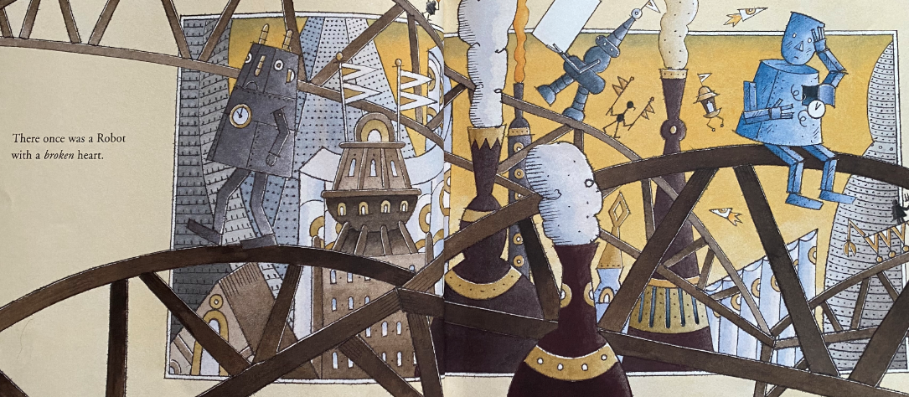
Who is the main character and how do you know? What is different about the character? What does it mean to have a ‘broken heart’? Once you have thought about these things, complete the ‘questions grid’ sheet to explain all of your ideas and what the story could be about.

Reading
Complete the How to Make a Pirate Stew comprehension.

Maths – Find the Total
Watch the video https://vimeo.com/479815623 and complete the worksheet. Please be aware that we do not use the formal method of addition/subtraction (column method) until the end of Year 2/Year 3.
Instead we write out the calculation in parts, for example:

34 + 25 = 59

30 + 20 = 50 (add the tens together)
4 + 5 = 9 (now add the ones together)
So, 50 + 9 = 59 (add together the tens/ones to get final answer)

Or, we use a number line, for example:
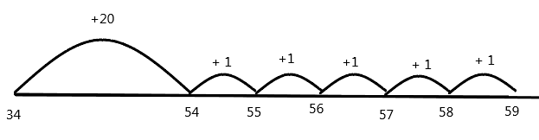
34 + 25 = 59

TT Rockstars/Hit the Button/NumBots
Log onto TT Rockstars, NumBots or go onto Hit the Button (https://www.topmarks.co.uk/maths-games/hit-the-button) and play for around 15-20 mins to practise your times tables or number bonds.

RE – Islam: Worship in a Mosque
Following on from Mosques last week, this week we will understand the different parts of a Mosque and how this is used for worship. Watch this tour of a Mosque: https://www.youtube.com/watch?v=GWi7plHFJI8 and then using the PowerPoint, complete the activity sheet called ‘Places of worship: Mosque’.

Computing – Using 2Question (see pre-recorded video on Dojo)
This week we are going to be thinking about how questions can lead us to an answer. Open one of the ‘2Question’ activities on your 2Do list on Purple Mash. There should be a minibeast or dinosaur option. Depending on which you choose, you need to think of a type of minibeast or dinosaur in your head. The program will then ask you questions to try and guess what you’ve chosen.

Tuesday 2nd February
SPaG
Today we are learning about apostrophes again, but today using them to show possession. Read the powerpoint and then complete the assessment activity.

English – Role on the wall (Live session – See Dojo)
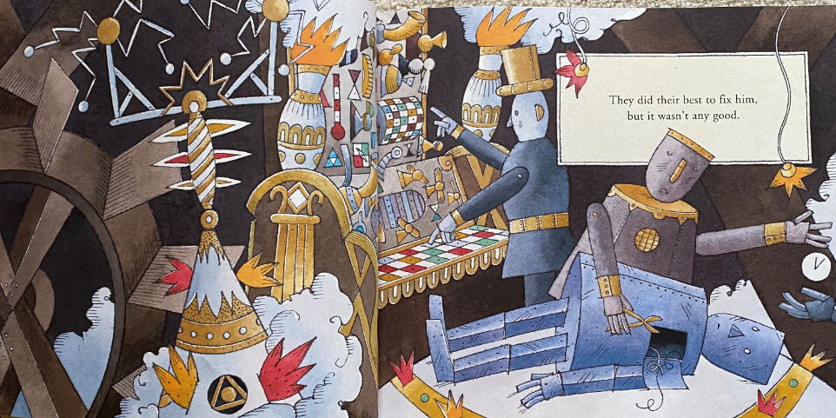
Listen to the pages of the story that I have posted on Dojo this week. Now look at this page below:

What is happening here? How many robots can you see? Thinking about robots, what do we know about them? What jobs are they programmed to do? How is this main character who is a robot different to a usual robot?

Today we are going to make a role on the wall. Open the ‘robot role on the wall’ template. On the inside of the robot, write adjectives/phrases that describe how the main robot is feeling/thinking. In the outside space around the robot, write adjectives/phrases that describe what the robot’s appearance is like.

Reading
Complete the Minibeasts comprehension.

Maths – Find the difference
Watch the video https://vimeo.com/479816379 and complete the worksheet.

TT Rockstars/Hit the Button/NumBots
Log onto TT Rockstars, NumBots or go onto Hit the Button (https://www.topmarks.co.uk/maths-games/hit-the-button) and play for around 15-20 mins to practise your times tables or number bonds.

Science – Living things and their habitats: Microhabitats
Following on from our learning on Microhabitats last week, this week I would like you to complete a description of one. Using the ‘Microhabitat description’ sheet, I would like you to explain 2 microhabitats you have found. These could be ones that you found last week or you could go back out and find 2 new microhabitats!
Wednesday 3rd February
SPaG
Today we are learning a new spelling rule - /l/ sound spelt with ‘le’ at the end of words after consonants. Open the powerpoint and learn the spellings at the end.

English – Writing in role as the Robot (Live session – See Dojo)
Following on from the role on the wall we made yesterday to describe the robot character, today we are going to be writing in role as the robot. Look at the same page again and this time listen to this soundscape of a factory at the same time: https://www.youtube.com/watch?v=-Ih0JJLoMIg&list=RD-Ih0JJLoMIg#t=19.

Today I would like you to write in role as the main robot. How may the robot be feeling at this moment? What do you think he is thinking about? If he was able to speak, what may he say here? Remember, as you are in role as the robot, you need to write in the first person tense using ‘I’ or ‘we’.

Reading
Choose a reading book of your choice/a school book to read for 15-20 mins and record this in your reading record for Buster Book Club.
If you have ran out of things to read at home, you could read/listen to the author of the week on Oak National Academy – this week it is Nizrana Farook https://library.thenational.academy/

Maths – Find change
Watch the video https://vimeo.com/479816820 and complete the worksheet.

TT Rockstars/Hit the Button/NumBots
Log onto TT Rockstars, NumBots or go onto Hit the Button (https://www.topmarks.co.uk/maths-games/hit-the-button) and play for around 15-20 mins to practise your times tables or number bonds.

PE
Choose one of the following to complete:
- PE with Joe workout https://www.youtube.com/c/TheBodyCoachTV/videos
- Cosmic Kids yoga https://www.youtube.com/c/CosmicKidsYoga/videos
- PASS live zoom multi-skills lesson 1.30pm-2.15pm
https://zoom.us/j/91302539690?pwd=UlIrSkczektYWDNrbWVlc3FoZytpUT09
Meeting ID: 913 0253 9690
Password: PASSLIVE

PSHE – Children’s Mental Health Week activities (Live session – See Dojo)
Masks have been used throughout history to show different feelings and emotions. Have a look at the following BBC link https://www.bbc.co.uk/teach/class-clips-video/design-and-technology-ks1-ks2-making-masks/z7p4382.
Create or design your own mask that expresses who you are or how you are feeling. If you don’t want to make a mask, you can design one using the ‘mask template’.

Thursday 4th February (Dress to Express Day)
SPaG
Go onto Spelling Frame https://spellingframe.co.uk/ click on Year 2 and complete spelling rule 7 (/l/ sound spelt ‘-le’ at the end of words)

English – Forming questions (Live session – See Dojo)
Listen back to the pages from the story that I’ve posted on Dojo this week. Look at the pages of the robot on the scrapheap and left outside in all the types of weather.

In role as the robot again, I would like you to write a list of questions that the robot may be thinking or want to ask to someone if he could. What is he thinking about? What could his worries be? For example, ‘How long will I be here for?’ or ‘Why have I been sent to this place?’. Don’t forget, questions must end with a question mark.

Reading
Complete The Little Red Hen comprehension

Maths – Two step problems
Watch the video https://vimeo.com/479817217 and complete the worksheet.

TT Rockstars/Hit the Button
Log onto TT Rockstars or go onto Hit the Button (https://www.topmarks.co.uk/maths-games/hit-the-button) and play for around 15-20 mins to practise your times tables or number bonds.

Geography/Art – Willow patterns (Live session – See Dojo)
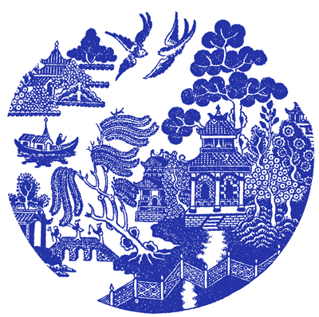
Willow patterns are very popular patterns found on crockery and the design comes from China! Open and read the story of the willow pattern (you may need an adult to help you with some of the words) and then research willow patterns.

Friday 5th February
End of the day story/games and catch-up live session – see Dojo
SPaG
Go onto BBC Bitesize and complete the activities/quiz on tenses: https://www.bbc.co.uk/bitesize/topics/zrqqtfr/articles/z3dbg82. Then complete the ‘tenses sorting activity’.

English – Describing a setting (Live session – See Dojo)
Today we are going to be looking at the pictures from the story so far. There are lots of different places that we see the robot in, from factories to scrapheaps. I would like you to choose one of these pictures and describe the setting that the robot is in. It may be a good idea to make a word bank of adjectives and verbs before you begin writing as this will help you form ideas. Look at my example below:

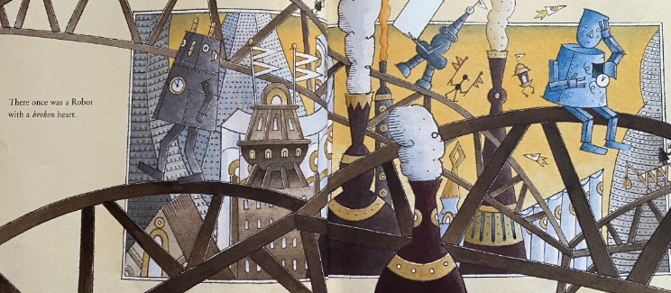
This metal city is filled with towering skyscraper towers and winding, metal tracks. In the distance you can see fiery rockets zooming through the glowing, yellow sky. Tall chimneys are making a ‘puff’ ‘puff’ ‘puff’ sound and blowing thick grey steam into the air around you. Metal programmed robots of all shapes and sizes are creaking and spluttering to complete their tasks…..

Reading
Open a reading book of your choice, and make a list of all the adjectives, verbs and nouns you can find. (Look at this BBC bitesize link for information on adjectives, verbs and nouns: https://www.bbc.co.uk/bitesize/topics/zrqqtfr)

Maths – Money assessment
We’ve now come to the end of our Money topic. To see how much you’ve learnt, please complete the mini assessment.

TT Rockstars/Hit the Button
Log onto TT Rockstars or go onto Hit the Button (https://www.topmarks.co.uk/maths-games/hit-the-button) and play for around 15-20 mins to practise your times tables or number bonds.

Music – Understanding pulse: creating simple patterns/understanding how sound is represented by symbols
Complete the Oak Learning Academy lessons called ‘Creating Simple Patterns’
https://classroom.thenational.academy/lessons/creating-simple-patterns-6rwk8d
and ‘Understanding how sound is represented by symbols’ https://classroom.thenational.academy/lessons/understanding-how-sound-is-represented-by-symbols-64w62

