Monday 25th January
SPaG
Last week we learnt the spelling rule for the /n/ sound spelt as ‘kn’ and ‘gn’ at the beginning of words. Practise this rule by completing the wordsearch.

English – Sequencing the story of Traction Man is Here (live session – see Dojo)
Watch the new video of the story that I have posted on Dojo. This is the final part of the story.
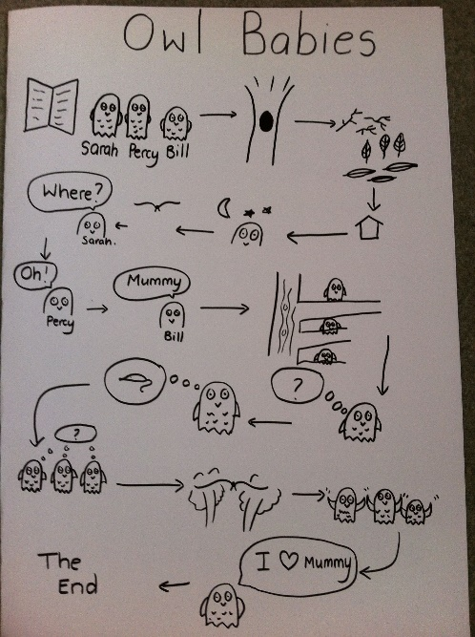
Today I would like you to make a storymap to put all the events of the story in order. Your storymap needs to be simple pictures with an arrow to the next event in the story. Try and focus on the key parts and characters. Once you’ve completed your drawings, annotate the storymap with speech/thought bubbles for the characters and keywords to describe each picture.
(see example of a storymap )

Once your storymap is completed, practise retelling the story to someone else in your own words.

Reading
Complete the Turning Milk into Cheese comprehension.

Maths – Count money: pounds
Watch the video https://vimeo.com/471307411 and complete the worksheet

TT Rockstars/Hit the Button
Log onto TT Rockstars or go onto Hit the Button (https://www.topmarks.co.uk/maths-games/hit-the-button) and play for around 15-20 mins to practise your times tables or number bonds.

RE – Islam: Mosques
This week we are learning about Mosques which are holy buildings for Muslims. Here they can go to pray, worship and learn more about Allah (the name of God in Islam).
Watch the following BBC clip: https://www.bbc.co.uk/teach/class-clips-video/religious-education-ks2-my-life-my-religion-east-london-mosque/zmctvk7. Then write some facts you have learnt about Mosques and why Muslim people visit them. You could then try and draw a picture of a Mosque.

Computing – Making a pictogram (watch pre-recorded video on Dojo beforehand)
Over the new few weeks we will be learning about questioning.
This week we are going to make a pictogram. A pictogram is type of chart that uses pictures to represent data. Log into Purple Mash and open the 2Do called ‘2Count’.
Ask people in your house some questions about a topic, for example ‘What is your favourite type of fruit?’. You will need to give them some options to choose from.
You then need to show me this information as a pictogram using 2Count. You can change the topic by clicking on one of the pictures. Give your pictogram a title once you are finished to explain what your data shows.
Make sure you then save your work to your work folder.

Tuesday 26th January
SPaG
Today we are learning about apostrophes to mark where letters are missing in words. These are called contractions. Read through the powerpoint and complete the contractions activity sheet.

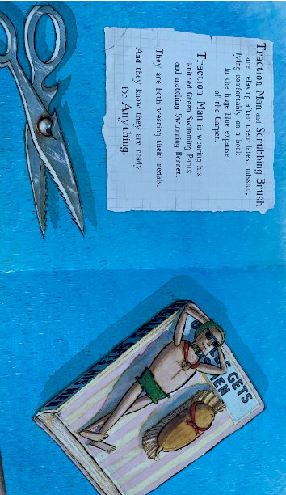
English – Creating a sequel to the story (live session – see Dojo)
Look at the final page of the story:

I would like you to predict what will happen next as the scissor shark approaches Traction Man and Scrubbing Brush. Then, I would like you to give this character a name i.e. ‘Scissor Shark of Doom’.

Today we are going to plan a sequel to Traction Man is Here based on his new battle against the scissors.

Open the ‘storyboard planning’ document and in the larger boxes draw out what happens on the new adventure against the scissors. Remember, in most of Traction Man’s adventures he meets the villain, defeats them and saves the person who was kidnapped. On the lines underneath, write a short sentence to explain what is happening in each part of Traction Man’s new adventure.

Reading
Complete the Rumpelstiltskin comprehension.

Maths – Count money: notes and coins
Watch the video https://vimeo.com/471307831 and complete the worksheet.

TT Rockstars/Hit the Button
Log onto TT Rockstars or go onto Hit the Button (https://www.topmarks.co.uk/maths-games/hit-the-button) and play for around 15-20 mins to practise your times tables or number bonds.

Science – Living things and their habitats: Microhabitats (live session – see Dojo)
Read the powerpoint on ‘Microhabitats’. Then go outside into your garden or local area on your daily walk and see if you can find any microhabitats. Did you manage to spot any minibeasts living there? If so, count up how many you saw and what they were.
Wednesday 27th January
SPaG
Today we are learning a new spelling rule - /igh/ sound spelt with ‘-y’ at the end of words. Open the powerpoint and learn the spellings at the end.
English – Writing the sequel story (live session – see Dojo)
Across today and tomorrow, I would like you to write out your sequel story to Traction Man is Here based on the storyboard plan you completed yesterday.

Remember a good story has a clear structure of a beginning, middle and end. As I said, in most of Traction Man’s adventures he meets the villain, defeats them and saves the person who was kidnapped.

In your sequel story, try and include lots of expanded noun phrases to describe what is happening/to describe the characters (made up of an adjective and a noun as we did previously – deep, blue sea). You may also be able to use some interesting sentence openers/phrases from the story or make up your own such as, “Oh no!”, “Traction Man is back for a new mission”, “Traction Man and Scrubbing Brush are…”. By adding these things to your stories, it will help you write in a similar style to the original story!

It may be a good idea to write the beginning/start of the middle section today, and leave the other part of the middle/ending for tomorrow.

Reading
Choose a reading book of your choice/a school book to read for 15-20 mins and record this in your reading record for Buster Book Club.
If you have ran out of things to read at home, you could read/listen to the author of the week on Oak National Academy – this week is Jacqueline Wilson (one of my favourite authors when I was younger!) https://library.thenational.academy/

Maths – Select money
Watch the video https://vimeo.com/473051856 and complete the worksheet.

TT Rockstars/Hit the Button
Log onto TT Rockstars or go onto Hit the Button (https://www.topmarks.co.uk/maths-games/hit-the-button) and play for around 15-20 mins to practise your times tables or number bonds.

PE
Choose one of the following to complete:
- PE with Joe workout https://www.youtube.com/c/TheBodyCoachTV/videos
- Cosmic Kids yoga https://www.youtube.com/c/CosmicKidsYoga/videos
- PASS live zoom multi-skills lesson 1.30pm-2.15pm
https://zoom.us/j/91302539690?pwd=UlIrSkczektYWDNrbWVlc3FoZytpUT09
Meeting ID: 913 0253 9690
Password: PASSLIVE

PSHE – Jigsaw: Dreams and Goals – My learning strengths
Think of a learning goal that you want to achieve by the end of Year 2.

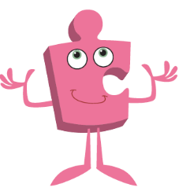
On the ‘ladder template’ document, think about the steps you will need to take to achieve this goal, and write them onto the steps of the ladder. Can you then colour in the step that you think will be the most challenging? In Jigsaw Jo’s speech bubble, write a message that he could give you to persevere with the most challenging step.

Thursday 28th January
SPaG
Go onto Spelling Frame https://spellingframe.co.uk/ click on Year 2 and complete spelling rule 10 (/igh/ sound spelt as ‘-y’ at the end of words).

English – Writing the sequel story (live session – see Dojo)
Today you are continuing to write your sequel story that you began yesterday. Don’t forget to use your storyboard plan to help you with your structure. Also try to include lots of expanded noun phrases and interesting sentence openers so that your sequel sounds similar to the original story!

Once you have finished writing up your sequel story, make sure you read it aloud so that it makes sense. When doing this, you may spot some things that need editing or correcting (we usually use a purple pen to do this in school, but you could use any colour).
Then, draw an illustration to go with your sequel of the adventure. In Traction Man is Here, the author drew the illustrations to look like a comic book, using lots of different shaped boxes and speech bubbles for characters. Perhaps you could do something similar?

Reading
Complete the Mr Snuggles gets Lost comprehension.

Maths – Make the same amount
Watch the video https://vimeo.com/471402395 and complete the worksheet.

TT Rockstars/Hit the Button
Log onto TT Rockstars or go onto Hit the Button (https://www.topmarks.co.uk/maths-games/hit-the-button) and play for around 15-20 mins to practise your times tables or number bonds.

Geography – Comparing London and Beijing (capital cities) (live session – see Dojo)
This week I would like you find similarities and differences between London (capital city of England) and Beijing (capital city of China). Look at the ‘sorting cards’ document to help you.
Create a table with the headings ‘similarities’ and ‘differences’ and write down your ideas.
Friday 29th January
End of the day story/games and catch-up live session – see Dojo
SPaG
Go onto BBC Bitesize and complete the activity on using commas in a list: https://www.bbc.co.uk/bitesize/topics/z8x6cj6/articles/zxvcrdm. Then practise writing your own sentences using commas in a list:

English – Book review (live session – see Dojo)
We have now finished the story Traction Man is Here!

Today I would like you to write a book review of the story. Use the following to help you structure your book review:
- Who are the main characters?
- Where do the adventures take place?
- What did you like about the story - what was your favourite part and why?
- What do you find interesting about the illustrations? How is this different to other picture books you have read before?
- Is there anything you did not enjoy about the story and why?
- Who would you recommend the story to and why?
Reading
Research the author of one of your favourite books. You could find out where they live, what other books they’ve written, why they became an author or where they get their ideas from!

Maths – Compare money
Watch the video https://vimeo.com/479814464 and complete the worksheet.

TT Rockstars/Hit the Button
Log onto TT Rockstars or go onto Hit the Button (https://www.topmarks.co.uk/maths-games/hit-the-button) and play for around 15-20 mins to practise your times tables or number bonds.

Art – Chinese masks
Following on from our research into collage and Chinese masks, this week I would like you to design your own Chinese mask using the ‘mask template’ document. Make sure your mask is based on Chinese culture, so the colours, patterns and symbols should be similar.

Once you’ve completed your design, label your mask with the materials you are going to need i.e. glue, scissors, magazine (chopped into pieces, colouring pens etc.
Next week we will be making our masks using collage.

Music – Rhythm, vocal and body sounds
Follow this link to BBC Bitesize https://www.bbc.co.uk/bitesize/topics/zk86qfr/articles/zqtm8hv and complete the activities to do with syllables and sound.

