1. 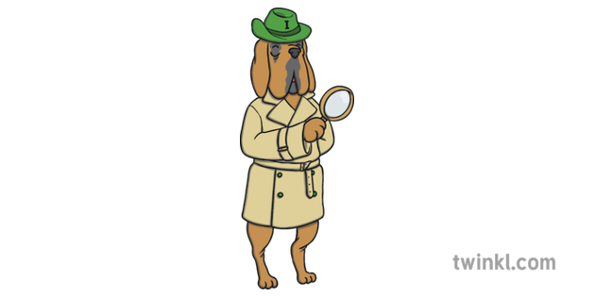Do you think Traction Man comes to life in the story or do you think this is in the little boy’s imagination as he plays with his Traction Man action figure?
2. Where is Traction Man having his adventures? How do you know?
3. What type of pet is Scrubbing Brush meant to be?
4. Traction Man goes on an adventure at the bottom of the bath where he meets the Mysterious Toes. Who’s toes do you think they are?

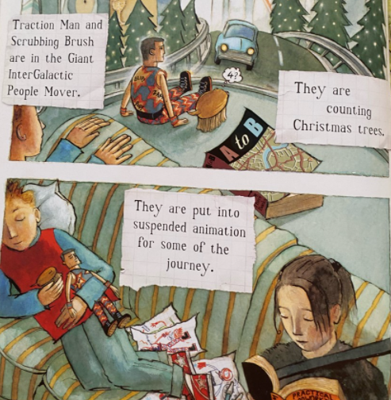

1. Look at this page.
   1. What do you think an ‘InterGalactic People Mover’ is meant to be?
   2. The boys are put into ‘suspended animation’ for the journey – what do you think this means?
2. Why do you think the story says Traction Man’s new green romper suit from Granny is a ‘perfect fit’ when the picture shows us it actually isn’t?

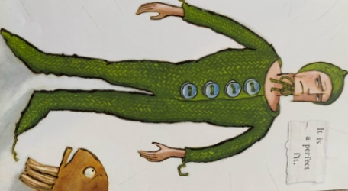

1. Look at the page below.

Cupcake and Doctor Sock are laughing at Traction Man.

* 1. 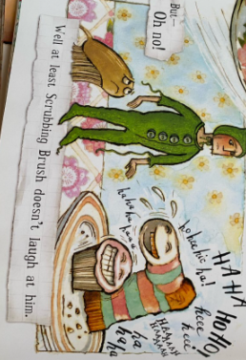Why do you think this is?
  2. How do you think Traction Man and Scrubbing Brush are feeling here?