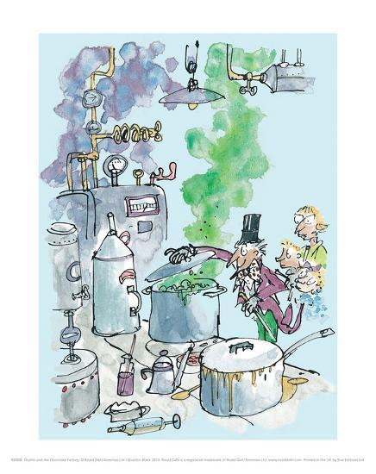Charlie Bucket stared around the gigantic room in which he now found himself. The place was like a witch’s kitchen! All about him black metal pots were boiling and bubbling on huge stoves, and kettles were hissing and pans were sizzling, and strange iron machines were clanking and spluttering, and there were pipes running all over the ceiling and walls, and the whole place was filled with smoke and steam and delicious rich smells. Mr Wonka himself had suddenly become even more excited than usual, and anyone could see that this was the room he loved best of all. He was hopping about among the saucepans and the machines like a child among his Christmas presents, not knowing which thing to look at first. He lifted the lid from a huge pot and took a sniff; then he rushed over and dipped a finger into a barrel of sticky yellow stuff and had a taste; then he skipped across to one of the machines and turned half a dozen knobs this way and that; then he peered anxiously through the glass door of a gigantic oven, rubbing his hands and cackling with delight at what he saw inside. Then he ran over to another machine, a small shiny affair that kept going phut-phut-phut-phut-phut, and every time it went phut, a large green marble dropped out of it into a basket on the floor.

1. How does the author Roald Dahl describe the smell in the room?
2. How did Charlie feel when he was looking around the room?
3. Which verbs tell you the machines were noisy?
4. What did Mr Wonka put his finger into?
5. How would you feel walking into that room? Explain your answer.
6. Why do you think Mr Wonka was ‘*rubbing his hands and cackling with delight at what he saw inside’*?