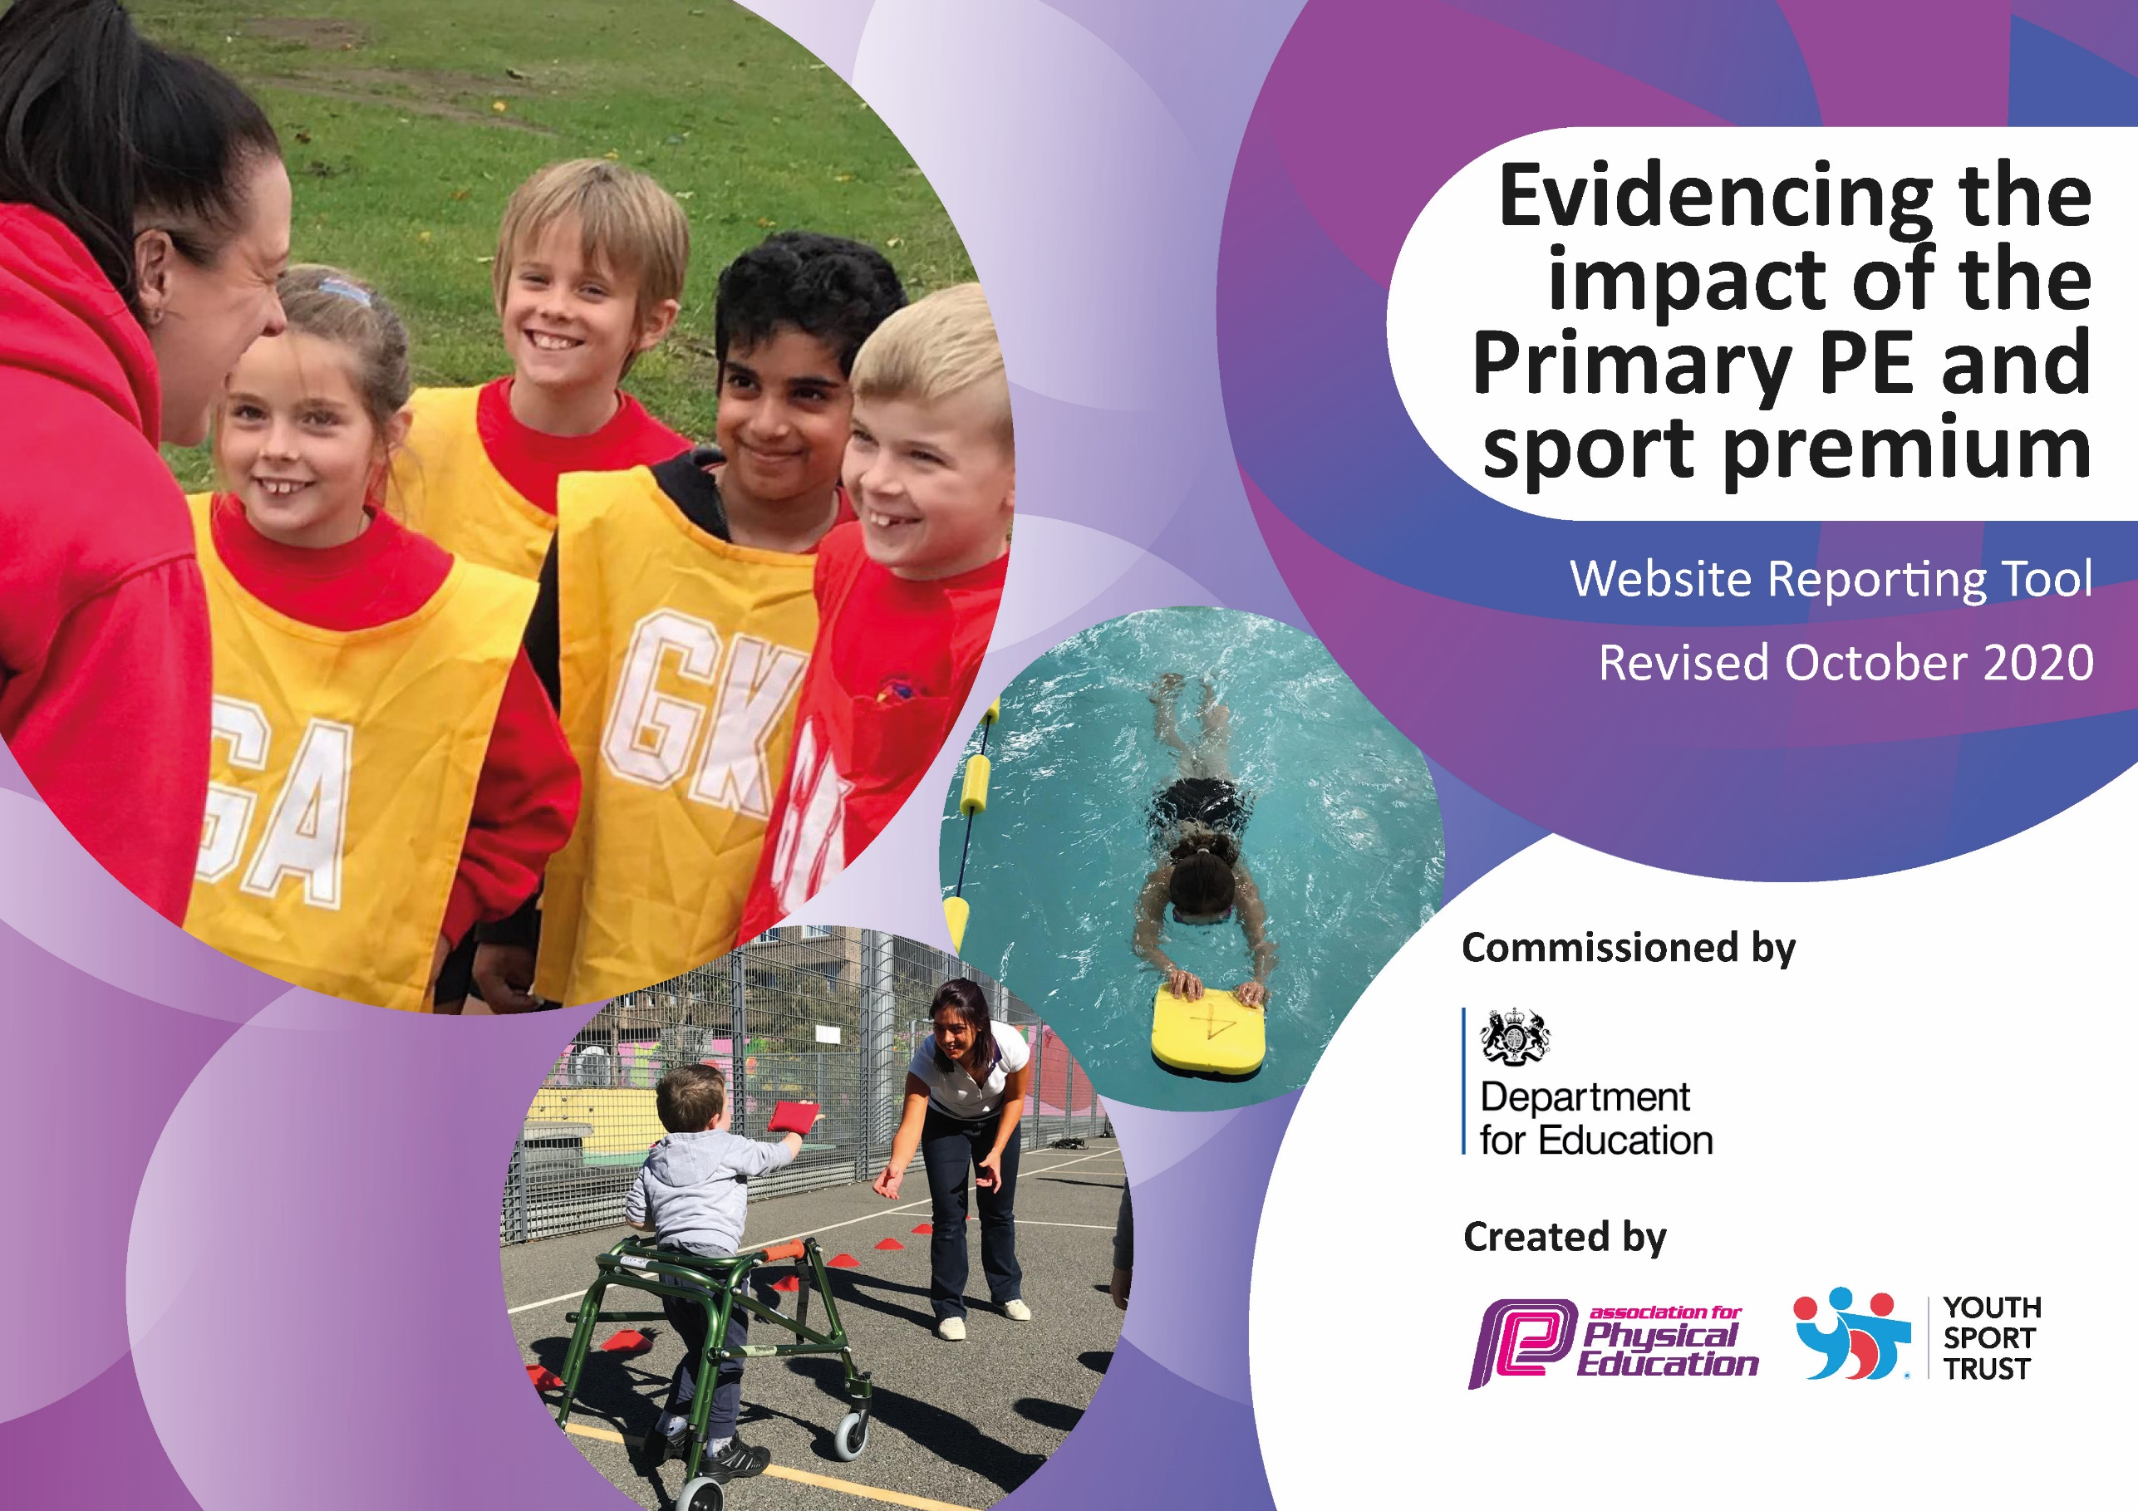

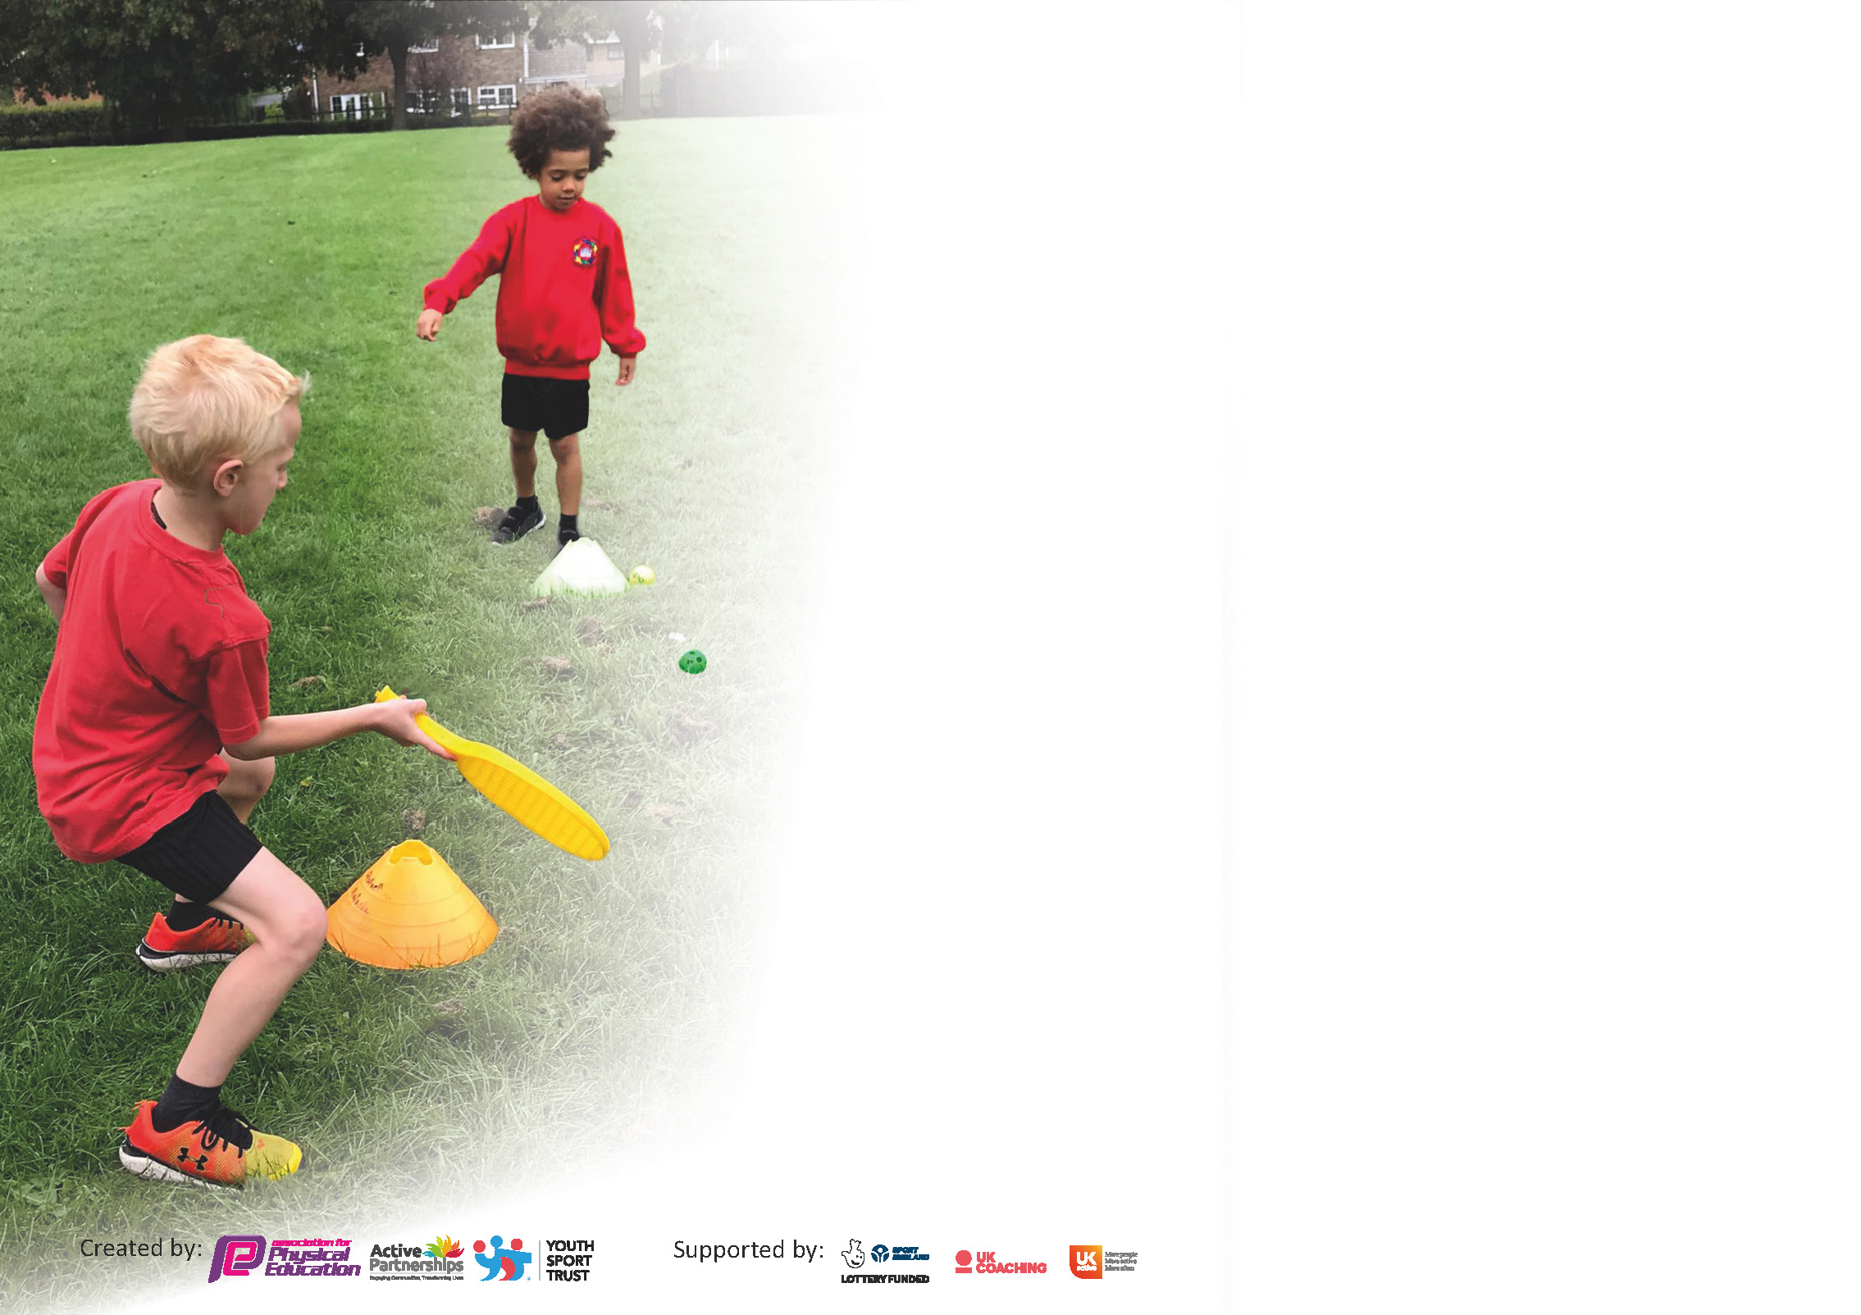

It is important that your grant is used effectively and based on school need. The Education Inspection Framework (Ofsted 2019 p64) makes clear there will be a focus on **‘whether leaders and those responsible for governors all understand their respective roles and perform these in a way that enhances the effectiveness of the school’**.

Under the Quality of Education criteria (p41) inspectors consider the extent to which schools can articulate their curriculum (INTENT), construct their curriculum (IMPLEMENTATION) and demonstrate the outcomes which result (IMPACT).

To assist schools with common transferable language this template has been developed to utilise the same three headings which should make your plans easily transferable between working documents.

Schools must use the funding to make **additional and sustainable** improvements to the quality of Physical Education, School Sport and Physical Activity (PESSPA) they offer. This means that you should use

the Primary PE and sport premium to:

* Develop or add to the PESSPA activities that your school already offer
* Build capacity and capability within the school to ensure that improvements made now will benefit pupils joining the school in future years

Please visit gov.uk for the revised DfE guidance including the 5 key indicators across which schools should demonstrate an improvement. This document will help you to review your

provision and to report your spend. DfE encourages schools to use this template as an effective way of meeting the reporting requirements of the Primary PE and sport premium.

We recommend you start by reflecting on the impact of current provision and reviewing the previous spend.

Schools are required to publish details of how they spend this funding as well as on the impact it has on pupils’ PE and sport participation and attainment by the end of the summer term or by **31st July 2021** at the latest.

# ** In the case of any under-spend from 2019/20 which has been carried over this must be used and published by 31st March 2021.

We recommend regularly updating the table and publishing it on your website throughout the year. This evidences your ongoing self-evaluation of how you are using the funding to secure maximum, sustainable impact. Final copy must

be posted on your website by the end of the academic year and no later than the 31st July 2021. To see an example of how to complete the table please click HERE.

Created by: Supported by:

Please note: Although there has been considerable disruption in 2020 it is important that you publish details on your website of how you spend the funding - this is a legal requirement.

Support for review and reflection - considering the 5 key indicators from DfE, what development needs are a priority for your setting and your pupils now and why? Use the space below to reflect on previous spend and key achievements and areas for development.

N.B. In this section you should refer to any adjustments you might have made due to Covid-19 and how these will influence further improvement.

|  |  |
| --- | --- |
| Key achievements to date until July 2020: | Areas for further improvement and baseline evidence of need: |
| * Bronze Sports Award 2015-2016 * Silver Sports Mark Award 2016-2017 * Silver Sports Mark Award 2017-2018   . Gold School Games Mark award (2018-19)   * Increase in number of KS1 clubs available to pupils * Increase in number of KS2 clubs available to pupils * Year on year increase in number of pupils participating in school clubs from April 2016 * Introduction of new after school clubs for different sports – ie Tri Golf, Hockey * Introduction of Balancability for Reception Class in Summer Term 2018 * Increase in staff confidence, knowledge and skills of all staff teaching PE * Introduction of Forest School for whole school * Increased participation in school sports competitions and festivals * Review of sporting curriculum throughout the school   The profile of PE and sport is raised across the school as a tool for whole school improvement  Sport continues to have a very high profile throughout the school and is celebrated on a weekly basis.  Taster sessions for Forest Schools were run for all children throughout the school by an external Forest School Leader in January 2018 – Forest Schools now forms part of the curriculum for all children in the school and is run by Rachel Murray.  .Introduction of Balance Ability course, teaching all year R pupils to ride push bikes safely and effectively.  .Upskilling of all teaching staff in PE since introduction of Sports Premium funding  . Increased number of extracurricular opportunities | . Introduction of play leaders and more comprehensive School Sports Organising Committee (Representatives from each class)  . Audit and replace PE equipment in line with Head, Heart and Hands scheme of work updates |

Did you carry forward an underspend from 2019-20 academic year into the current academic year? YES/NO * Delete as applicable

# If YES you must complete the following section

**If NO, the following section is not applicable to you**

|  |  |
| --- | --- |
| Meeting national curriculum requirements for swimming and water safety.  N.B Complete this section to your best ability. For example you might have practised safe self-rescue techniques on dry land. |  |
| What percentage of your current Year 6 cohort swim competently, confidently and proficiently over a distance of at least 25 metres?  **N.B.** Even though your pupils may swim in another year please report on their attainment on leaving primary school at the end of the summer term 2021. | % |
| What percentage of your current Year 6 cohort use a range of strokes effectively [for example, front crawl, backstroke and breaststroke]? | % |
| What percentage of your current Year 6 cohort perform safe self-rescue in different water-based situations? | % |
| Schools can choose to use the Primary PE and sport premium to provide additional provision for swimming but this must be for activity **over and above** the national curriculum requirements. Have you used it in this way? | Yes/No |

**Action Plan and Budget Tracking**

Capture your intended annual spend against the 5 key indicators. Clarify the success criteria and evidence of impact that you intend to measure to evaluate for pupils today and for the future.

|  |  |  |  |  |
| --- | --- | --- | --- | --- |
| **Academic Year:** 2020/21 | **Total fund allocated:** £ | **Date Updated:** | |  |
| **Key indicator 1:** The engagement of all pupils in regular physical activity – Chief Medical Officers guidelines recommend that primary school pupils undertake at least 30 minutes of physical activity a day in school | | | | Percentage of total allocation: |
| % |
| **Intent** | **Implementation** | | **Impact** |  |
| Your school focus should be clear what you want the pupils to know and be able to do and about  what they need to learn and to  consolidate through practice: | Make sure your actions to achieve are linked to your intentions: | Funding allocated: | Evidence of impact: what do pupils now know and what can they now do? What has changed?: | Sustainability and suggested next steps: |
| To ensure class teachers are using PASS Ltd. schemes of work inline with the PE curriculum map to ensure engagement and progression within PE lessons.  To train playground leaders and staff to oversee break/lunch time sessions  To increase opportunities for children to become involved in extra curricular activity as well as intra/inter school competitions and personal challenges.  Home learning- Children who are unable to attend school will still be able to access 30mins of PE a day from home | Created and circulated a long term curriculum plan, inline with season sports and local competitions. Teachers have 2 topics a term to choose from and receive support in the other.  Year 6 children will be trained to lead and run playground sessions for younger children in the school. They will then train the next cohort of play leaders.  Review and additions to extra curricular mapping. Engagement in the personal challenge competitions and intra school events.  Children had access to 8 pre-recorded lesson per week that could be accessed from home or school. |  | Teachers follow schemes that ensure progression across years in school and provide differentiated opportunities for all children to become physically active.  Higher standards of PE delivery due to improved lesson content and teacher training.  Opportunities to address/improve physical and mental wellbeing within  Due to schools closing in Term 4, many plans/events were put on hold for the year 20/21. | . Target mental wellbeing days  . Ongoing training in using PASS schemes of work in new activity areas.  Year 6 children train year 5 children to continue play leaders in future . |
| **Key indicator 2:** The profile of PESSPA being raised across the school as a tool for whole school improvement | | | | Percentage of total allocation: |
| % |
| **Intent** | **Implementation** | | **Impact** |  |
| Your school focus should be clear what you want the pupils to know and be able to do and about  what they need to learn and to  consolidate through practice: | Make sure your actions to achieve are linked to your intentions: | Funding allocated: | Evidence of impact: what do pupils now know and what can they now do? What has changed?: | Sustainability and suggested next steps: |
| Updated the PE notice board to include clubs/fixtures/results/sporting successes.  Include sporting news in school media e.g newsletters and website  Use the Dojo system to praise and award success in PE  Sports award to be issued in celebration assembly | Updates in Term 2,4  Ensuring PE news is sent to head teacher/office to be included in school media.    Teachers to increasing use Dojo systems on IPAD during indoor and outdoor PE  Head teacher made aware of sports achievements and awards. |  | Children able to identify clubs to join via school sports notice board  Increased awareness of PE and sport within school  Children striving for improvement in lessons to achieve Dojo points  Points given for effort in PE and not only sporting success.  Improved profile of PE and sport | Ensure notice boards remain up to date.  Continue to use Dojo system in PE |

|  |  |  |  |  |
| --- | --- | --- | --- | --- |
| **Key indicator 3:** Increased confidence, knowledge and skills of all staff in teaching PE and sport | | | | Percentage of total allocation: |
| % |
| **Intent** | **Implementation** | | **Impact** |  |
| Your school focus should be clear | Make sure your actions to | Funding | Evidence of impact: what do | Sustainability and suggested |
| what you want the pupils to know | achieve are linked to your | allocated: | pupils now know and what | next steps: |
| and be able to do and about | intentions: |  | can they now do? What has |  |
| what they need to learn and to |  |  | changed?: |  |
| consolidate through practice: |  |  |  |  |
| Gold Membership with PASS which offers:  -Curriculum support  -Twilight sessions for all staff to meet the needs of the school.  -Sessions to develop subject knowledge.  -Schemes of work and lesson plans Years R-6.  -Midday supervisor training to support play time.  -Training for children to support play provision.  -Competitive opportunities for the whole school.  -Balanceability  - Carry out a staff audit on confidence, knowledge and skills. | PASS Ltd. To work with all teachers in terms 1-6. PASS will deliver and support in PE lessons to upskill the subject knowledge of staff. Staff surveys to identify gaps in confidence, knowledge and skills.  Staff to select 1 of 2 mapped topics to receive training on each term. At times staff may be observed to ensure impact and progression  Midday staff to be trained in running playtime sports and activities.  Balance ability course to be run with R children to improve their abilities to use balance bikes.  . |  | Targeted staff training has ensured that teachers are improving in the topics that have the most impact.  Curriculum maps ensure the correct topics are being taught for the season and upcoming events  Midday staff having increased presence on the playground and less behavioural management issues due to active children. | PASS to target working with new staff and staff with specified needs. |
| **Key indicator 4:** Broader experience of a range of sports and activities offered to all pupils | | | | Percentage of total allocation: |
| % |
| **Intent** | **Implementation** | | **Impact** |  |
| Your school focus should be clear | Make sure your actions to | Funding | Evidence of impact: what do | Sustainability and suggested |
| what you want the pupils to know | achieve are linked to your | allocated: | pupils now know and what | next steps: |
| and be able to do and about | intentions: |  | can they now do? What has |  |
| what they need to learn and to |  |  | changed?: |  |
| consolidate through practice: |  |  |  |  |
| Additional achievements:  Curriculum Maps to ensure children experience a range of sports throughout the year- inline with the season and upcoming competitions.  To engage with PASS Ltd and SSCO to access sports and equipment not usually available in school  To target “alternative sports” for use in PE lesson and lunch times | Curriculum maps written to ensure all children experience a range of sports including dance, games, striking and fielding and OAA. Children had opportunities to trial some new sports including indoor curling, lacrosse and volleyball (equipment borrowed from SSCO) |  | Children have developed a deeper knowledge and understanding of sport by trailing new activities with many transferable skills. | To continue links with PASS and SSCO to try new sports in the future. |

|  |  |  |  |  |
| --- | --- | --- | --- | --- |
| **Key indicator 5:** Increased participation in competitive sport | | | | Percentage of total allocation: |
| % |
| **Intent** | **Implementation** | | **Impact** |  |
| Your school focus should be clear | Make sure your actions to | Funding | Evidence of impact: what do | Sustainability and suggested |
| what you want the pupils to know | achieve are linked to your | allocated: | pupils now know and what | next steps: |
| and be able to do and about | intentions: |  | can they now do? What has |  |
| what they need to learn and to |  |  | changed?: |  |
| consolidate through practice: |  |  |  |  |
| Through PASS Ltd. and Kent School Games, children will have opportunities to get involved in a diverse range of competitive sports. This will include personal challenge, inter and intra school events. | Timetable of events/fixtures to be displayed on school PE notice board  Inter school Competitions:  Dodgeball  Football  Cricket  Tag rugby  Netball  Athletics  Curling  Intra school Competitions:  Football  Indoor Athletics |  | Children are able to compare their scores and results with other children in school and in other schools. This can be motivational for improvement. | Children to continue to enter KSG and PASS Ltd intra and inter competitions |

|  |  |
| --- | --- |
| Signed off by | |
| Head Teacher: |  |
| Date: |  |
| Subject Leader: |  |
| Date: |  |
| Governor: |  |
| Date: |  |