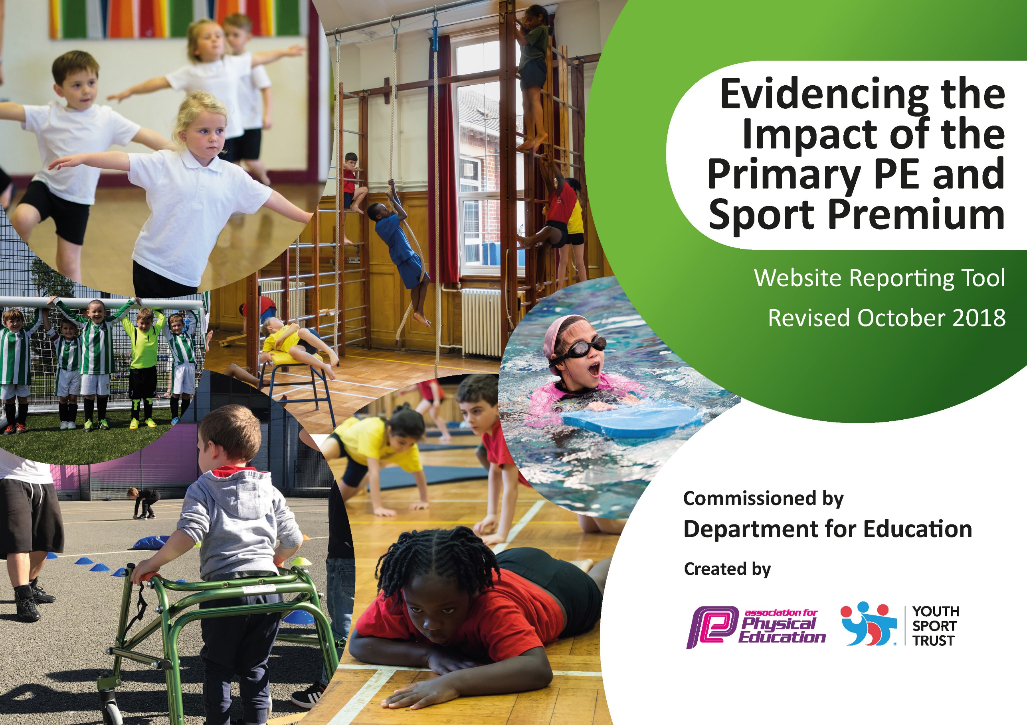

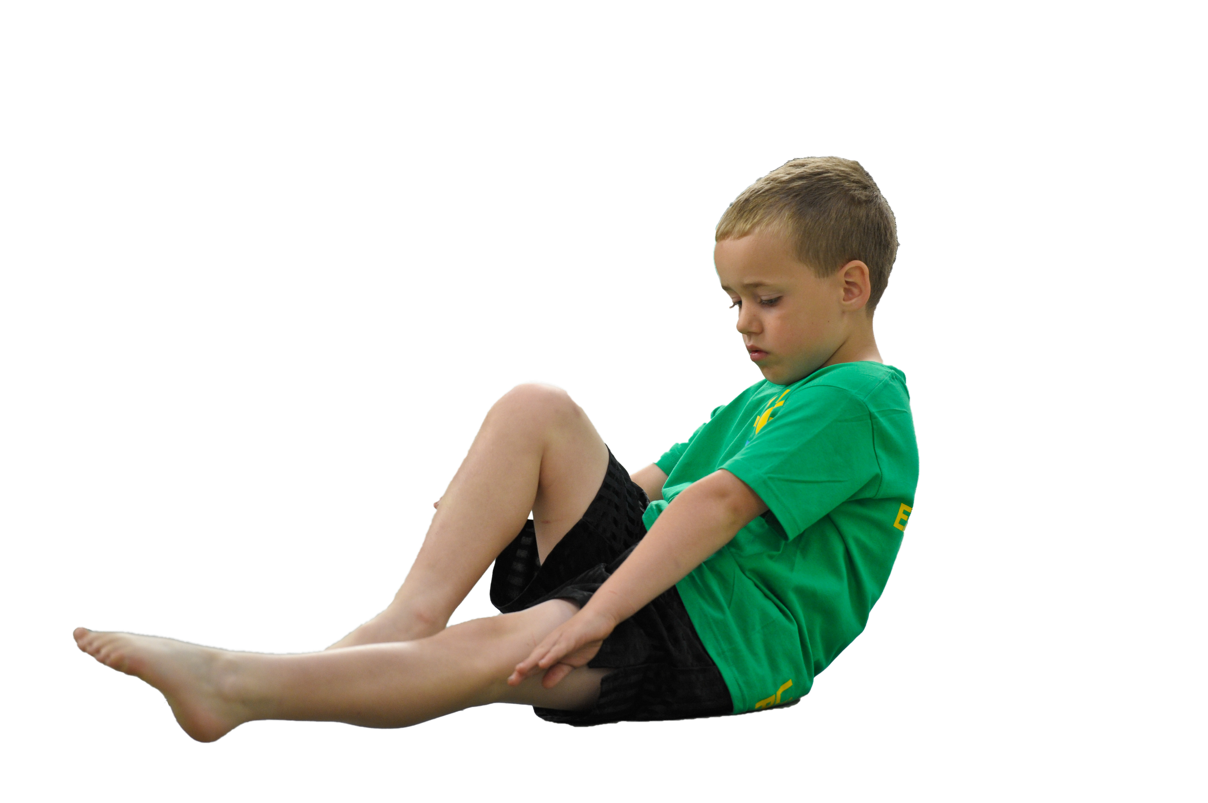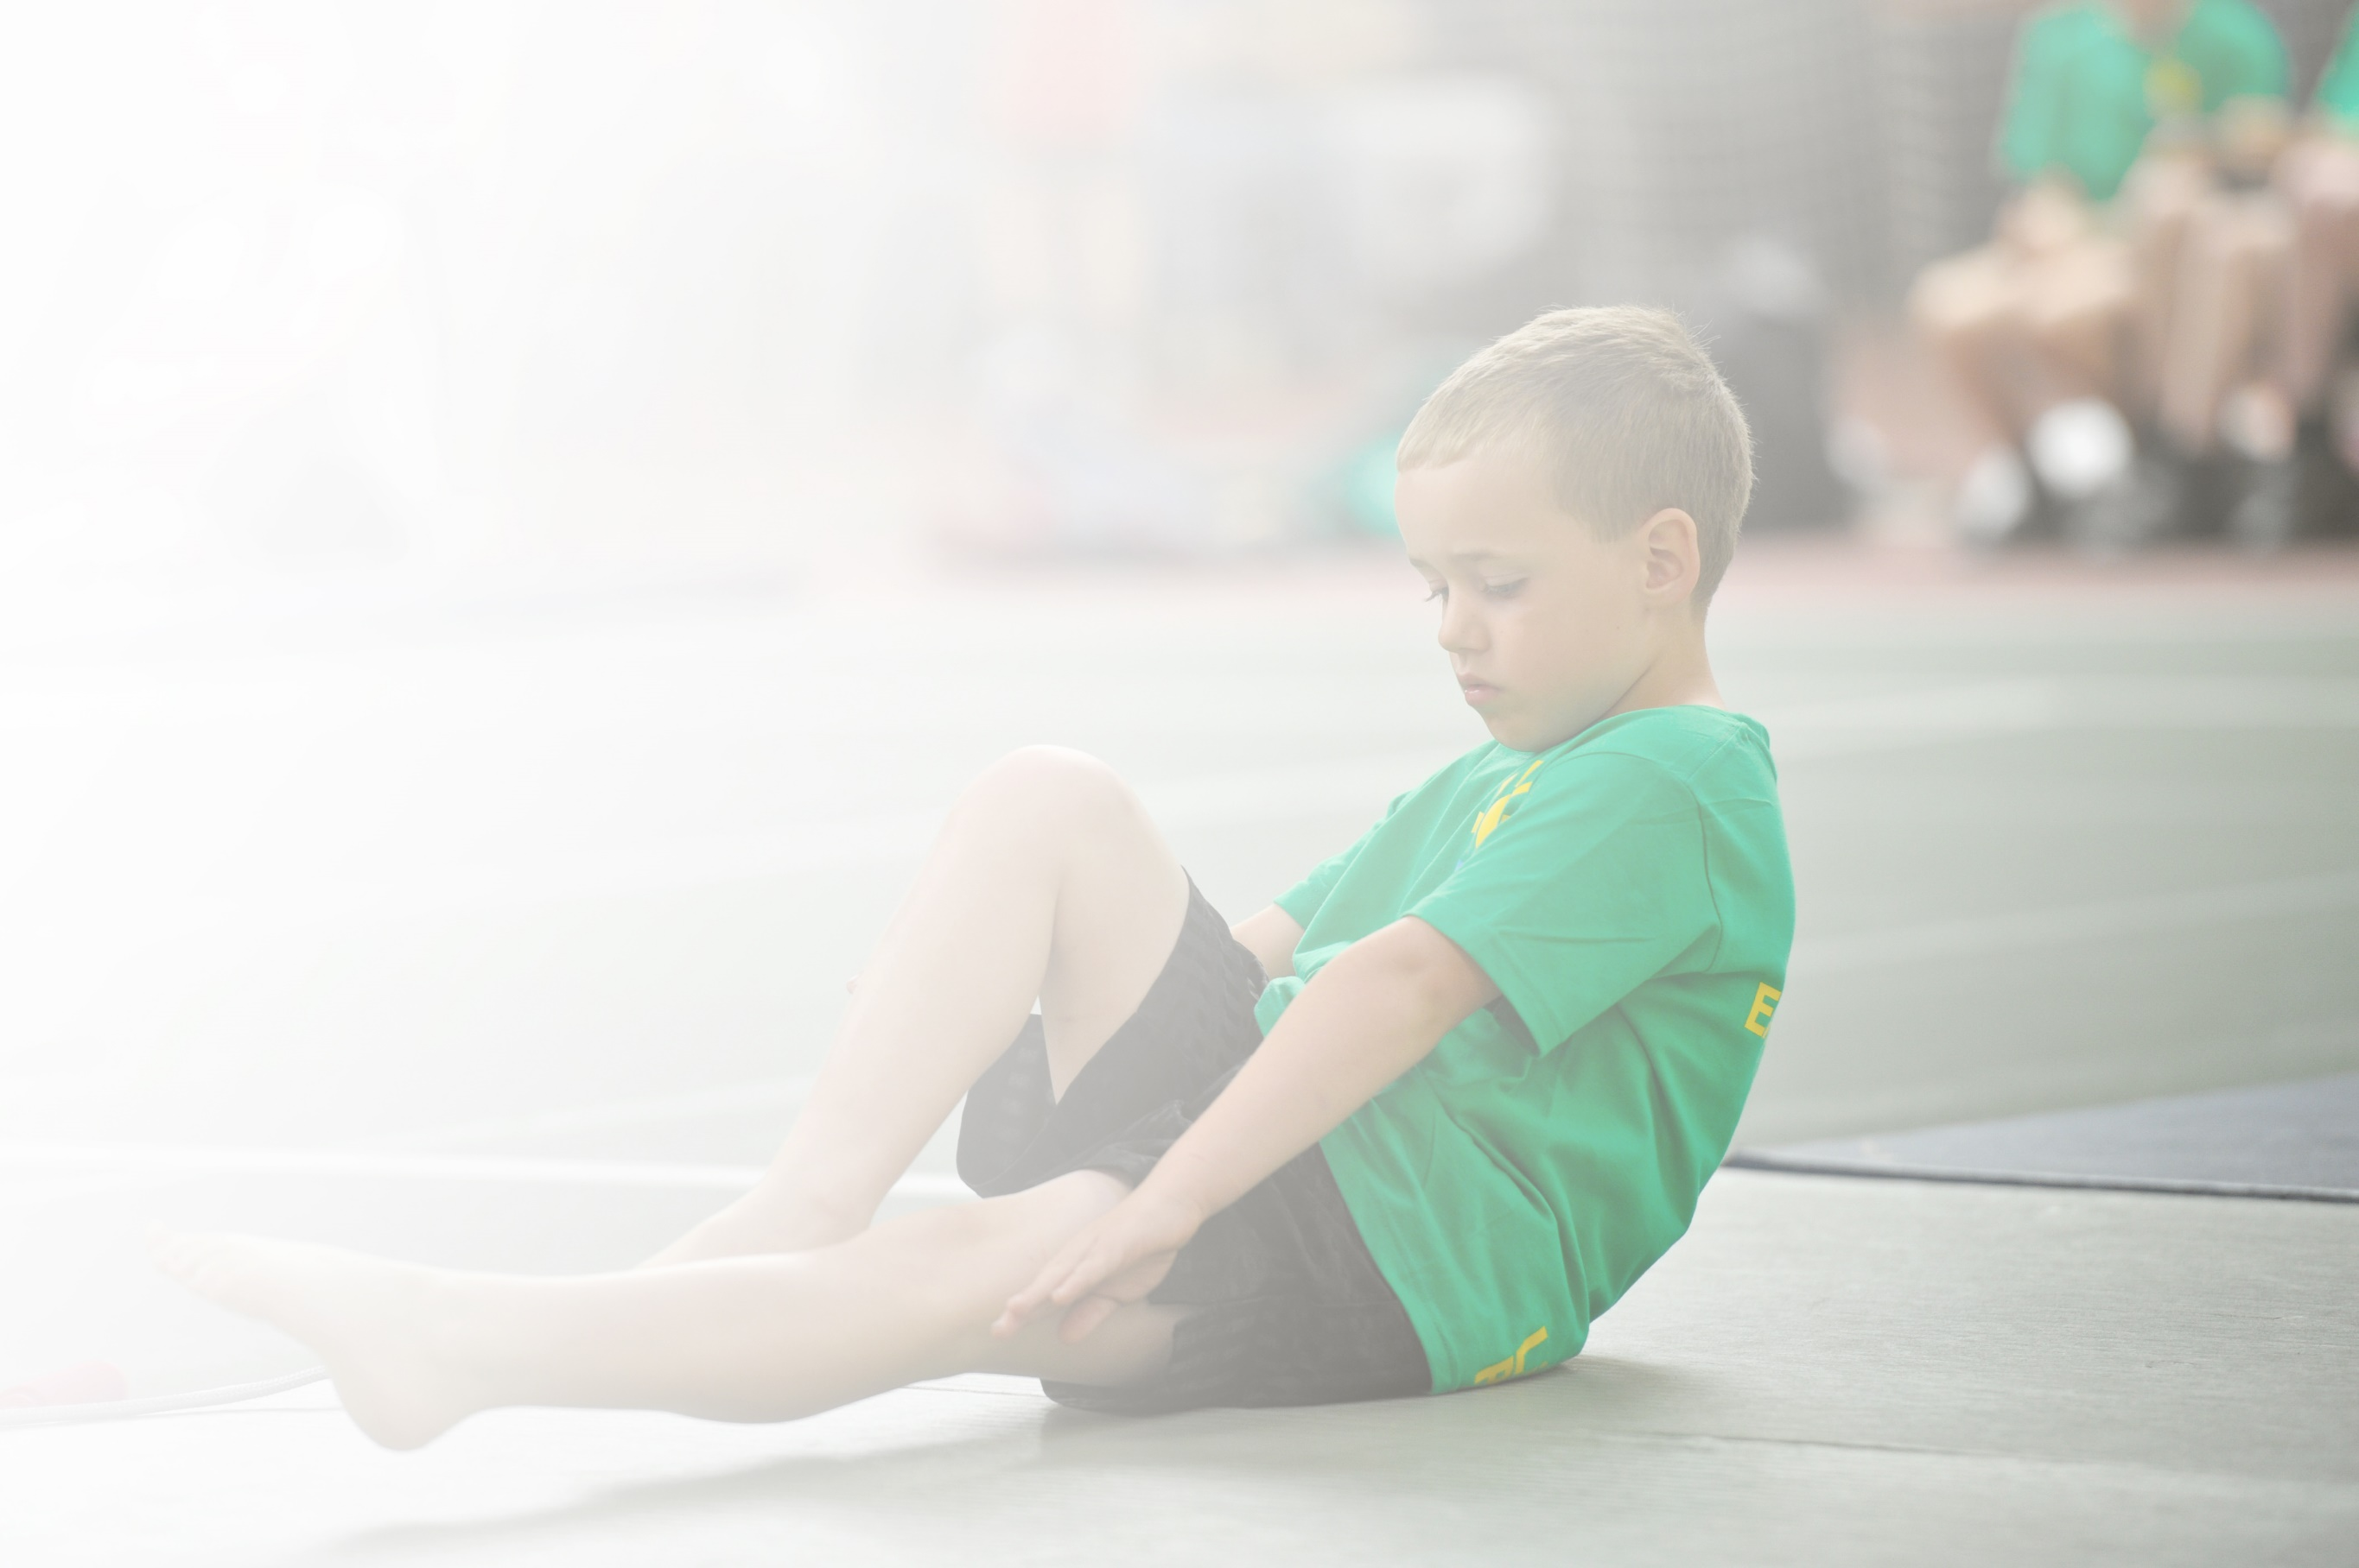Schools must use the funding to make **additional and sustainable** improvements to the quality of Physical Education, Sport and Physical Activity (PESPA) they offer. This means that you should use the Primary PE and Sport Premium to:

* Develop or add to the PESPA activities that your school already offer
* Build capacity and capability within the school to ensure that improvements made now will benefit pupils joining the school in future years

Please visit [gov.uk](https://www.gov.uk/guidance/pe-and-sport-premium-for-primary-schools) for the revised DfE guidance including the 5 key indicators across which schools should demonstrate an improvement. This document will help you to review your provision and to report

your spend. DfE encourages schools to use this template as an effective way of meeting the reporting requirements of the Primary PE and Sport Premium.

We recommend you start by reflecting on the impact of current provision and reviewing the previous

spend. Under the [Ofsted Schools Inspection Framework](https://www.gov.uk/government/publications/school-inspection-handbook-from-september-2015), inspectors will assess how effectively leaders use the Primary PE and Sport Premium and measure its impact on outcomes for pupils, and how effectively [governors](https://www.gov.uk/government/publications/governance-handbook) hold them to account for this.

Schools are required to [publish details](https://www.gov.uk/guidance/what-maintained-schools-must-publish-online#pe-and-sport-premium-for-primary-schools) of how they spend this funding as well as on the impact it has on pupils’ PE and sport participation and attainment by the end of the summer term or by **31 July 2019** at the   
latest.   
  
We recommend regularly updating the table and publishing it  
on your website throughout the year, as evidence of your   
ongoing review into how you are using the money to   
secure maximum, sustainable impact. To see an   
example of how to complete the table please   
click [HERE](http://www.afpe.org.uk/physical-education/wp-content/uploads/afPE-Example-Template-Indicator-2018-Final.pdf).

Support for review and reflection - considering the 5 key indicators from DfE, what development needs are a priority for your setting and your students now and why? Use the space below to reflect on previous spend, identify current need and priorities for the future.

|  |  |
| --- | --- |
| Key achievements to date: | Areas for further improvement and baseline evidence of need: |
| * Bronze Sports Award 2015-2016 * Silver Sports Mark Award 2016-2017 * Silver Sports Mark Award 2017-2018 * Increase in number of KS1 clubs available to pupils * Increase in number of KS2 clubs available to pupils * Year on year increase in number of pupils participating in school clubs from April 2016 * Introduction of new after school clubs for different sports – ie Tri Golf, Hockey * Introduction of Balancability for Reception Class in Summer Term 2018 * Increase in staff confidence, knowledge and skills of all staff teaching PE * Introduction of Forest School for whole school * Increased participation in school sports competitions and festivals * Review of sporting curriculum throughout the school   The profile of PE and sport is raised across the school as a tool for whole school improvement  Sport continues to have a very high profile throughout the school and is celebrated on a weekly basis.  Taster sessions for Forest Schools were run for all children throughout the school by an external Forest School Leader in January 2018 – Forest Schools now forms part of the curriculum for all children in the school and is run by Rachel Murray.  A Sports Coach, Chris Dickinson, came into school for one day per week throughout 2017-18 to train all staff including midday meal supervisors. This is as part of our agreement with the sports company PASS. | Increased confidence, knowledge and skills of all staff in teaching PE and sport. This is to be ratified using a staff audit. Anecdotally, staff report that they are more confident in delivering PE and Sport.  Continuation and embedding of Forest School from September 2018. A Scottish study found activity levels were 2.2 times higher in a typical Forest School day than during a school day that included PE lessons. |

|  |  |
| --- | --- |
| Meeting national curriculum requirements for swimming and water safety | Please complete all of the below: |
| What percentage of your current Year 6 cohort swim competently, confidently and proficiently over a distance of at least 25 metres?  **N.B.** Even though your children may swim in another year please report on their attainment on leaving  primary school. | 83% (January 2019) |
| What percentage of your current Year 6 cohort use a range of strokes effectively [for example, front crawl, backstroke and breaststroke]? | 70% (January 2019) |
| What percentage of your current Year 6 cohort perform safe self-rescue in different water-based situations? | 77% (January 2019) |
| Schools can choose to use the Primary PE and Sport Premium to provide additional provision for swimming but this must be for activity **over and above** the national curriculum requirements. Have you used it in this way? | Yes/No |

**Action Plan and Budget Tracking**

Capture your intended annual spend against the 5 key indicators. Clarify the success criteria and evidence of impact that you intend to measure to evaluate for students today and for the future.

|  |  |  |  |  |
| --- | --- | --- | --- | --- |
| **Academic Year:** 2018/19 | **Total fund allocated:** £ 17780 | **Date Updated: September 2018** | |  |
| **Key indicator 1:** The engagement of all pupils in regular physical activity – Chief Medical Officer guidelines recommend that primary school children undertake at least 30 minutes of physical activity a day in school | | | | Percentage of total allocation: |
| 59% |
| School focus with clarity on intended **impact on pupils**: | Actions to achieve: | Funding allocated: | Evidence and impact: | Sustainability and suggested next steps: |
| Consolidation and embedding of Forest School across the whole school – impact is a richer and more varied curriculum and increased physical exercise opportunities.  All children in Key Stage 2 to attend 5 x 1 hour swimming lessons as part of the core school curriculum.  Fit for Life club to be run for identified children by external provider.  To train playground leaders and staff to oversee break/lunch time sessions  To increase opportunities for children to become involved in extra curricular activity | Teachers to contribute to planning and development of activities in Forest School Spring/Summer 2019.  Resourcing for Forest School  Additional staffing to ensure ratios are suitable. TAs to support Forest School activities  To be organised with Chris Dickinson, PASS. 30 minutes per week sessions. | £8540  £1000  £1000 (proportion of PASS Gold Membership) | Year 5 pupil have been training in delivering sports activities during lunchtimes. Children have been grouped and are on a rota delivering different activities each day.  PASS have continued to assist with extra-curricular opportunities during the school day and after school.  Terms 1/2- netball  Term 3/4 – football  Term 5/6 - rounders | Year 5 will continue to run playleader sessions until the end of term 2 (2019/20). At which point they will being helping to train and mentor the new year 5 class.  Clubs to continue next year inline with the requests of the “children sport survey” |
| **Key indicator 2:** The profile of PESSPA being raised across the school as a tool for whole school improvement | | | | Percentage of total allocation: |
| 0% |
| School focus with clarity on intended **impact on pupils**: | Actions to achieve: | Funding allocated: | Evidence and impact: | Sustainability and suggested next steps: |
| To update/share sporting activities with the pupils and school community  Personal challenge opportunities for all children to take part in termly inter/intra school competitions | Increase profile of Sport on website and in Newsletters to parents  As part of inter/intra focus this year to raise participation rates whole school personal challenges to take place each term | N/A  N/A | All PASS documents have been made available to the school and are available through the school website. In school sports board is regularly updated with new, results and fixtures  All children have taken part in 5/6 personal challenge activities this year with results entered into the county wide statistics | Continue to maintain and update displays/website  Continue to take part in personal challenge events. |

|  |  |  |  |  |
| --- | --- | --- | --- | --- |
| **Key indicator 3:** Increased confidence, knowledge and skills of all staff in teaching PE and sport | | | | Percentage of total allocation: |
| 51% |
| School focus with clarity on intended  **impact on pupils**: | Actions to achieve: | Funding  allocated: | Evidence and impact: | Sustainability and suggested  next steps: |
| Gold Membership with PASS which offers:  -Curriculum support  -Twilight sessions for all staff to meet the needs of the school.  -Sessions to develop subject knowledge.  -Schemes of work and lesson plans Years R-6.  -Midday supervisor training to support play time.  -Training for children to support play provision.  -Competitive opportunities for the whole school.  -Balanceability  - Carry out a staff audit on confidence, knowledge and skills. | Ensure that all the opportunities that PASS offer are booked into the school diary. Audit to be compiled, shared and collated, and evaluated. | £9000 | Children have developed a range of skills in sports identified on the curriculum map. Teachers have observed a range of strategies used for effective delivery of PASS 2019 SOW.  Term 1 - 9.15am - 12.00pm PE Subject Lead Training - Evaluating the impact of the Sport Premium (suitable particularly for new PE subject Leads as well as existing.)  12.30-3.00 - NQT PE training (theory & practical) an overview of PE curriculum, PASS SOW, practical application examples.  @ Aylesford Community Centre  S.B / L.R      PLEASE ENCOURAGE SCHOOLS TO ATTEND PARTIC NQT's  Term 2 - Dance  @ Kings Hill VIAT (date TBC afternoon session) H.T  Term 3 - Gymnastics @ Kings Hill Primary (date TBC afternoon session) S.B  Term 4 - Summer Sports Training Wednesday 27th March 2019 (Athletics & Striking & Fielding) @ Ditton Community Centre 9.15-3.00pm S.B  Term 5 - PE fundamentals for EYFS/KS1 (date & venue TBC afternoon session poss at St Katherines, Snodland ) S.B  Term 6 - School Games Mark application support session (date and venue TBC probably twilight)  All 2019 SOW available at [www.passltd.org](http://www.passltd.org)  All teachers have undergone an observation this year to monitor teaching standards  All children in reception have taken part in balance ability over the course of the week, developing fundamental skills in cycling, balance and health and safety | Continue with PASS gold membership |
| **Key indicator 4:** Broader experience of a range of sports and activities offered to all pupils | | | | Percentage of total allocation: |
| 0% |
| School focus with clarity on intended  **impact on pupils:** | Actions to achieve: | Funding  allocated: | Evidence and impact: | Sustainability and suggested  next steps: |
| To increase opportunities for children to become involved in extra-curricular activity  Fit for Life club to be run for identified children by external provider.  Further embed Forest School across the whole school – impact is a richer and more varied curriculum and increased physical exercise opportunities. | Monitor and evaluate number of school clubs offered and participation rates of pupils  To be organised with Chris Dickinson, PASS. 30 minutes per week sessions.  Additional member of staff to become Forest School trained in Autumn 2019.  Resourcing for Forest School  Additional staffing to ensure ratios are suitable.  Sports Leader to attend relevant collaboration meetings and to set up matches | N/A  Already budgeted above | PASS have continued to assist with extra-curricular opportunities during the school day and after school.  Terms 1/2- netball  Term 3/4 – football  Term 5/6 - rounders | Continue to offer extra curricular opportunities in line with children’s sport survey |
| **Key indicator 5:** Increased participation in competitive sport | | | | Percentage of total allocation: |
| 0% |
| School focus with clarity on intended  **impact on pupils**: | Actions to achieve: | Funding  allocated: | Evidence and impact: | Sustainability and suggested  next steps: |
| Personal challenge opportunities for all children to take part in termly inter/intra school competitions. | Sports Leader to attend relevant collaboration meetings and to set up matches. Contact other schools, admin, ensure pool is booked etc. Contact other schools, admin, ensure pool is booked etc. | N/A | All children have taken part 5/6 personal challenge activities this year with results entered into the county wide statistics. | Continue to enter personal challenge events |