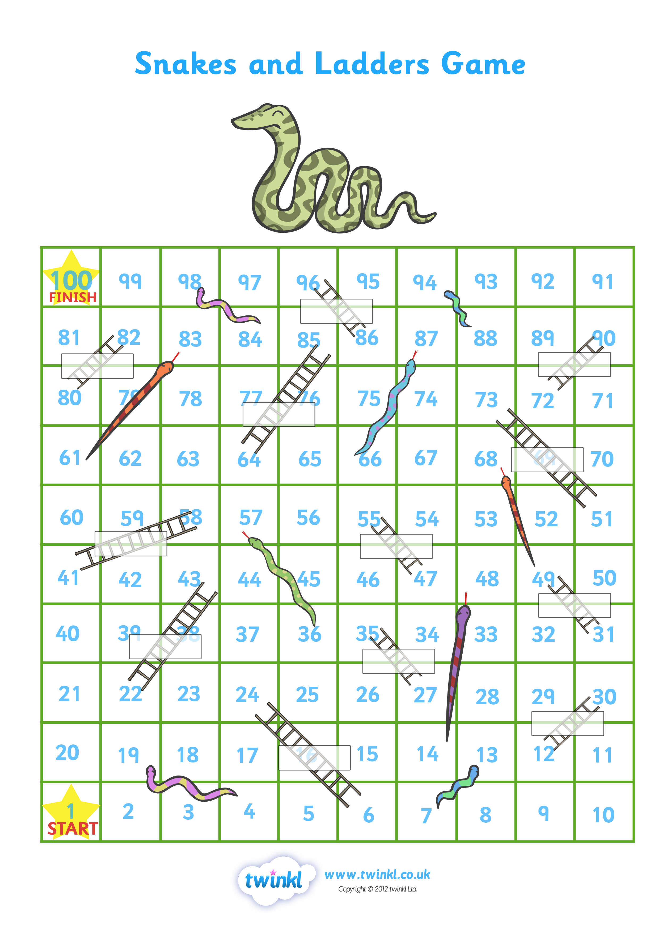
TEXT HERE
TEXT HERE
TEXT HERE
TEXT HERE
TEXT HERE
TEXT HERE
TEXT HERE
TEXT HERE
TEXT HERE
TEXT HERE
TEXT HERE
TEXT HERE
TEXT HERE

