Literacy  In Term 4 we will be studying:  Handa's surprise  We’re going on an egg hunt.  Outcomes:  Reading: 40 -6 0  Can segment the sounds in simple words and blend them together.  Begins to read words and sentences.  Writing: 40 – 60  Hears and says the initial sounds in words.  Uses some identifiable letters to communicate meaning.  Can segment the sounds in simple words and blend them together.  Attempts to write short sentences.  Begins to break the flow of speech into words. | Mathematics  White Rose topic titles:  Alive in 5  Growing 6,7,8  Building 9,10  Ten Town 7 – 10  Number blocks 7 – 10 | Personal, social and emotional development.  Term 4: Healthy Me  Exercising bodies Physical activity Healthy food Sleep Keeping clean Safety  Making Relationships 40 – 60  Initiates conversation  Explains own knowledge and asks questions.  Resolves conflicts  Self Confidence and Self Awareness 40 – 60  Confident to speak to others  Can describe themselves in positive terms  Managing Feelings and Behaviour 40 – 60  Beginning to negotiate and solve problems without aggression.
World book day

4th March is also world book day that we will be celebrating with an extra text.
People and communities  Enjoys joining in with family customs and routine.  To meet this objective please send me photo of your child and their family over Christmas. Doesn’t have to be with presents, maybe whilst you are on a walk, eating dinner or just a cheesy grin. I would love to print these out and put them all over our home corner. As well as building the children’s confidence in talking in front of the class. | Term 4  I am healthy | Physical Development  We should have PE with Mr Dickinson again this term. Please remember full warm PE kits. PE will be on a Monday.
Understanding The world  People and communities ELG  Talk about past and present event in own lives and lives of family.  Know that children don’t always enjoy the same things.  Know about similarities and differences between themselves and others including traditions.  The world 40 – 60  Looks closely at similarities, differences, patterns and changes  Food and decay. | Expressive arts and design  E and UM 40 – 60  Handa’s surprise retelling story using masks  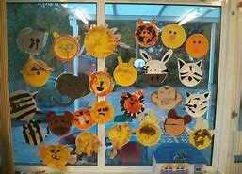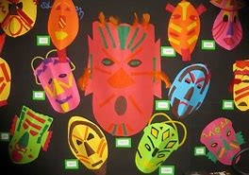  Selects appropriate resources and adapts work.  Selects tools and techniques needed to shape, assembly and join materials.  Easter cards-selects tools and techniques to assemble materials  Being Imaginative 40 – 60  Play’s co-operatively as part of a group to develop and act out a narrative. | Technology  Completes a simple program on a computer.  Uses ICT to interact with age appropriate computer software.  Technology – iPads and BeeBots, in Term 4 we will go to the ICT suite once a week. Technology in school is different to at home, we use a mouse which is so alien to children. If you have a mouse at home and can practice using it with your child it will be invaluable.

Key vocabulary
Phonics | Literacy | Mathematics
Continue with your child’s level of tricky words.  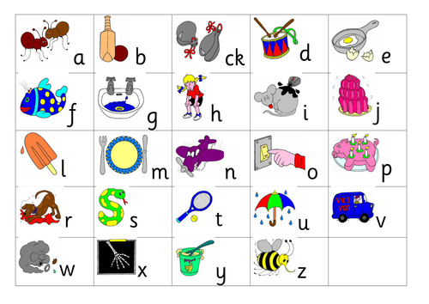  We will be continuing to learn the letters of the alphabet. | 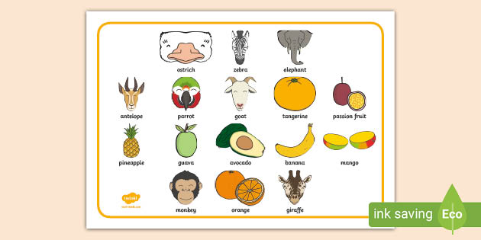 | Equal to  Lighter than  Heavier than  Lightest heaviest  How do you know?  Prove it!  One more  One less  How many will there be now?  What if …?  Addition, add, plus,  Subtraction, minus, take away

