

Lunsford Primary School – Home Learning
Week starting 4th January 2021
EYFS – Panda Class
Weekly Maths Tasks | Daily reading
White Rose Maths (approx. 15-20 mins a day)  Maths  https://whiterosemaths.com/homelearning/early-years/alive-in-5-week-1/  Monday = inset  Tuesday = Alive in 5! Week 1 session 4  Wednesday = alive in 5! Week 1 session 5  https://whiterosemaths.com/homelearning/early-years/alive-in-5-week-2/  Thursday = Alive in 5! Week 2 session 1  Friday = Alive in 5! Week 2 session 2  Just follow these four steps…  - Click on the set of lessons for Early Years  - Watch the video  - Click on the section next to the video afterwards: get the activity. (this week this part is on the slides in the video so you can just watch the video.)  - Use the video guidance to support you as you work through a lesson. | Reading  This needs to happen daily. Both your child reading to you and good modelling from you on any other texts you have at home. If you need some extra texts to read – as I’m sure you have all read your reading book from school then please head to:  https://home.oxfordowl.co.uk/reading/free-ebooks/  You need to register buts it’s free  This is the page you need to be on. Make sure you are selecting the level. If your child only has words in their reading book they need to be on level - 1, these books have sentences though so your child will need support. If your child has sentences, they need to be on level – 1+. 2. 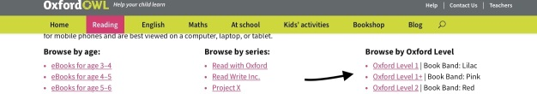  If it looks different to the above just make sure you head to – free e book library, the scroll down to oxford levels and select from the drop down.  Please keep a note of what your child is reading in their reading record and how they are reading.
Weekly Phonics
(daily – 15 - 20 mins)

Use your flashcards before teaching phonics daily. I have recorded 3 videos for you – have a look and choose the video that is most appropriate for your child.

Monday = inset day

Tuesday = sound buttons. These are dots under each sound. You ‘press’ these buttons and hear the sounds. Write out the following words and add sound buttons then practice reading/ blending. it, is, in, up, on, tut, rut, rug, nun, tap.

Wednesday = what’s on the blanket?. Put some easy things on top of a blanket EG. clip, spoon, fork, plate, soap, book. Then say to your child ‘ I am going to sound talk the word and you have to figure out what I am saying’ then say ‘c-l-i-p and they say clip and pick up the clip. Then say s-oa-p they say soap and pick up the soap. You could make it fun by saying every time they get an object correct they get a point and they can swap that for a treat afterwards if they get 5 or more points.

Thursday = matching words and pictures – see tapestry for the sheet

Friday = buried treasure. Have a picture of a treasure chest and a bin. Or a tick and a cross. Write out these words on paper(or cut into coin shapes if you are feeling creative) cat, dog, frog, tap, pat, mat, nac, cig, gat, un – each word to be on a new piece of paper/ coin. If the word is real it goes in the treasure chest/ tick if it is fake it goes in the bin/ cross.

When the children are in phonics session – please make sure they have their phoneme mat with them at all times. There is a photograph of this on Tapestry as well.

Please make sure you are practising your tricky words daily as well.

Weekly English Tasks
I have linked the lesson ideas with the story Rainbow Fish
Please have to hand – your tricky words, your phoneme alphabet mat and you have re-watched my tapestry video on how to support writing.

Monday = inset day
Tuesday
To write about what you did/ got for Christmas.
In this lesson I would expect all children to verbally tell me one short sentence. If your child starts to ramble-stop them (kindly) they need to think of one short sentence. EG. I got some slime. I would then say it with them twice and then draw my lines. One line for each word. As I draw the lines. I say the words. EG. __ ______ ______ _______. Remember the longer the line the longer the word. Then I would point to the lines and say each word another 2 times. Then get out their phoneme alphabet mats. I have them at school in their homework folder, so you have one attached on Tapestry and on the home learning page. Also, get out their tricky word list, which you have in their book bag. Support your child in writing. Remind them of each word if they need it. They do not have to write what they got that was an easy example as I imagine that’s a short sentence they can write. If they want to write more they can. Please write 1 sentence at a time this helps them with understanding full stops. If your child can only hear the initial sounds in words that fine and that’s amazing!

Wednesday – we will start to read our new text Rainbow fish tomorrow. For today’s lesson you need a sea video, a piece of plain paper, then whatever you choose to create the sea with – paint, pencils etc
Today we will create a sea background.
On you tube watch some sea clips – here are some if you need ideas:
https://www.youtube.com/watch?v=G52dUQLxPzg

Whilst/ after watching talk to your child about the sea using their 5 senses; look, smell, taste, touch and hearing. Then get the things you would like to create a sea picture. Discuss the sea whilst you are creating and try and discuss that it’s not just one block colour. I am expecting something like below – maybe try to add some white and green. If your child wants to after their painting has dried or they have coloured the sea they can draw some coral, sea weed or other living plants and add them to the sides – Rainbow fish will be making an appearance at some point so please don’t add any animals.

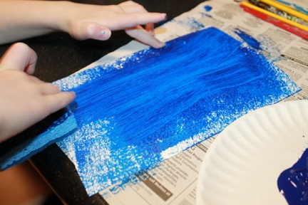

Thursday – you will need – to watch the video on Tapetsry of me reading Rainbow fish, the template of rainbow fish or you to draw rainbow fish on a piece of paper – whatever you would like to decorate him in, a small piece of kitchen foil (or a silver pen).
Today, your child is going to listen to me read the first page or so which describes rainbow fish. This is the first time properly that we will touch upon adjectives (describing words). After you have watched the video re-cap what rainbow fish looks like in the book. Today your child will decorate rainbow fish. They can colour, paint, use materials, uses tissue paper I do not mind. At the moment rainbow fish has quite a few shiny scales you can cut some out of tin foil and add or colour these in silver. Whatever you have at home would be amazing! If you child would like to do some writing today as in English we haven’t written since Tuesday and you might want to continue practising at home. They could write a list of colours they have used or write a sentence to describe him. EG. Rainbow fish is beautiful. Rainbow fish is shiny.

Friday
On a Friday the children normally have a write dance lesson which develops their handwriting, this is a programme for in school use only. So some ideas for handwriting/ pencil control to do today:
Playdough – https://www.youtube.com/watch?v=BOLR3pQt8zg
Stencils
Tracing
Colouring

When writing remember:
- To have your phoneme mat next to your child and remind them to use it.
- To remind them about full stops, capital letters and finger spaces.

Creative / Active Activities
Monday = PE https://www.passltd.org/copy-of-hl-year-1-2-1
Tuesday = PSHE – mindful card – see tapestry.
Wednesday = science – exploring forms of water. What happens to water when it freezes? Please ask your child this question and then test this out together. Were they correct?
Thursday = Topic – local area – if you can go for a walk, discuss what you can see. What things are old, what things are new and why things are there.
Friday = Computing – the children in school will be going to the ICT suite, practicing writing their name to log on and then going on a colouring programme. At home I would like you to choose
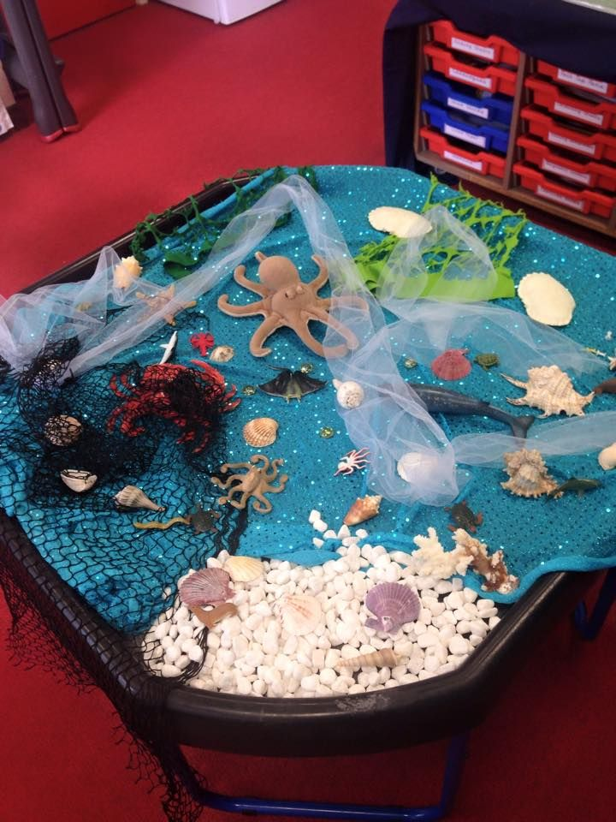
It would be a nice idea if you could set up a small world area each week based on the book. Things that they can re-tell the story with. Feel free to add anything extra. It doesn’t have to be in a tuff tray, it could be in a lid, on tray or just on a table/ blanket.

#TheLearningProjects

