

Lunsford Primary School – Home Learning
Week starting 25th January 2021
EYFS – Panda Class
Weekly Maths Tasks
White Rose Maths (approx. 15-20 mins a day)
Maths
https://whiterosemaths.com/homelearning/early-years/growing-6-7-8/
Monday = growing 6,7,8 week 1 session 3
Tuesday = growing 6,7,8 week 1 session 4
Wednesday = growing 6,7,8 week 1 session 5
https://whiterosemaths.com/homelearning/early-years/growing-6-7-8-week-2/
Thursday = growing 6,7,8 week 2 , session 1
Friday = growing 6,7,8 week 2, session 2

Just follow these four steps…
- Click on the set of lessons for Early Years
- Watch the video
- Click on the section next to the video afterwards: get the activity. (this week this part is on the slides in the video so you can just watch the video.)
- Use the video guidance to support you as you work through a lesson.
Reading
This needs to happen daily. Both your child reading to you and good modelling from you on any other texts you have at home. If you need some extra texts to read – as I’m sure you have all read your reading book from school then please head to:
https://home.oxfordowl.co.uk/reading/free-ebooks/
You need to register buts it’s free
This is the page you need to be on. Make sure you are selecting the level. If your child only has words in their reading book they need to be on level - 1, these books have sentences though so your child will need support. If your child has sentences, they need to be on level – 1+. 2. 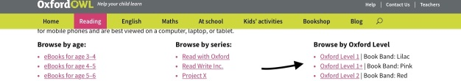

If it looks different to the above just make sure you head to – free e book library, the scroll down to oxford levels and select from the drop down.
Please keep a note of what your child is reading in their reading record and how they are reading.

Something different to try, if you want to:
Teach your monsters to read
https://www.teachyourmonstertoread.com/?gclid=EAIaIQobChMIrL_JhdqJ7gIVk77tCh3-mg9DEAAYASAAEgLElPD_BwE

This is a website that I was recommended by a teacher friend whose child is also in Year R. You can register and access for free via the website on a laptop/ iPad though if you want the app you have to pay. I’ve been on the first few levels and it looks so fun and interactive and focus’ on phonics and the sounds letters makes. My friend says it does go above what the child has been taught at school but her daughter is coping well with it and finds it so fun.
I just thought I would give you a different website to try out.
Weekly Phonics
(daily – 15 - 20 mins)

Use your flashcards before teaching phonics daily. I have recorded 4 videos for you – have a look and choose the video that is most appropriate for your child.

Monday = Teach f,ff jolly phonics song – focus saying and hearing, tell your child that a word can begin with f but will only start with 1 f. double ff is for the ends of words. Ask them to think of any words that start with f. now you tell them and write down any words that end with double ff. EG. huff, puff, stuff, stiff, fluff, cliff. If you want to show your child these words in a phoneme frame the ff share a box as together they make one sound!

Tuesday = practice writing f. start at the top and go down, then across. Have your Lunsford handwriting sheet to hand as it doesn’t go all the way to the top. Then in phoneme frames write:
fat, fin, fan, fit, fog then write fluff, stiff, huff, puff

Wednesday = Teach l, ll jolly phonics song – focus saying and hearing, tell your child that a word can begin with l but will only start with 1 l. double ll is for the ends of words. Ask them to think of any words that start with l now you tell them and write down any words that end with double ll. EG. doll, toll, tell, fell

Thursday = practice writing l. in phoneme frames write:
let, land, leg, log then write doll, toll, tell, fell

Friday = Teach ss-jolly phonics song - focus saying and hearing. They already know s so remind them any double letters come at the end of words.
Show them and tell them the words – miss, fuss, hiss, kiss, loss, toss, then ask them to write some in phoneme frames. Remember ss will share a box.

When the children are in phonics session – please make sure they have their phoneme mat with them at all times. There is a photograph of this on Tapestry as well.

Please make sure you are practising your tricky words daily as well.

Phonicsplay.co.uk
Username:jan21
Password: home

Weekly English Tasks
I have linked the lesson ideas with the story Pirates love underpants
Please have to hand – your tricky words, your phoneme alphabet mat and you have re-watched my tapestry video on how to support writing.
Monday = go through the word mat – make sure your child knows what a pirate is and the words associated with them. Take a look at the first 2 pages, the pirates all aboard the ship. Look at all of the pants – talk about your favourite. Look at all of the pirates. Some have 1 leg why? Some have an eye patch – why? What are they carrying aboard the boat – why?
today is a discussion lesson to get them thinking about pirates and their roles.
Tuesday = treasure map making! Take a look at the next 2 pages. What is a treasure map and why did pirates use them? Today I would like the children to make their own pirate treasure maps.- I have included one you can print out and use or you can make you own and stain it with tea bags. Remember x marks the spot. For this lesson at the end once you have made and followed the map and found the treasure. I would like your child to send me a video to talk about their map. It doesn’t have to be long.
Wednesday = Big knicker bay. Today I would like your child to design a new pair of knickers for a shark to wear, these can be as frilly as they like. They can draw, paint, make our of playdough, find things to stick on I don’t mind. Afterwards I would like them to write a sentence about their knickers EG. My knickers have spots on them. I would like you to write out the word knicker for them to copy but do not write out any other words for them to copy, their writing has to be their own writing otherwise when they come back to school they will expect a higher level of support.
Thursday = footprints. Draw a picture of who you think has been there before. You can do this on purple mash if you like. Then write down OR tell your grown up (you have a choice today) who you think it is.
Friday = write a sentence about what you would like to do in your choosing time today. EG Today I would like to play with some water.
Please let this be all their own writing bar lines for support.

When writing remember:
- To have your phoneme mat next to your child and remind them to use it.
- To remind them about full stops, capital letters and finger spaces.

Creative / Active Activities
Monday = PE https://www.passltd.org/copy-of-hl-year-1-2-1 , Remember Joe wicks is back Monday, Wednesday and Friday’s 9am for 20 minutes. There is also cosmic yoga that we enjoy on you tube. So you have a few options. As well as getting outside and going for a walk/ bike ride.
Tuesday = Go for a walk/ play in the park – just get outside and have fun and be active fresh air is so good for the soul.
Wednesday = well-being Wednesday video from Mrs Davies.
Thursday = science – https://thestemlaboratory.com/walking-water-rainbow/
This is my favourite science activity with water to do, see the above website. She uses 6 glasses and therefore needs 6 different food colouring. You don’t need this many. Please can you talk to your child first about what they think will happen (a prediction) and then at the end asked them what they found out and if they were correct (the conclusion)
Friday = Computing – purple mash - Let your child explore and I have set them something to do – see the alarm at the top.
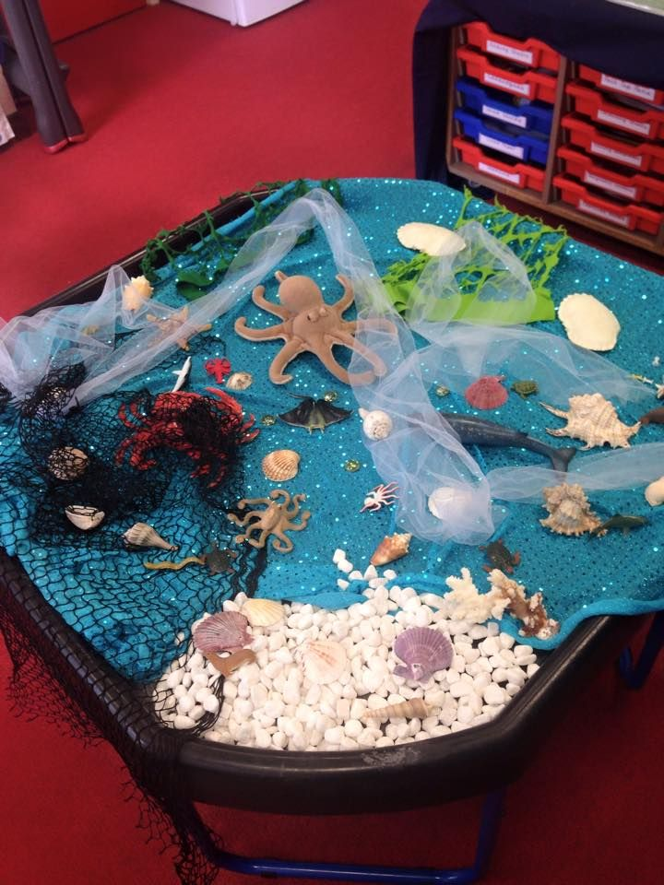
It would be a nice idea if you could set up a small world area each week based on the book. Things that they can re-tell the story with. Feel free to add anything extra. It doesn’t have to be in a tuff tray, it could be in a lid, on tray or just on a table/ blanket.

Other links that may be helpful: mainly dancing songs.
Wake up, shake up song: https://www.youtube.com/watch?v=1gUbdNbu6ak

Time to tidy up: https://www.youtube.com/watch?v=LV1sMws_Gqg

Get ready to dance: https://www.youtube.com/watch?v=2UcZWXvgMZE

Tricky words: https://www.youtube.com/watch?v=TvMyssfAUx0

https://www.youtube.com/watch?v=R087lYrRpgY

#TheLearningProjects

