

Lunsford Primary School – Home Learning
Week starting 18^{h} January 2021
EYFS – Panda Class
Weekly Maths Tasks

White Rose Maths (approx. 15-20 mins a day)
Maths
https://whiterosemaths.com/homelearning/early-years/alive-in-5-week-3/
Monday = Alive in 5! Week 3 session 3
Tuesday = Alive in 5! Week 3 session 4
Wednesday = Alive in 5! Week 3 session 5
https://whiterosemaths.com/homelearning/early-years/growing-6-7-8/
Thursday = growing 6,7,8 week 1 session 1
Friday = growing 6,7,8 week 1 session 1

Just follow these four steps…
- Click on the set of lessons for Early Years
- Watch the video
- Click on the section next to the video afterwards: get the activity. (this week this part is on the slides in the video so you can just watch the video.)
- Use the video guidance to support you as you work through a lesson.
Reading
This needs to happen daily. Both your child reading to you and good modelling from you on any other texts you have at home. If you need some extra texts to read – as I’m sure you have all read your reading book from school then please head to:
https://home.oxfordowl.co.uk/reading/free-ebooks/
You need to register buts it’s free
This is the page you need to be on. Make sure you are selecting the level. If your child only has words in their reading book they need to be on level - 1, these books have sentences though so your child will need support. If your child has sentences, they need to be on level – 1+. 2. 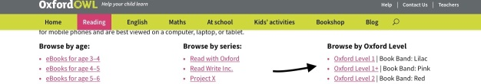

If it looks different to the above just make sure you head to – free e book library, the scroll down to oxford levels and select from the drop down.
Please keep a note of what your child is reading in their reading record and how they are reading.

Something different to try, if you want to:
Teach your monsters to read
https://www.teachyourmonstertoread.com/?gclid=EAIaIQobChMIrL_JhdqJ7gIVk77tCh3-mg9DEAAYASAAEgLElPD_BwE

This is a website that I was recommended by a teacher friend whose child is also in Year R. You can register and access for free via the website on a laptop/ iPad though if you want the app you have to pay. I’ve been on the first few levels and it looks so fun and interactive and focus’ on phonics and the sounds letters makes. My friend says it does go above what the child has been taught at school but her daughter is coping well with it and finds it so fun.
I just thought I would give you a different website to try out.
Weekly Phonics
(daily – 15 - 20 mins)

Use your flashcards before teaching phonics daily. I have recorded 4 videos for you – have a look and choose the video that is most appropriate for your child.

Monday = teach ‘h’ phoneme. Watch jolly phonics for the sound. What words do you know that start h? https://www.youtube.com/watch?v=2Xy2e78qxNg

Tuesday = write the words: hat, had, has, hop, hum in phoneme frames like last week. Then write the sentence: I like to hop. Tell the children how to write like.

Wednesday = teach ‘b’ phoneme. Watch jolly phonics for the sound. What words do you know that start b?
https://www.youtube.com/watch?v=2Xy2e78qxNg

Thursday = write the words: bad, bed, ban, bat, bin. Then write the sentence: I have a pet bat.

Friday = go to phonicsplay.co.uk – resources – picnic on Pluto - play obb and bob on phonics play. Choose h and b to play. If you can’t get on for whatever reason this game is just the real and made up words from last week. So you could write out real and made up words on coins like last week.

When the children are in phonics session – please make sure they have their phoneme mat with them at all times. There is a photograph of this on Tapestry as well.

Please make sure you are practising your tricky words daily as well.

Phonicsplay.co.uk
Username:jan21
Password: home

Weekly English Tasks
I have linked the lesson ideas with the story The Rainbow Fish
Please have to hand – your tricky words, your phoneme alphabet mat and you have re-watched my tapestry video on how to support writing.
This week we are going to write the story of The Rainbow Fish. I have included paper for you to write on in my uploads. Please support you child as above in verbalising what they want to write before they write it and then using their phoneme mats to support letter knowledge. Think about a short achievable sentence they can write. They should have a go at spelling all words independently – please do not let them copy any words from you as they need to be confident in sounding out themselves. (Though I would write down and let them copy – scales - )
Monday = Write the beginning of the story. Talk about what happened at the beginning of the story. They could write – Rainbow Fish is in the sea. Or . Rainbow Fish is swimming. Or. Rainbow Fish has sparkly scales. Just some short ideas.
Tuesday = Write the next page of The Rainbow Fish when Blue fish asks for a scale.
Wednesday = Write the next page of The Rainbow Fish – Rainbow fish meets the octopus.
Thursday = write the next page of The Rainbow Fish – Rainbow fish shares his scales.
Friday = Make a front cover for your story. Then read it together and enjoy.

When writing remember:
- To have your phoneme mat next to your child and remind them to use it.
- To remind them about full stops, capital letters and finger spaces.

Creative / Active Activities
Monday = PE https://www.passltd.org/copy-of-hl-year-1-2-1 , Remember Joe wicks is back Monday, Wednesday and Friday’s 9am for 20 minutes. There is also cosmic yoga that we enjoy on you tube. So you have a few options. As well as getting outside and going for a walk/ bike ride.
Tuesday = PSHE – mindful card – see tapestry.
Wednesday = well-being Wednesday video from Mrs Davies.
Thursday = science – sinking and floating. Get objects from around your house and test out if they sink or float. Can your child predict what they think will happen before they test it out- were they correct?
Friday = Computing – purple mash - Let your child explore and I have set them something to do – see the alarm at the top.
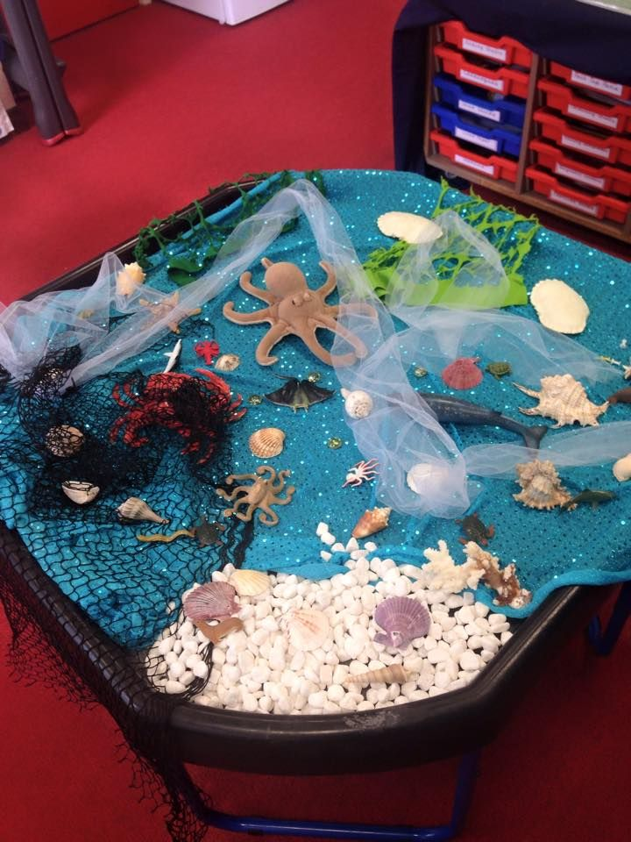
It would be a nice idea if you could set up a small world area each week based on the book. Things that they can re-tell the story with. Feel free to add anything extra. It doesn’t have to be in a tuff tray, it could be in a lid, on tray or just on a table/ blanket.

Other links that may be helpful: mainly dancing songs.
Wake up, shake up song: https://www.youtube.com/watch?v=1gUbdNbu6ak

Time to tidy up: https://www.youtube.com/watch?v=LV1sMws_Gqg

Get ready to dance: https://www.youtube.com/watch?v=2UcZWXvgMZE

Tricky words: https://www.youtube.com/watch?v=TvMyssfAUx0

https://www.youtube.com/watch?v=R087lYrRpgY

#TheLearningProjects

