

Lunsford Primary School – Home Learning
Week starting 11^{h} January 2021
EYFS – Panda Class
Weekly Maths Tasks

White Rose Maths (approx. 15-20 mins a day)
Maths
https://whiterosemaths.com/homelearning/early-years/alive-in-5-week-2/
Monday = Alive in 5! Week 2 session 3
Tuesday = Alive in 5! Week 2 session 4
Wednesday = Alive in 5! Week 2 session 5
https://whiterosemaths.com/homelearning/early-years/alive-in-5-week-3/
Thursday = Alive in 5! Week 3 session 1
Friday = Alive in 5! Week 3 session 2

Just follow these four steps…
- Click on the set of lessons for Early Years
- Watch the video
- Click on the section next to the video afterwards: get the activity. (this week this part is on the slides in the video so you can just watch the video.)
- Use the video guidance to support you as you work through a lesson.
Reading
This needs to happen daily. Both your child reading to you and good modelling from you on any other texts you have at home. If you need some extra texts to read – as I’m sure you have all read your reading book from school then please head to:
https://home.oxfordowl.co.uk/reading/free-ebooks/
You need to register buts it’s free
This is the page you need to be on. Make sure you are selecting the level. If your child only has words in their reading book they need to be on level - 1, these books have sentences though so your child will need support. If your child has sentences, they need to be on level – 1+. 2. 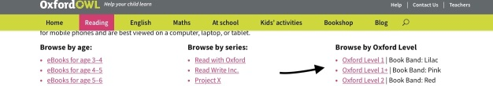

If it looks different to the above just make sure you head to – free e book library, the scroll down to oxford levels and select from the drop down.
Please keep a note of what your child is reading in their reading record and how they are reading.

Something different to try, if you want to:
Teach your monsters to read
https://www.teachyourmonstertoread.com/?gclid=EAIaIQobChMIrL_JhdqJ7gIVk77tCh3-mg9DEAAYASAAEgLElPD_BwE

This is a website that I was recommended by a teacher friend whose child is also in Year R. You can register and access for free via the website on a laptop/ iPad though if you want the app you have to pay. I’ve been on the first few levels and it looks so fun and interactive and focus’ on phonics and the sounds letters makes. My friend says it does go above what the child has been taught at school but her daughter is coping well with it and finds it so fun.
I just thought I would give you a different website to try out.
Weekly Phonics
(daily – 15 - 20 mins)

Use your flashcards before teaching phonics daily. I have recorded 3 videos for you – have a look and choose the video that is most appropriate for your child.

Monday = reading captions. See extra sheet. Can they read the caption and match to the correct picture?

Tuesday = match the caption to the picture. See extra sheet.

Wednesday = phoneme frames – see below. Tell your child the words and they have to write the correct phonemes in the correct space. Words to write: pat, tap, tag, got, dot, met, ten

Thursday = same as yesterday’s lesson. With words: cat, can, cap, peg, rat, ran

Friday = same as yesterday’s lesson. With words: run, din, sin, sun, dim

When the children are in phonics session – please make sure they have their phoneme mat with them at all times. There is a photograph of this on Tapestry as well.

Please make sure you are practising your tricky words daily as well.

A phoneme frame: is just a rectangle with as many spaces as you need phonemes.
EG the phoneme frame for ‘cat’ would look like:

The phoneme frame for ‘it’ would look like:

Weekly English Tasks
I have linked the lesson ideas with the story Rainbow Fish
Please have to hand – your tricky words, your phoneme alphabet mat and you have re-watched my tapestry video on how to support writing.

Monday = watch my video (today’s reading of Rainbow fish) – Rainbow fish is not very good at sharing, talk to your child about why they need to share.
Tuesday = watch my video (today’s reading of Rainbow fish) – Today we are going to write a conversation between rainbow fish and Octopus in speech bubbles. See my extra sheet. Talk through what Rainbow fish would say to the Octopus and what Octopus would say back. Draw lines for your child to write on to represent each word.
Wednesday = watch my video (today’s reading of Rainbow fish) – Rainbow fish shares his scales. Make fish scales or maybe sharing tokens to share with friends and family. I know we can’t see people at the moment so instead you could make these and send a video/ photo or even make a video to send to a loved one to say how much you love them instead.
Thursday = watch my video (today’s reading of Rainbow fish) book review = see extra sheet
Friday = write about what you would like to do for choosing time. Watch back the video of how I teach writing if needed. Your child at home might want to write: I want to play with my lego. Remember to draw lines for them and have their phoneme sheet and tricky words to hand.

When writing remember:
- To have your phoneme mat next to your child and remind them to use it.
- To remind them about full stops, capital letters and finger spaces.

Creative / Active Activities
Monday = PE https://www.passltd.org/copy-of-hl-year-1-2-1 , Remember Joe wicks is back Monday, Wednesday and Friday’s 9am for 20 minutes. There is also cosmic yoga that we enjoy on you tube. So you have a few options.
Tuesday = PSHE – mindful card – see tapestry.
Wednesday = well-being Wednesday video from Mrs Davies.
Thursday = science – can you make a boat that floats on water. This can be made out of whatever you like. Junk modelling, tin foil, paper. You could even teach them origami paper boats – this is definitely something for you to try if you are feeling very brave and calm and not for me to ever try with 30 children.
Friday = Computing – purple mash - Let your child explore.
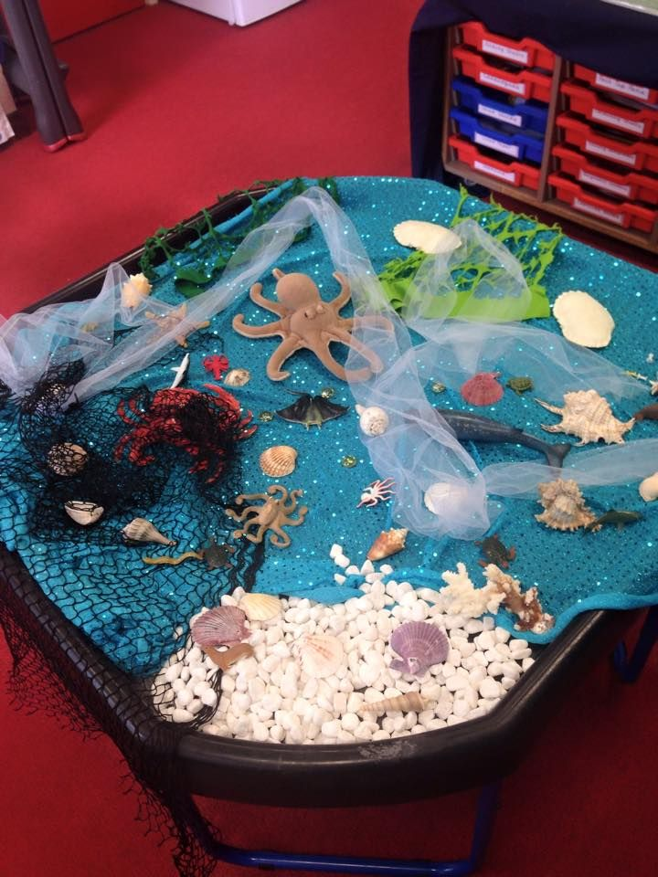
It would be a nice idea if you could set up a small world area each week based on the book. Things that they can re-tell the story with. Feel free to add anything extra. It doesn’t have to be in a tuff tray, it could be in a lid, on tray or just on a table/ blanket.

Other links that may be helpful: mainly dancing songs.
Wake up, shake up song: https://www.youtube.com/watch?v=1gUbdNbu6ak

Time to tidy up: https://www.youtube.com/watch?v=LV1sMws_Gqg

Get ready to dance: https://www.youtube.com/watch?v=2UcZWXvgMZE

Tricky words: https://www.youtube.com/watch?v=TvMyssfAUx0

https://www.youtube.com/watch?v=R087lYrRpgY

#TheLearningProjects

