Children’s Mental Health Week
Monday 1st February – Sunday 7th February
‘Express Yourself’
What is self-expression and why is it important?
Self-expression is about communicating your individuality. This can be through words, clothing and hairstyle, or through art forms such as writing, drawing, music and dance.
Self-expression can help you to showcase your true self – your story, your thoughts, feelings and emotions. But this can also make us feel vulnerable, so you might want to take things one step at a time.
We often get told by our family, friends, school, communities and even through social media how we ‘should’ look, think, speak, and act. These constant messages about what we ought to do, and who we ought to be, can make it difficult to let go of expectations and express our true selves.
Why is self-expression important to mental health?
Self-expression is a great way to relieve yourself of stress and free your mind. Self-expression can help you to reflect on your life, actions, decisions, relationships, beliefs and thoughts – rather than keep them buried deep down.
Self-expression can help us to connect during good times and bad
By expressing ourselves thoughtfully, we can better communicate, collaborate and build a community with others. At times of crisis, people come together to express themselves individually, and as a group, through the arts.
Here are some examples you might want to get your classes to look at:
- Gareth Malone’s online choir – bringing people together during the Covid-19 lockdown
Classic FM Report Great British Home Chorus First Rehearsal
- Grayson’s Art Club – a series of online masterclasses to help unleash creativity during lockdown Grayson's Art Club
Dates to note throughout the week:
Monday 1st Feb | Tuesday 2nd Feb | Wednesday 3rd Feb | Thursday 4th Feb | Friday 5th Feb
9am Intro Assembly  Oak Academy Assembly for Children’s Mental Health Week available to view online | 2pm Wellbeing Assembly | Wellbeing Wednesday | ‘Dress to express’ | 2.30pm Celebration Assembly

Panda class activities:

- (Monday 1st February)On Monday’s zoom session I will be asking the children to take turns sharing something with the class. I would like the children to share their favourite toy. I will mute the whole class and ask your child to unmute and then tell us about their toy. It can only be short as I know Zoom is so odd for small children. Please practice prior as to what they want to say.
- If you are at home – please bring your favourite toy in on this day. (If you are happy to – if not a photograph will do)
- (Tuesday 2nd February) On Tuesday’s Zoom session we will imagine they got stuck on an island for a day. The ship is on it’s way to rescue you but before it arrives, think about the following questions:
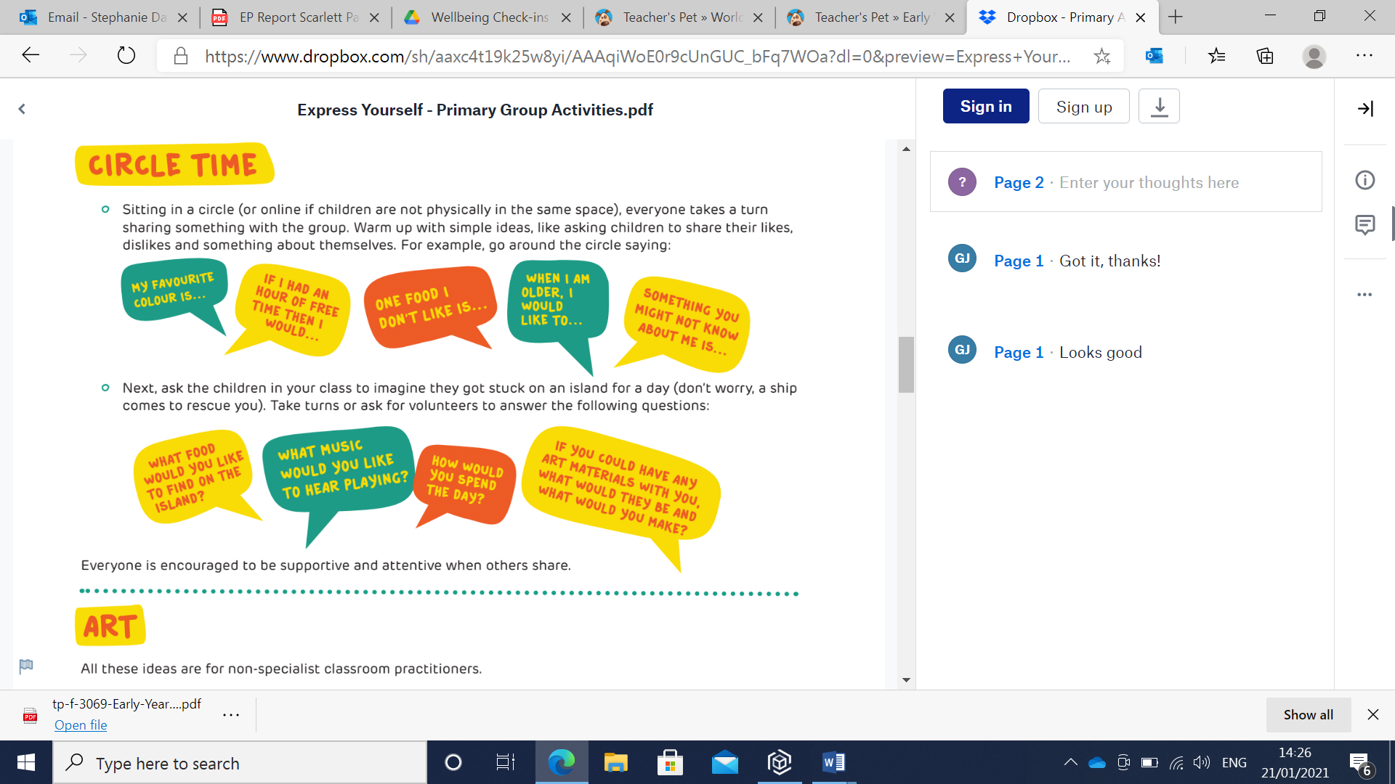

I will ask them what food they would like to eat on the island/ what is their favorite food. If they have it to hand they could show it but if not telling us is just perfect!

- (Wednesday 3rd February) Create their own model garden or colour in the garden on the attached worksheet. If this garden was to reflect your personality, what would it look like? Share their ‘creations’ during one of your zoom calls this week. We will have a later zoom this day and share our work, so you have some time if you want to create a garden.

- (Thursday 4th February). ‘Dress to Express’ – children to express themselves through their clothes i.e. specific colours etc. Children could wear their favourite colour or wear colours to express how they are feeling. Colour is personal and can mean different things to different people so the main aim is to encourage self-expression and celebrate a range of emotions. Please can you send in a video on tapestry on this day of your child talking about what they have chosen to wear. Prior to this talk about how we can use colour to help make sense of how we are feeling, who we are and the world we live in.

