2023

EYFS Parent Questionnaire



***Lunsford Primary School***

***EYFS Parent Questionnaire – March 2023***

|  |  |
| --- | --- |
| **1.** [**My child is happy in**](https://parentview.ofsted.gov.uk/parent-view-results/survey/result/13478/current) **Reception** | |
| **Yes**  96% | **No**  4% |

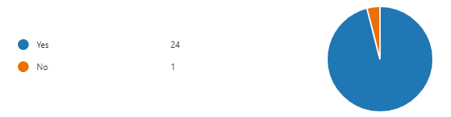

|  |  |
| --- | --- |
| **2.** [**My child feels safe in**](https://parentview.ofsted.gov.uk/parent-view-results/survey/result/13478/current) **Reception** | |
| **Yes**  **100%** | **No**  **0%** |

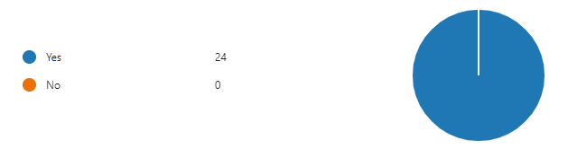

|  |  |
| --- | --- |
| **3. My child speaks positively about their time in Reception** | |
| **Yes**  **96%** | **No**  **4%** |

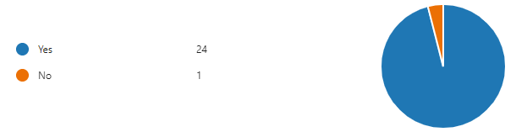

|  |  |
| --- | --- |
| [**4. My child makes good progress in Reception**](https://parentview.ofsted.gov.uk/parent-view-results/survey/result/13478/current) | |
| **Yes**  **100%** | **No**  **0%** |

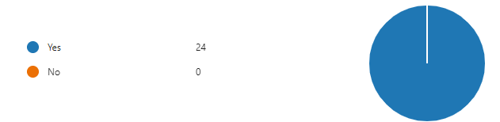

|  |  |
| --- | --- |
| **5.** [**My child is well looked after in**](https://parentview.ofsted.gov.uk/parent-view-results/survey/result/13478/current) **Reception** | |
| **Yes**  **100%** | **No**  0% |



|  |  |
| --- | --- |
| **6.** [**My child is taught well in**](https://parentview.ofsted.gov.uk/parent-view-results/survey/result/13478/current) **Reception** | |
| **Yes**  100% | **No**  **0%** |



|  |  |
| --- | --- |
| **7.** [**I**](https://parentview.ofsted.gov.uk/parent-view-results/survey/result/13478/current) **receive valuable information about how to support my child’s learning at home** | |
| **Yes**  **100%** | **No**  **0%** |

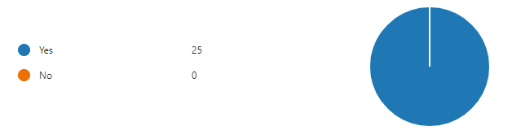

|  |  |
| --- | --- |
| **8. Reception ensures that children are well behaved** | |
| **Yes**  **100%** | **No**  0% |



|  |  |
| --- | --- |
| **9.**  [**Reception deals effectively with bullying**](https://parentview.ofsted.gov.uk/parent-view-results/survey/result/13478/current) | |
| **Yes**  **100%** | **No**  **0%** |

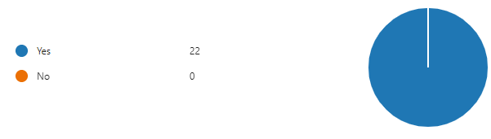

|  |  |
| --- | --- |
| **10. Reception is well led and managed** | |
| **Yes**  100% | **No**  **0%** |

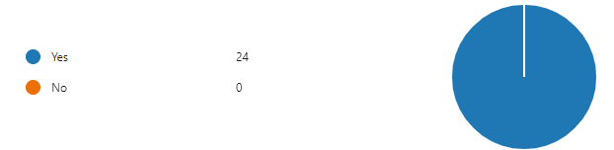

|  |  |
| --- | --- |
| **11. Reception responds well to any concerns I raise** | |
| **Yes**  96% | **No**  **4%** |

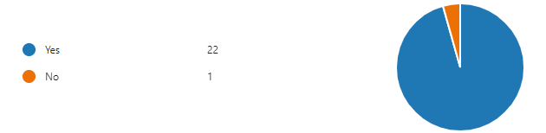

|  |  |
| --- | --- |
| **12.** [**I receive valuable information from the school about my child’s progress**](https://parentview.ofsted.gov.uk/parent-view-results/survey/result/13478/current) | |
| **Yes**  **88%** | **No**  **12%** |

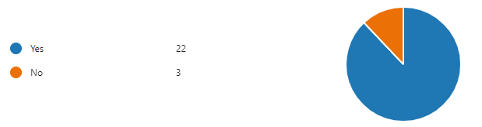

|  |  |
| --- | --- |
| **13. Would you recommend our Reception classes to another parent?** | |
| **Yes**  100% | **No**  **0%** |

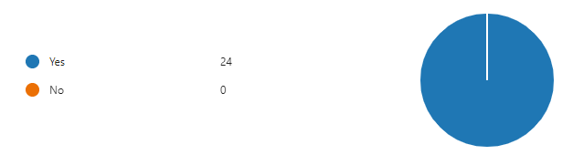

***Parents Comments:***

“My child has been very happy and is very positive to go to school.”

“My child has settled really well into school life at Lunsford. The transitions they have had have been well planned and handled and despite a change of building and teacher within the first 3 terms he has remained settled and loved every day at school. The provision seems wide and varied and he has made good progress across all areas of learning. We are really happy with his start to formal education!”

“(***My son***) is really enjoying his time in reception and has really warmed to Mrs Pring. We love to hear all about the adventures and learning that happens in class and Jack is thriving. Mrs Pring and Mrs Bruckin go above and beyond to offer exciting learning opportunities through play and deliver them with great energy and enthusiasm, thank you :) Tapestry is a great tool to keep parents up to date and Mrs Pring is fantastic at sharing lots with the families. Thank you for all your hard work and dedication :)”

“Brilliant!”

“(***My son***) absolutely loves going to school every day. He is always so excited to come home and share all the fun activities he has done each day. We are so pleased with the progress he is making and that he has had such a brilliant start to his time at Lunsford.”

“(***My daughter***) very much enjoys her time in reception class, she's always got positive things to say and looks forward to going to school every morning.”

“I’m so happy with the progress (***my daughter***) has made since she has started at Lunsford. I have told my friends about the school and how happy I am about the school and I would definitely recommend the school to people.”

“My son loves school, I feel he has a wonderful class and teachers.”

“(***My daughter***) has loved her time in reception with her new teacher Mrs Pring. (***She***) is always excited to tell me what they’ve been up to and she lets me know when it’s a special day eg Chinese New Year etc. (***She***) enjoys being busy and loves learning new things and we feel that Mrs Pring has fulfilled this very well - your enthusiasm is infectious. Thank you.”